English · Grade 4 | Summary
Verb "to be": am, is, are
הפועל ‎"to be": am, is, are‎
الفعل ‎"to be": am, is, are‎
Summary: everything to remember about am, is and are, in one place
סיכום: כל מה שצריך לזכור על ‎am, is‎ ו-‎are‎, במקום אחד
ملخّص: كل ما يجب أن تتذكّره عن ‎am‎ و ‎is‎ و ‎are‎ في مكان واحد
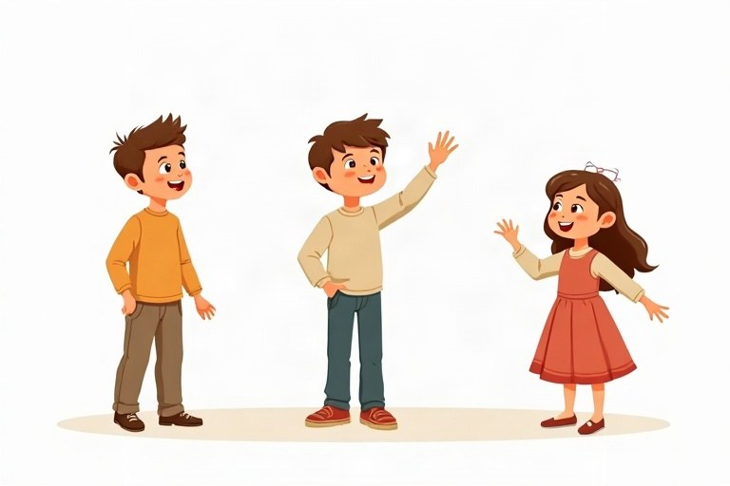
◆ Who goes with what?
מי הולך עם מה?
مَن يأتي مع ماذا؟
Subject | to be | Short form
I | am | I'm
he / she / it | is | he's / she's / it's
you / we / they | are | you're / we're / they're

◆ Saying no
איך אומרים "לא"
كيف نقول "لا"
1. Add not after the verb: I am not, he is not, we are not.
הוסיפו ‎not‎ אחרי הפועל: ‎I am not, he is not, we are not‎.
أضف ‎not‎ بعد الفعل: ‎I am not, he is not, we are not‎.
2. Short forms: isn't, aren't (but: I'm not).
צורות מקוצרות: ‎isn't, aren't (‎אבל: ‎I'm not)‎.
الصيغ المختصرة: ‎isn't, aren't (‎لكن: ‎I'm not)‎.
Example:
דוגמה:
مثال:
Ben isn't sick. We aren't late.
◆ Asking and answering
שואלים ועונים
نسأل ونجيب
1. Put the verb first: Are they at school?
שימו את הפועל ראשון: ‎Are they at school?‎
ضع الفعل أولًا: ‎Are they at school?‎
2. Short answers: Yes, they are. / No, they aren't.
תשובות קצרות: ‎Yes, they are. / No, they aren't‎.
الإجابات القصيرة: ‎Yes, they are. / No, they aren't‎.
Example:
דוגמה:
مثال:
Is Shira nine? – No, she isn't. She is ten.
🖼️ Picture words · מילים בתמונות‎ · كلمات بالصّور‎
  school  בית ספר  مدرسة |   dog  כלב  كلب |   cat  חתול  قطة |   football  כדורגל  كرة القدم |   park  פארק  حديقة عامة |   bag  תיק  حقيبة

Remember! I + am, he/she/it + is, you/we/they + are. In a question, the verb comes first: Is he happy?
‎I + am, he/she/it + is, you/we/they + are‎. בשאלה הפועל בא ראשון: ‎Is he happy?‎
‎I + am‎، ‎he/she/it + is‎، ‎you/we/they + are‎. في السؤال يأتي الفعل أولًا: ‎Is he happy?‎
✏️ Worked example: Yoav and I ___ good friends.
1. "Yoav and I" means "we".
2. We goes with are.
Answer: are
Check yourself – Complete with am, is or are. Use the table:
השלימו עם ‎am, is‎ או ‎are‎. היעזרו בטבלה:
أكمل بـ ‎am‎ أو ‎is‎ أو ‎are‎. استعن بالجدول:
a. My dog __________ very big.
b. I __________ in class 4A.
c. Tamar and Noa __________ sisters.
d. __________ it your birthday today?
Self-check answers: a. is · b. am · c. are · d. Is

