English · Grade 4 | Summary
Wh-questions with "to be" and prepositions of place
שאלות ‎Wh‎ עם ‎"to be"‎ ומילות מקום
أسئلة ‎Wh‎ مع ‎"to be"‎ وحروف المكان
Summary: asking questions with Wh-words and saying where things are
סיכום: שואלים שאלות עם מילות ‎Wh‎ ואומרים איפה דברים נמצאים
ملخّص: نسأل بكلمات ‎Wh‎ ونقول أين توجد الأشياء
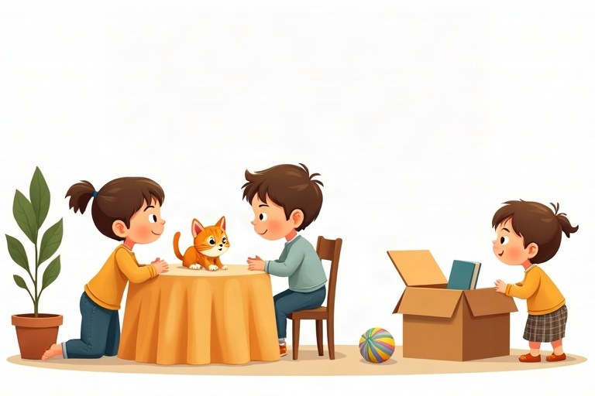
◆ Wh-words
מילות שאלה ‎(Wh)‎
كلمات السؤال ‎(Wh)‎
Question word | We ask about | Example
What | a thing | What is this? – It's a pen.
Who | a person | Who is he? – He's my uncle.
Where | a place | Where is the cat? – On the sofa.
How old | age | How old are you? – I'm nine.

◆ Prepositions of place
מילות מקום
حروف المكان
1. in = inside: in the box
‎in =‎ בתוך: ‎in the box‎
‎in =‎ داخل: ‎in the box‎
2. on = on top: on the desk
‎on =‎ על (למעלה‎): on the desk‎
‎on =‎ على (فوق‎): on the desk‎
3. under = below: under the chair
‎under =‎ מתחת: ‎under the chair‎
‎under =‎ تحت: ‎under the chair‎
4. next to = near, at the side: next to the door
‎next to =‎ ליד, בצד: ‎next to the door‎
‎next to =‎ بجانب، قرب: ‎next to the door‎
◆ is or are?
‎is‎ או ‎are?‎
‎is‎ أم ‎are‎؟
1. One thing: Where is the ball?
דבר אחד: ‎Where is the ball?‎
شيء واحد: ‎Where is the ball?‎
2. Two or more: Where are the balls?
שניים או יותר: ‎Where are the balls?‎
اثنان أو أكثر: ‎Where are the balls?‎
🖼️ Picture words · מילים בתמונות‎ · كلمات بالصّور‎
  ball  כדור  كرة |   bed  מיטה  سرير |   cat  חתול  قطة |   dog  כלב  كلب |   box  קופסה  صندوق |   book  ספר  كتاب

Remember! Wh-word + is/are + subject: Where is the dog? Where are the dogs?
מילת שאלה ‎+ is/are +‎ נושא: ‎Where is the dog?‎‏ ‎Where are the dogs?‎
كلمة السؤال ‎+ is/are +‎ الفاعل: ‎Where is the dog?‎‏ ‎Where are the dogs?‎
✏️ Worked example: ___ are your parents? – They are at work.
1. The answer is a place: at work.
2. For a place we ask with Where.
Answer: Where
Check yourself – Complete. Use the table and the points:
השלימו. היעזרו בטבלה ובנקודות:
أكمل. استعن بالجدول وبالنقاط:
a. __________ is that boy? – He's Itay.
b. Where __________ the cookies?
c. The cat is __________ the bed. (below)
d. __________ old is your brother?
Self-check answers: a. Who · b. are · c. under · d. How

