English · Grade 4 | Summary
There is / There are and plural nouns
‎There is / There are‎ ושמות עצם ברבים
‎There is / There are‎ وأسماء الجمع
Summary: There is / There are and how to make nouns plural
סיכום: ‎There is / There are‎ ואיך עושים רבים משמות עצם
ملخّص: ‎There is / There are‎ وكيف نجمع الأسماء
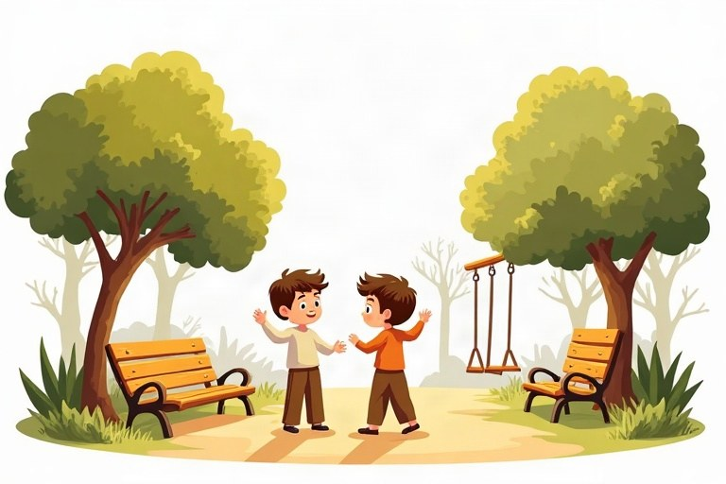
◆ One or many?
אחד או הרבה?
واحد أم كثير؟
 | One | Many
✔ | There is a bench. | There are benches.
✘ | There isn't a bench. | There aren't any benches.
? | Is there a bench? | Are there any benches?

◆ Making plurals
איך עושים רבים
كيف نكوّن الجمع
1. Most words: + s (a pen – pens)
רוב המילים: ‎+ s (a pen – pens)‎
معظم الكلمات: ‎+ s (a pen – pens)‎
2. After s, sh, ch, x: + es (a box – boxes)
אחרי ‎s, sh, ch, x: + es (a box – boxes)‎
بعد ‎s‎ و ‎sh‎ و ‎ch‎ و ‎x: + es (a box – boxes)‎
3. Special words: child – children, man – men, woman – women, foot – feet, tooth – teeth, mouse – mice
מילים מיוחדות: ‎child – children, man – men, woman – women, foot – feet, tooth – teeth, mouse – mice‎
كلمات خاصّة: ‎child – children, man – men, woman – women, foot – feet, tooth – teeth, mouse – mice‎
◆ How many?
כמה?
كم؟
1. How many + plural noun + are there?
‎How many +‎ שם עצם ברבים ‎+ are there?‎
‎How many +‎ اسم بصيغة الجمع ‎+ are there?‎
Example:
דוגמה:
مثال:
How many chairs are there? – There are six.
🖼️ Picture words · מילים בתמונות‎ · كلمات بالصّور‎
  box  קופסה  صندوق |   bus  אוטובוס  حافلة |   park  פארק  حديقة عامة |   book  ספר  كتاب |   cat  חתול  قطة |   tree  עץ  شجرة

Remember! There is + a/an + one thing. There are + many things (books, boxes, children).
‎There is + a/an +‎ דבר אחד. ‎There are +‎ הרבה דברים ‎(books, boxes, children)‎.
‎There is + a/an +‎ شيء واحد. ‎There are +‎ أشياء كثيرة ‎(books, boxes, children)‎.
✏️ Worked example: There ___ two ___ in the park. (man)
1. Two means more than one, so we use are.
2. man is a special word: the plural is men.
Answer: are, men
Check yourself – Complete. Use the table and the points:
השלימו. היעזרו בטבלה ובנקודות:
أكمل. استعن بالجدول وبالنقاط:
a. There __________ a bus at the bus stop.
b. one watch – two __________
c. There aren't __________ cookies in the jar.
d. __________ there a library in your town?
Self-check answers: a. is · b. watches · c. any · d. Is

