English · Grade 4 | Summary
Imperatives and "Let's…"
ציווי ו-‎"Let's…"‎
الأمر و ‎"Let's…"‎
Summary: giving instructions and making suggestions
סיכום: נותנים הוראות ומציעים הצעות
ملخّص: إعطاء التعليمات وتقديم الاقتراحات
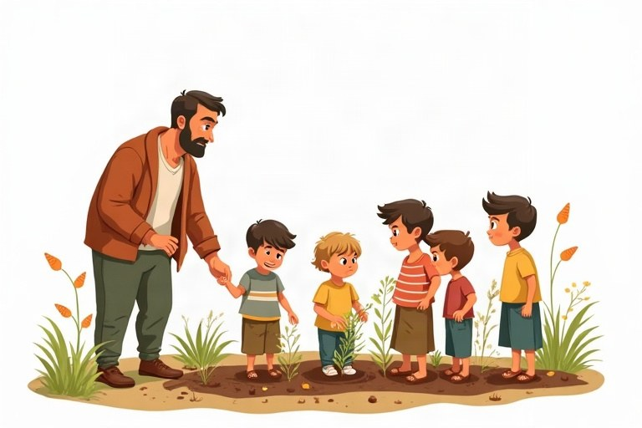
◆ Three patterns
שלוש תבניות
ثلاثة أنماط
Pattern | Use | Example
Verb + … | do it | Wash your hands.
Don't + verb | don't do it | Don't eat in class.
Let's + verb | we do it together | Let's sing a song.

◆ Be polite
דברו בנימוס
كُن مهذّبًا
1. Add please: Please sit down. / Sit down, please.
הוסיפו ‎please: Please sit down. / Sit down, please‎.
أضف ‎please: Please sit down. / Sit down, please‎.
2. Answer a suggestion: Good idea! / OK! / Sorry, I can't.
ענו להצעה: ‎Good idea! / OK! / Sorry, I can't‎.
ردّ على اقتراح: ‎Good idea! / OK! / Sorry, I can't‎.
◆ Where do we see imperatives?
איפה אנחנו פוגשים ציווי?
أين نرى صيغة الأمر؟
1. class rules, recipes, signs and games
כללי כיתה, מתכונים, שלטים ומשחקים
قواعد الصف، الوصفات، اللافتات والألعاب
Example:
דוגמה:
مثال:
Mix the eggs. Don't swim here. Turn left.
🖼️ Picture words · מילים בתמונות‎ · كلمات بالصّور‎
  door  דלת  باب |   hand  יד  يد |   cake  עוגה  كعكة | 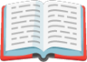  book  ספר  كتاب |   park  פארק  حديقة عامة |   school  בית ספר  مدرسة

Remember! Imperative = verb first (Close the door). Don't + verb = no (Don't close the door). Let's + verb = we do it together.
ציווי = הפועל ראשון ‎(Close the door).‎‏ ‎Don't +‎ פועל = לא ‎(Don't close the door).‎‏ ‎Let's +‎ פועל = עושים את זה ביחד.
الأمر = الفعل أولًا ‎(Close the door).‎‏ ‎Don't +‎ فعل = لا ‎(Don't close the door).‎‏ ‎Let's +‎ فعل = نفعل ذلك معًا.
✏️ Worked example: Make a negative imperative: You shout in the library.
1. Start with Don't.
2. Then the verb without you: shout.
Answer: Don't shout in the library.
Check yourself – Complete. Use the table:
השלימו. היעזרו בטבלה:
أكمل. استعن بالجدول:
a. __________ your teeth before bed. (brush)
b. __________ eat in the computer room!
c. It's hot. __________ go swimming!
d. __________ be late for school, please.
Self-check answers: a. Brush · b. Don't · c. Let's · d. Don't

