English · Grade 4 | Summary
Present simple: my day (I, you, we, they)
הווה פשוט: היום שלי ‎(I, you, we, they)‎
المضارع البسيط: يومي ‎(I, you, we, they)‎
Summary: the present simple with I, you, we and they
סיכום: הווה פשוט עם ‎I, you, we‎ ו-‎they‎
ملخّص: المضارع البسيط مع ‎I‎ و ‎you‎ و ‎we‎ و ‎they‎
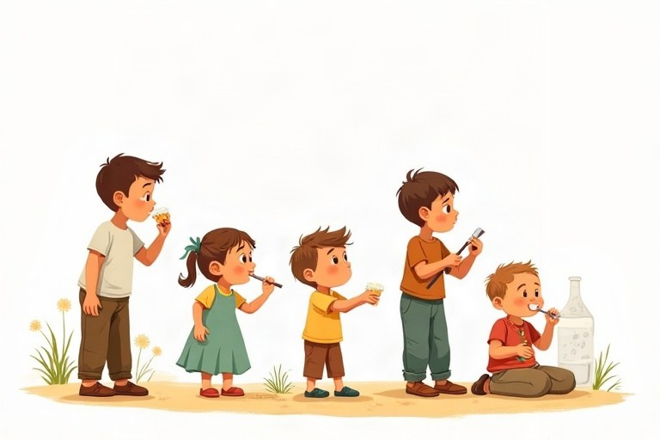
◆ The pattern
התבנית
النمط
 | Example
✔ I / you / we / they + verb | We walk to school.
✘ don't + verb | We don't walk to school.
? Do … + verb? | Do you walk to school?
Short answer | Yes, I do. / No, I don't.

◆ Daily routine verbs
פעלים של סדר היום
أفعال الروتين اليومي
1. get up, wash, get dressed, eat breakfast, go to school
2. do homework, play, have dinner, read, go to bed
◆ Time words
מילות זמן
كلمات الزمن
1. in the morning / afternoon / evening, at night, at 8 o'clock
2. every day, on Mondays, always, sometimes, never
🖼️ Picture words · מילים בתמונות‎ · كلمات بالصّور‎
  school  בית ספר  مدرسة |   bed  מיטה  سرير |   basketball  כדורסל  كرة السلة |   pizza  פיצה  بيتزا |   tennis  טניס  تنس |   bus  אוטובוס  حافلة

Remember! I / you / we / they + verb: I play. Negative: I don't play. Question: Do you play?
‎I / you / we / they +‎ פועל: ‎I play‎. שלילה: ‎I don't play‎. שאלה: ‎Do you play?‎
‎I / you / we / they +‎ فعل: ‎I play‎. النفي: ‎I don't play‎. السؤال: ‎Do you play?‎
✏️ Worked example: Make a question: They play tennis on Fridays.
1. Start with Do.
2. Then they + play (no change).
Answer: Do they play tennis on Fridays?
Check yourself – Complete. Use the table:
השלימו. היעזרו בטבלה:
أكمل. استعن بالجدول:
a. I __________ my teeth every morning. (brush)
b. They __________ watch TV at night. (negative)
c. __________ we have English today? – Yes, we do.
d. Do you like music? – No, I __________.
Self-check answers: a. brush · b. don't · c. Do · d. don't

