English · Grade 4 | Summary
"Can" and "can't" for ability
‎"Can"‎ ו-‎"can't"‎ ליכולת
‎"Can"‎ و ‎"can't"‎ للتعبير عن القدرة
Summary: can and can't for ability
סיכום: ‎can‎ ו-‎can't‎ ליכולת
ملخّص: ‎can‎ و ‎can't‎ للتعبير عن القدرة
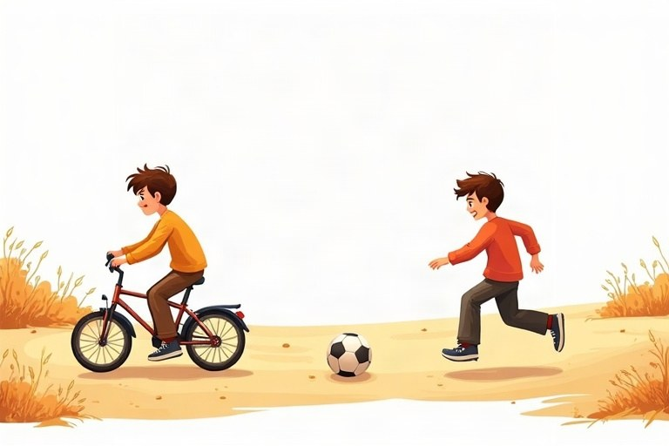
◆ The pattern
התבנית
النمط
 | Example
✔ can + verb | He can climb trees.
✘ can't + verb | He can't climb trees.
? Can … + verb? | Can he climb trees?
Short answer | Yes, he can. / No, he can't.

◆ Remember
זכרו
تذكّر
1. Same form for everyone: I can, she can, they can.
אותה צורה לכולם: ‎I can, she can, they can‎.
الصيغة نفسها للجميع: ‎I can, she can, they can‎.
2. No -s and no to after can: She can swim.
בלי -‎s‎ ובלי ‎to‎ אחרי ‎can: She can swim‎.
بدون -‎s‎ وبدون ‎to‎ بعد ‎can: She can swim‎.
◆ Ability words
מילים של יכולת
كلمات القدرة
1. swim, ride a bike, play the piano, speak English
2. jump, run fast, cook, draw, climb, dance
🖼️ Picture words · מילים בתמונות‎ · كلمات بالصّور‎
  tree  עץ  شجرة |   cat  חתול  قطة |   dog  כלב  كلب |   fish  דג  سمكة |   bike  אופניים  دراجة |   horse  סוס  حصان

Remember! can + verb with no -s and no to: She can sing (not: She cans sing / She can to sing).
‎can +‎ פועל בלי -‎s‎ ובלי ‎to: She can sing (‎לא: ‎She cans sing / She can to sing)‎.
‎can +‎ فعل بدون -‎s‎ وبدون ‎to: She can sing (‎وليس: ‎She cans sing / She can to sing)‎.
✏️ Worked example: Correct the sentence: Noa cans plays tennis.
1. can never takes -s.
2. The verb after can has no -s.
Answer: Noa can play tennis.
Check yourself – Complete. Use the table and the points:
השלימו. היעזרו בטבלה ובנקודות:
أكمل. استعن بالجدول وبالنقاط:
a. My grandpa __________ use a computer. (✔)
b. Penguins __________ fly. (✘)
c. Can you cook? – No, I __________.
d. __________ Ben speak French? – Yes, he can.
Self-check answers: a. can · b. can't · c. can't · d. Can

