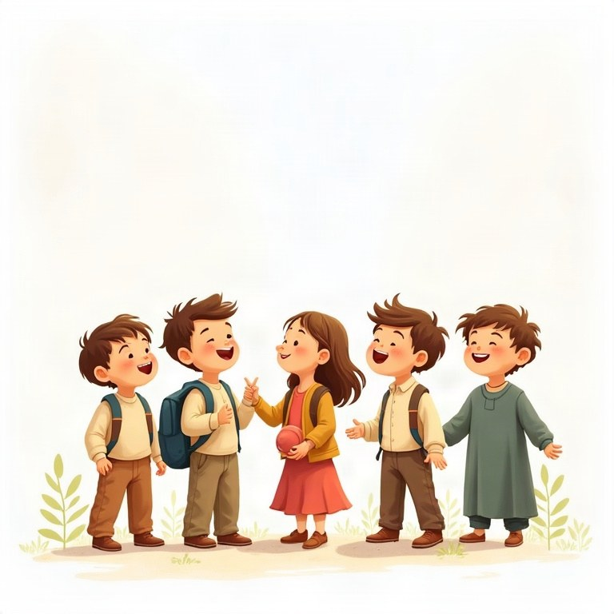
Workbook
English
Grade 4

Contents
תוכן העניינים
المحتويات
Topic
Introduction
Unit 1: Verb "to be": am, is, are
Unit 2: Wh-questions with "to be" and prepositions of place
Unit 3: There is / There are and plural nouns
Unit 4: Adjectives before nouns
Unit 5: Imperatives and "Let's…"
Unit 6: Present simple: my day (I, you, we, they)
Unit 7: "Can" and "can't" for ability
Review – What did we learn?

Introduction
מבוא
مقدّمة
Hello, pupils of grade 4! Welcome to your English book.
שלום, תלמידי כיתה ד'! ברוכים הבאים לספר האנגלית שלכם.
مرحبًا يا تلاميذ الصف الرابع! أهلًا بكم في كتاب اللغة الإنجليزية.
This year you will learn to talk about yourself, your family, your home and your day. You will ask questions, describe people and things, give instructions and say what you can do.
השנה תלמדו לדבר על עצמכם, על המשפחה, על הבית ועל היום שלכם. תשאלו שאלות, תתארו אנשים ודברים, תיתנו הוראות ותספרו מה אתם יודעים לעשות.
في هذه السنة ستتعلّم أن تتحدّث عن نفسك وعن عائلتك وبيتك ويومك. ستسأل أسئلة، وتصف أشخاصًا وأشياء، وتعطي تعليمات، وتقول ماذا تستطيع أن تفعل.
In every chapter there is a short explanation, examples, a "Remember!" box and lots of practice. At the end there is a review and a final test. Have fun and good luck!
בכל פרק יש הסבר קצר, דוגמאות, תיבת ‎"Remember!"‎ והרבה תרגול. בסוף יש חזרה ומבחן מסכם. תהנו ובהצלחה!
في كل فصل يوجد شرح قصير وأمثلة ومربّع ‎"Remember!"‎ وتمارين كثيرة. في النهاية توجد مراجعة وامتحان نهائي. استمتع وبالتوفيق!

English · Grade 4 | Unit 1
Unit 1: Verb "to be": am, is, are
הפועל ‎"to be": am, is, are‎
الفعل ‎"to be": am, is, are‎
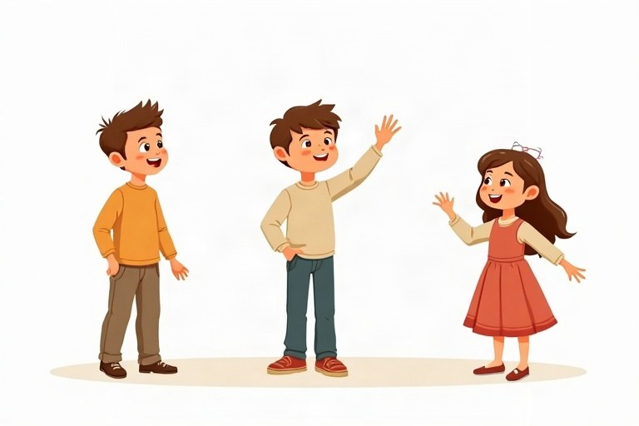
◆ Who goes with what?
מי הולך עם מה?
مَن يأتي مع ماذا؟
Subject | to be | Short form
I | am | I'm
he / she / it | is | he's / she's / it's
you / we / they | are | you're / we're / they're

◆ Saying no
איך אומרים "לא"
كيف نقول "لا"
1. Add not after the verb: I am not, he is not, we are not.
הוסיפו ‎not‎ אחרי הפועל: ‎I am not, he is not, we are not‎.
أضف ‎not‎ بعد الفعل: ‎I am not, he is not, we are not‎.
2. Short forms: isn't, aren't (but: I'm not).
צורות מקוצרות: ‎isn't, aren't (‎אבל: ‎I'm not)‎.
الصيغ المختصرة: ‎isn't, aren't (‎لكن: ‎I'm not)‎.
Example:
דוגמה:
مثال:
Ben isn't sick. We aren't late.
◆ Asking and answering
שואלים ועונים
نسأل ونجيب
1. Put the verb first: Are they at school?
שימו את הפועל ראשון: ‎Are they at school?‎
ضع الفعل أولًا: ‎Are they at school?‎
2. Short answers: Yes, they are. / No, they aren't.
תשובות קצרות: ‎Yes, they are. / No, they aren't‎.
الإجابات القصيرة: ‎Yes, they are. / No, they aren't‎.
Example:
דוגמה:
مثال:
Is Shira nine? – No, she isn't. She is ten.
🖼️ Picture words · מילים בתמונות‎ · كلمات بالصّور‎
  school  בית ספר  مدرسة |   dog  כלב  كلب |   cat  חתול  قطة |   football  כדורגל  كرة القدم |   park  פארק  حديقة عامة |   bag  תיק  حقيبة

1. Complete with am, is or are.
השלימו עם ‎am, is‎ או ‎are‎.
أكمل بـ ‎am‎ أو ‎is‎ أو ‎are‎.
Word bank: am | is | are
a. My mother __________ a doctor.
b. I __________ at the park.
c. Yoav and Ben __________ in the pool.
d. The sun __________ hot.
e. You __________ a good singer.
f. My shoes __________ new.
2. Match the question to the answer.
התאימו את השאלה לתשובה.
صِلِ السؤال بالإجابة.
Column A | Column B
1. Are you ten? | [ ] Yes, she is.
2. Is Omer your brother? | [ ] Yes, he is.
3. Is the cat black? | [ ] No, they aren't.
4. Are they at school? | [ ] No, it isn't. It's white.
5. Is Shira at home? | [ ] Yes, I am.

3. Correct or wrong? Sort the sentences.
נכון או שגוי? מיינו את המשפטים.
صحيح أم خطأ؟ صنّف الجمل.
Words: I am nine. | She are happy. | We are friends. | It is big. | They is late. | I is tall.
Correct ✔ | Wrong ✘

4. Complete with is or are.
השלימו עם ‎is‎ או ‎are‎.
أكمل بـ ‎is‎ أو ‎are‎.
a. Noa __________ my sister. She is eight.
b. Itay and Daniel __________ in the yard.
c. The dog __________ under the table.
d. My grandparents __________ from Tel Aviv.
5. Circle the correct word.
הקיפו את המילה הנכונה.
ضع دائرة حول الكلمة الصحيحة.
a. ___ you hungry?
○ Is ○ Are ○ Am
b. ___ your teacher nice?
○ Is ○ Are ○ Am
c. ___ I late?
○ Is ○ Are ○ Am
d. ___ the children at the party?
○ Am ○ Is ○ Are
6. Write the sentence as a question.
כתבו את המשפט כשאלה.
اكتب الجملة على شكل سؤال.
Sentence | Question
Tom is sick.
You are cold.
They are at the zoo.
It is your bag.

7. Make the sentence negative. Use isn't, aren't or 'm not.
הפכו את המשפט לשלילה. השתמשו ב-‎isn't, aren't‎ או ‎'m not‎.
حوّل الجملة إلى النفي. استعمل ‎isn't‎ أو ‎aren't‎ أو ‎'m not‎.
a. The room is clean. → The room __________ clean.
b. We are at home. → We __________ at home.
c. I am thirsty. → I __________ thirsty.
d. Maya is in Jerusalem. → Maya __________ in Jerusalem.
8. Look at the short answers. True (correct) or False (wrong)? Correct the wrong ones.
הסתכלו על התשובות הקצרות. נכון ‎(True)‎ או שגוי ‎(False)?‎ תקנו את השגויות.
انظر إلى الإجابات القصيرة. صحيحة ‎(True)‎ أم خاطئة ‎(False)‎؟ صحّح الخاطئة.
a. Is he at school? – Yes, he is. True / False
b. Are you happy? – Yes, I'm. True / False
c. Are they brothers? – No, they aren't. True / False
d. Is it a cat? – No, it not. True / False
9. Find the mistake and write the sentence correctly.
מצאו את הטעות וכתבו את המשפט נכון.
جد الخطأ واكتب الجملة بشكل صحيح.
a. My friends is funny.
b. I are in the classroom.
c. Is you OK?
d. Ben and I is cousins.
Class 4B
This is class 4B. Our teacher is Ms. Levi. She is very kind. There are thirty children in our class. Omer is very tall. He is good at football.
Itay and Shira are new in our school. They are from Be'er Sheva. Today is Sunday, and we are on a class trip to the zoo. The lions are big, but they are not scary. They are asleep!
10. Read "Class 4B". Choose the correct answer.
קראו את ‎"Class 4B"‎. בחרו את התשובה הנכונה.
اقرأ ‎"Class 4B"‎. اختر الإجابة الصحيحة.
a. Who is Ms. Levi?
○ a pupil ○ the teacher ○ Omer's sister
b. Where are Itay and Shira from?
○ Be'er Sheva ○ Haifa ○ Eilat
c. Why are the lions not scary today?
○ They are small. ○ They are asleep. ○ They are at school.
11. Read the text again. Complete with information from the text.
קראו שוב את הטקסט. השלימו לפי המידע שבטקסט.
اقرأ النص مرة أخرى. أكمل بمعلومات من النص.
a. Ms. Levi is very __________.
b. Omer is good at __________.
c. Today the class is at the __________.
12. Answer about you: Are you tall? Is your teacher kind? Are you good at football? Write full sentences.
ענו על עצמכם: ‎Are you tall?‎‏ ‎Is your teacher kind?‎‏ ‎Are you good at football?‎ כתבו משפטים מלאים.
أجب عن نفسك: ‎Are you tall?‎‏ ‎Is your teacher kind?‎‏ ‎Are you good at football?‎ اكتب جملًا كاملة.
________________________________________________________________________
________________________________________________________________________
________________________________________________________________________
13. Write 4 sentences about your family. Use am, is, are and one negative sentence. (Example: My brother is ... He isn't ...)
כתבו 4 משפטים על המשפחה שלכם. השתמשו ב-‎am, is, are‎ ובמשפט שלילה אחד. (דוגמה: ‎My brother is ...‎‏ ‎He isn't ...)‎
اكتب 4 جمل عن عائلتك. استعمل ‎am‎ و ‎is‎ و ‎are‎ وجملة نفي واحدة. (مثال: ‎My brother is ...‎‏ ‎He isn't ...)‎
________________________________________________________________________
________________________________________________________________________
________________________________________________________________________
________________________________________________________________________

English · Grade 4 | Unit 2
Unit 2: Wh-questions with "to be" and prepositions of place
שאלות ‎Wh‎ עם ‎"to be"‎ ומילות מקום
أسئلة ‎Wh‎ مع ‎"to be"‎ وحروف المكان
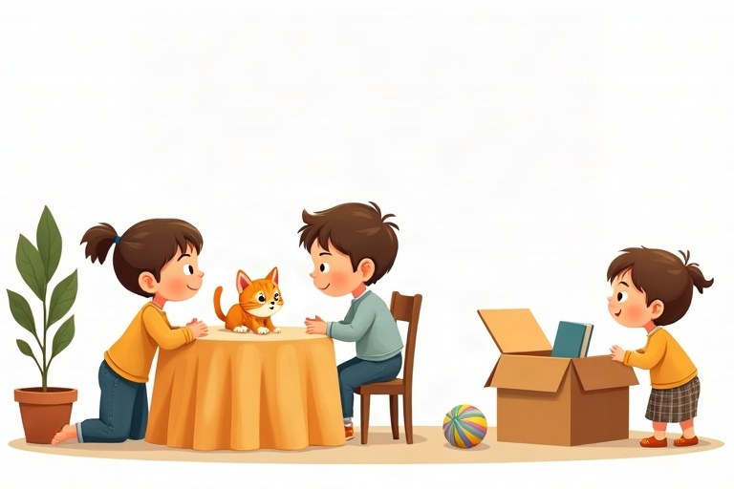
◆ Wh-words
מילות שאלה ‎(Wh)‎
كلمات السؤال ‎(Wh)‎
Question word | We ask about | Example
What | a thing | What is this? – It's a pen.
Who | a person | Who is he? – He's my uncle.
Where | a place | Where is the cat? – On the sofa.
How old | age | How old are you? – I'm nine.

◆ Prepositions of place
מילות מקום
حروف المكان
1. in = inside: in the box
‎in =‎ בתוך: ‎in the box‎
‎in =‎ داخل: ‎in the box‎
2. on = on top: on the desk
‎on =‎ על (למעלה‎): on the desk‎
‎on =‎ على (فوق‎): on the desk‎
3. under = below: under the chair
‎under =‎ מתחת: ‎under the chair‎
‎under =‎ تحت: ‎under the chair‎
4. next to = near, at the side: next to the door
‎next to =‎ ליד, בצד: ‎next to the door‎
‎next to =‎ بجانب، قرب: ‎next to the door‎
◆ is or are?
‎is‎ או ‎are?‎
‎is‎ أم ‎are‎؟
1. One thing: Where is the ball?
דבר אחד: ‎Where is the ball?‎
شيء واحد: ‎Where is the ball?‎
2. Two or more: Where are the balls?
שניים או יותר: ‎Where are the balls?‎
اثنان أو أكثر: ‎Where are the balls?‎
🖼️ Picture words · מילים בתמונות‎ · كلمات بالصّور‎
ball  כדור  كرة |   bed  מיטה  سرير | cat  חתול  قطة | dog  כלב  كلب |   box  קופסה  صندوق |   book  ספר  كتاب

1. Complete with in, on, under or next to.
השלימו עם ‎in, on, under‎ או ‎next to‎.
أكمل بـ ‎in‎ أو ‎on‎ أو ‎under‎ أو ‎next to‎.
Word bank: in | on | under | next to
a. The pencils are __________ the pencil case.
b. The picture is __________ the wall.
c. The toy car is __________ the chair. (below)
d. The school is __________ the library. (at its side)
e. The birds are __________ the tree.
2. Match the question to the answer.
התאימו את השאלה לתשובה.
صِلِ السؤال بالإجابة.
Column A | Column B
1. What is this? | [ ] Next to the window.
2. Who is she? | [ ] It's an apple.
3. Where are the plates? | [ ] In the cupboard.
4. How old is your dog? | [ ] He's three.
5. Where is Grandma? | [ ] She's my cousin Shira.

3. Circle the correct word.
הקיפו את המילה הנכונה.
ضع دائرة حول الكلمة الصحيحة.
a. Where ___ my pencils?
○ is ○ are ○ am
b. The cat is ___ the box. (inside)
○ on ○ in ○ next to
c. ___ is your best friend? – Yoav.
○ Who ○ What ○ Where
d. The rug is ___ the table. (below)
○ under ○ on ○ in
4. Write Where, What, Who or How old.
כתבו ‎Where, What, Who‎ או ‎How old‎.
اكتب ‎Where‎ أو ‎What‎ أو ‎Who‎ أو ‎How old‎.
a. __________ is in the bag? – A sandwich.
b. __________ is your mom? – At work.
c. __________ is your sister? – She's six.
d. __________ is the man in the photo? – My uncle.
5. Sort the answers: thing, person or place?
מיינו את התשובות: חפץ, אדם או מקום?
صنّف الإجابات: شيء أم شخص أم مكان؟
Words: a bike | my teacher | at the beach | a book | Noam | in the kitchen
Thing (What?) | Person (Who?) | Place (Where?)

6. Write the question. Use Where is or Where are.
כתבו את השאלה. השתמשו ב-‎Where is‎ או ‎Where are‎.
اكتب السؤال. استعمل ‎Where is‎ أو ‎Where are‎.
Answer | Question
The keys are on the table.
The ball is in the yard.
The kids are next to the bus.
The milk is in the fridge.

7. True or False? Correct the false sentences.
נכון או לא נכון? תקנו את המשפטים הלא נכונים.
صحيح أم خطأ؟ صحّح الجمل الخاطئة.
a. We ask about a person with Who. True / False
b. "Where are the dog?" is correct. True / False
c. "under" means on top of something. True / False
d. "What is your name?" is correct. True / False
8. Find the mistake and write the question correctly.
מצאו את הטעות וכתבו את השאלה נכון.
جِد الخطأ واكتب السؤال بشكل صحيح.
a. Where is my books?
b. Who are your teacher?
c. What are this?
d. Where the bus stop is?
The Class Party
Today is the class party. Our classroom is beautiful. The balloons are on the walls. The cake is on the big table, next to the drinks.
"Where are the plates?" asks Ms. Cohen. "They're in the box under the table," says Omer. "And where is the music?" asks Noa. "It's on my phone!" says Ariel. Now everything is ready. Let the party start!
9. Read "The Class Party". True or False?
קראו את ‎"The Class Party"‎. נכון או לא נכון?
اقرأ ‎"The Class Party"‎. صحيح أم خطأ؟
a. The balloons are on the walls. True / False
b. The cake is under the table. True / False
c. The plates are in a box. True / False
d. The music is on Noa's phone. True / False
10. Read the text again and answer.
קראו שוב את הטקסט וענו.
اقرأ النص مرة أخرى وأجب.
a. Where is the cake? – On the big table, next to the __________.
b. Who asks about the plates? – Ms. __________.
c. Where is the music? – On Ariel's __________.
11. Write 3 questions for a new friend. Use What, Who, Where or How old.
כתבו 3 שאלות לחבר חדש. השתמשו ב-‎What, Who, Where‎ או ‎How old‎.
اكتب 3 أسئلة لصديق جديد. استعمل ‎What‎ أو ‎Who‎ أو ‎Where‎ أو ‎How old‎.
________________________________________________________________________
________________________________________________________________________
________________________________________________________________________
12. Your little brother can't find his things. Write 4 sentences to help him. (Example: Your ball is under the bed.)
אחיכם הקטן לא מוצא את הדברים שלו. כתבו 4 משפטים כדי לעזור לו. (דוגמה: ‎Your ball is under the bed.)‎
أخوك الصغير لا يجد أغراضه. اكتب 4 جمل لتساعده. (مثال: ‎Your ball is under the bed.)‎
________________________________________________________________________
________________________________________________________________________
________________________________________________________________________
________________________________________________________________________

English · Grade 4 | Unit 3
Unit 3: There is / There are and plural nouns
‎There is / There are‎ ושמות עצם ברבים
‎There is / There are‎ وأسماء الجمع
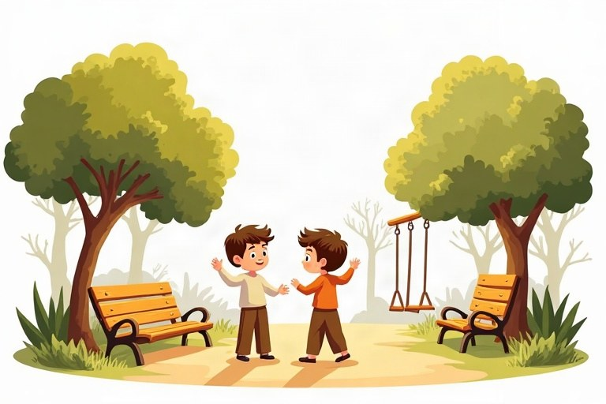
◆ One or many?
אחד או הרבה?
واحد أم كثير؟
 | One | Many
✔ | There is a bench. | There are benches.
✘ | There isn't a bench. | There aren't any benches.
? | Is there a bench? | Are there any benches?

◆ Making plurals
איך עושים רבים
كيف نكوّن الجمع
1. Most words: + s (a pen – pens)
רוב המילים: ‎+ s (a pen – pens)‎
معظم الكلمات: ‎+ s (a pen – pens)‎
2. After s, sh, ch, x: + es (a box – boxes)
אחרי ‎s, sh, ch, x: + es (a box – boxes)‎
بعد ‎s‎ و ‎sh‎ و ‎ch‎ و ‎x: + es (a box – boxes)‎
3. Special words: child – children, man – men, woman – women, foot – feet, tooth – teeth, mouse – mice
מילים מיוחדות: ‎child – children, man – men, woman – women, foot – feet, tooth – teeth, mouse – mice‎
كلمات خاصّة: ‎child – children, man – men, woman – women, foot – feet, tooth – teeth, mouse – mice‎
◆ How many?
כמה?
كم؟
1. How many + plural noun + are there?
‎How many +‎ שם עצם ברבים ‎+ are there?‎
‎How many +‎ اسم بصيغة الجمع ‎+ are there?‎
Example:
דוגמה:
مثال:
How many chairs are there? – There are six.
🖼️ Picture words · מילים בתמונות‎ · كلمات بالصّور‎
box  קופסה  صندوق |   bus  אוטובוס  حافلة | park  פארק  حديقة عامة | book  ספר  كتاب | cat  חתול  قطة |   tree  עץ  شجرة

1. Write the plural.
כתבו את צורת הרבים.
اكتب صيغة الجمع.
a. one girl – two __________
b. one glass – three __________
c. one man – five __________
d. one mouse – two __________
e. one sandwich – four __________
f. one class – two __________
2. Match the beginning to the end.
התאימו את ההתחלה לסוף.
صِلْ بداية الجملة بنهايتها.
Column A | Column B
1. There is | [ ] a bank near here?
2. There are | [ ] any eggs in the fridge.
3. There isn't | [ ] a window in the bathroom.
4. There aren't | [ ] many stars in the sky.
5. Is there | [ ] a dog in the garden.

3. Sort: which words go with There is and which go with There are?
מיינו: אילו מילים הולכות עם ‎There is‎ ואילו עם ‎There are?‎
صنّف: أيّ الكلمات تأتي مع ‎There is‎ وأيّها مع ‎There are‎؟
Words: a cake | two cakes | an orange | children | a bike | three buses
There is | There are

4. Circle the correct word.
הקיפו את המילה הנכונה.
ضع دائرة حول الكلمة الصحيحة.
a. There are five ___ in the class.
○ womans ○ women ○ woman
b. There ___ a cat under the car.
○ are ○ is
c. Are there any ___ in the zoo?
○ lions ○ lion
d. How many ___ are there in your family?
○ child ○ childs ○ children
5. Complete with There is, There are, Is there or Are there.
השלימו עם ‎There is, There are, Is there‎ או ‎Are there‎.
أكمل بـ ‎There is‎ أو ‎There are‎ أو ‎Is there‎ أو ‎Are there‎.
a. __________ a toy shop in the mall? – Yes, there is.
b. __________ two pools at the club.
c. __________ any apples in the bag? – No, there aren't.
d. __________ a big box on the table.
6. Look at the list and write sentences. Use There is / There are.
הסתכלו ברשימה וכתבו משפטים. השתמשו ב-‎There is / There are‎.
انظر إلى القائمة واكتب جملًا. استعمل ‎There is / There are‎.
In the kitchen | Sentence
1 table
4 chairs
2 glasses
1 fridge

7. True or False? Correct the false sentences.
נכון או לא נכון? תקנו את המשפטים הלא נכונים.
صحيح أم خطأ؟ صحّح الجمل الخاطئة.
a. The plural of foot is foots. True / False
b. "There are any cars." is a correct negative sentence. True / False
c. "Is there a pool? – Yes, there is." is correct. True / False
d. The plural of bus is buses. True / False
8. Find the mistake and write the sentence correctly.
מצאו את הטעות וכתבו את המשפט נכון.
جد الخطأ واكتب الجملة بشكل صحيح.
a. There is two pens on the desk.
b. There are three boxs.
c. Are there a park here?
d. There are many child in the pool.
A Day at the Beach
It is summer, and Tom and his family are at the beach in Tel Aviv. There are many people on the sand. There are colorful umbrellas and chairs. There is a lifeguard tower next to the water.
In the sea there are big waves. There aren't any fish near the beach, but there are two dolphins far away! There is an ice cream stand, too. Tom is happy. It's a great day!
9. Read "A Day at the Beach". Choose the correct answer.
קראו את ‎"A Day at the Beach"‎. בחרו את התשובה הנכונה.
اقرأ ‎"A Day at the Beach"‎. اختر الإجابة الصحيحة.
a. Where is the beach?
○ in Haifa ○ in Tel Aviv ○ in Eilat
b. What is next to the water?
○ a lifeguard tower ○ an ice cream stand ○ a car
c. How many dolphins are there?
○ one ○ two ○ many
10. Read the text again. True or False?
קראו שוב את הטקסט. נכון או לא נכון?
اقرأ النص مرة أخرى. صحيح أم خطأ؟
a. There are umbrellas on the sand. True / False
b. There are many fish near the beach. True / False
c. There isn't an ice cream stand. True / False
11. Answer with a short answer: Yes, there is. / No, there isn't. / Yes, there are. / No, there aren't.
ענו בתשובה קצרה: ‎Yes, there is. / No, there isn't. / Yes, there are. / No, there aren't‎.
أجب بإجابة قصيرة: ‎Yes, there is. / No, there isn't. / Yes, there are. / No, there aren't‎.
a. Are there people on the sand? – __________
b. Is there a lifeguard tower? – __________
c. Are there any fish near the beach? – __________
12. Write 4 sentences about your street or neighborhood. Use There is and There are. Add one question with How many.
כתבו 4 משפטים על הרחוב או על השכונה שלכם. השתמשו ב-‎There is‎ וב-‎There are‎. הוסיפו שאלה אחת עם ‎How many‎.
اكتب 4 جمل عن شارعك أو حيّك. استعمل ‎There is‎ و ‎There are‎. أضف سؤالًا واحدًا مع ‎How many‎.
________________________________________________________________________
________________________________________________________________________
________________________________________________________________________
________________________________________________________________________

English · Grade 4 | Unit 4
Unit 4: Adjectives before nouns
שמות תואר לפני שמות עצם
الصفات قبل الأسماء
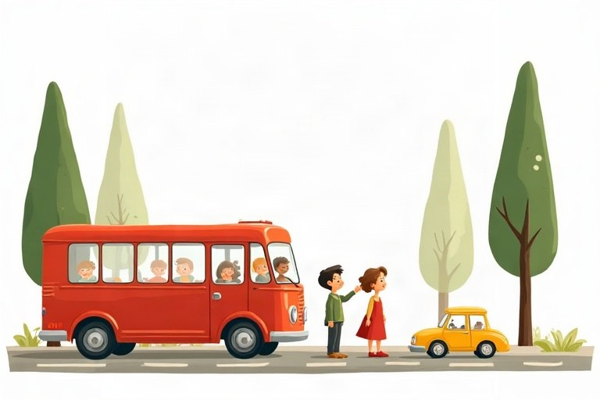
◆ Kinds of adjectives
סוגים של שמות תואר
أنواع الصفات
Kind | Examples
Color | red, blue, green, white, black
Size | big, small, tall, short, long
Feelings | happy, sad, angry, tired
Opinion | nice, funny, beautiful, boring

◆ Where does the adjective go?
איפה שם התואר?
أين نضع الصفة؟
1. Before the noun: a small bird, a new bike.
לפני שם העצם: ‎a small bird, a new bike‎.
قبل الاسم: ‎a small bird, a new bike‎.
2. After is/are: The bird is small.
אחרי ‎is/are: The bird is small‎.
بعد ‎is/are: The bird is small‎.
◆ Remember
זכרו
تذكّر
1. No -s on adjectives: two small birds.
בלי -‎s‎ בשמות תואר: ‎two small birds‎.
لا -‎s‎ في الصفات: ‎two small birds‎.
2. a or an? an + a, e, i, o, u sound: an old man, an orange bag.
‎a‎ או ‎an?‎‏ ‎an‎ לפני צליל ‎a, e, i, o, u: an old man, an orange bag‎.
‎a‎ أم ‎an‎؟ ‎an‎ قبل صوت ‎a, e, i, o, u: an old man, an orange bag‎.
🖼️ Picture words · מילים בתמונות‎ · كلمات بالصّور‎
  red  אדום  أحمر | cat  חתול  قطة |   car  מכונית  سيارة |   black  שחור  أسود | dog  כלב  كلب |   house  בית  بيت

1. Write the opposite.
כתבו את ההפך.
اكتب الضدّ.
a. big – __________
b. happy – __________
c. hot – __________
d. long – __________
e. new – __________
f. fast – __________
2. Match the adjective to the thing.
התאימו את שם התואר לדבר.
صل الصفة بالشيء.
Column A | Column B
1. yellow | [ ] a giraffe
2. cold | [ ] chocolate
3. tall | [ ] a turtle
4. slow | [ ] ice cream
5. sweet | [ ] the sun

3. Sort the adjectives: good feeling or bad feeling?
מיינו את שמות התואר: הרגשה טובה או הרגשה רעה?
صنّف الصفات: شعور جيّد أم شعور سيّئ؟
Words: happy | sad | angry | excited | tired | proud | bored | calm
Good feeling 🙂 | Bad feeling 🙁

4. Complete with an adjective from the bank.
השלימו עם שם תואר מהמחסן.
أكمل بصفة من بنك الكلمات.
Word bank: funny | dirty | beautiful | heavy | empty | loud
a. The clown is very __________. We all laugh.
b. My bag is __________. There are ten books in it.
c. Wash your hands. They are __________.
d. The music is too __________!
e. The fridge is __________. There is no food.
f. What a __________ flower!
5. Circle the correct answer.
הקיפו את התשובה הנכונה.
ضع دائرة حول الإجابة الصحيحة.
a. I see two ___.
○ big dogs ○ bigs dogs ○ dogs big
b. She has ___ umbrella.
○ a ○ an
c. My brother is ___.
○ a boy tall ○ tall ○ talls
d. It's ___ day.
○ a sunny ○ sunny a ○ an sunny
6. Write the phrase in the plural.
כתבו את הצירוף ברבים.
اكتب العبارة بصيغة الجمع.
One | Two
a red apple
a small box
a happy child
a tall man

7. True or False? Correct the false sentences.
נכון או לא נכון? תקנו את המשפטים הלא נכונים.
صحيح أم خطأ؟ صحّح الجمل الخاطئة.
a. In English, the adjective comes after the noun: a cat black. True / False
b. "blue" is a color. True / False
c. "three smalls birds" is correct. True / False
d. "The soup is hot." is correct. True / False
8. Find the mistake and write the sentence correctly.
מצאו את הטעות וכתבו את המשפט נכון.
جد الخطأ واكتب الجملة بشكل صحيح.
a. I have a bike new.
b. They are bigs boxes.
c. She has a orange cat.
d. We see a house white.
Lost Cat!
Hello! My name is Shira and I live in Ra'anana. My cat Pitzi is lost. She is a small gray cat with big green eyes and a long white tail. She has a pink collar with a little bell.
Pitzi is friendly, but she is shy with new people. She likes warm places, like the top of a car. If you see her, please call me. Thank you!
9. Read "Lost Cat!". Choose the correct answer.
קראו את ‎"Lost Cat!"‎. בחרו את התשובה הנכונה.
اقرأ ‎"Lost Cat!"‎. اختر الإجابة الصحيحة.
a. What color is Pitzi?
○ white ○ gray ○ black
b. What color is the collar?
○ pink ○ green ○ red
c. Why do you think Pitzi likes the top of a car?
○ It is cold. ○ It is warm. ○ It is clean.
10. Read the text again. Complete the poster.
קראו שוב את הטקסט. השלימו את המודעה.
اقرأ النص مرة أخرى. أكمل الإعلان.
a. LOST: a __________ gray cat
b. Eyes: big and __________
c. Tail: long and __________
d. She is friendly but __________ with new people.
11. Describe a friend in 3 sentences. Write about his or her hair, eyes and character. Use adjectives.
תארו חבר או חברה ב-3 משפטים. כתבו על השיער, העיניים והאופי. השתמשו בשמות תואר.
صِف صديقًا أو صديقة في 3 جمل. اكتب عن الشعر والعينين والطباع. استعمل الصفات.
________________________________________________________________________
________________________________________________________________________
________________________________________________________________________
12. Your pet is lost! Write a short poster (4 sentences). Say what it looks like and what it likes.
חיית המחמד שלכם הלכה לאיבוד! כתבו מודעה קצרה (4 משפטים). ספרו איך היא נראית ומה היא אוהבת.
حيوانك الأليف ضاع! اكتب إعلانًا قصيرًا (4 جمل). قل كيف يبدو وماذا يحبّ.
________________________________________________________________________
________________________________________________________________________
________________________________________________________________________
________________________________________________________________________

English · Grade 4 | Unit 5
Unit 5: Imperatives and "Let's…"
ציווי ו-‎"Let's…"‎
الأمر و ‎"Let's…"‎
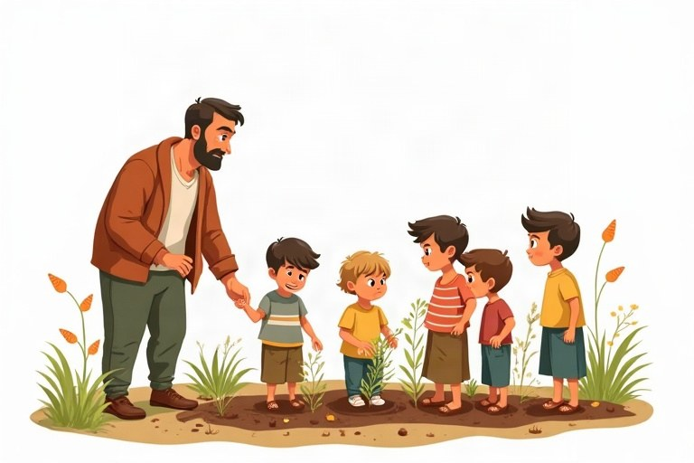
◆ Three patterns
שלוש תבניות
ثلاثة أنماط
Pattern | Use | Example
Verb + … | do it | Wash your hands.
Don't + verb | don't do it | Don't eat in class.
Let's + verb | we do it together | Let's sing a song.

◆ Be polite
דברו בנימוס
كُن مهذّبًا
1. Add please: Please sit down. / Sit down, please.
הוסיפו ‎please: Please sit down. / Sit down, please‎.
أضف ‎please: Please sit down. / Sit down, please‎.
2. Answer a suggestion: Good idea! / OK! / Sorry, I can't.
ענו להצעה: ‎Good idea! / OK! / Sorry, I can't‎.
ردّ على اقتراح: ‎Good idea! / OK! / Sorry, I can't‎.
◆ Where do we see imperatives?
איפה אנחנו פוגשים ציווי?
أين نرى صيغة الأمر؟
1. class rules, recipes, signs and games
כללי כיתה, מתכונים, שלטים ומשחקים
قواعد الصف، الوصفات، اللافتات والألعاب
Example:
דוגמה:
مثال:
Mix the eggs. Don't swim here. Turn left.
🖼️ Picture words · מילים בתמונות‎ · كلمات بالصّور‎
  door  דלת  باب |   hand  יד  يد |   cake  עוגה  كعكة | book  ספר  كتاب | park  פארק  حديقة عامة | school  בית ספר  مدرسة

1. Complete with a verb from the bank.
השלימו עם פועל מהמחסן.
أكمل بفعل من بنك الكلمات.
Word bank: Turn | Put | Wash | Take | Stand
a. __________ up, please.
b. __________ your hands with soap.
c. __________ off the light.
d. __________ your shoes in the closet.
e. __________ an umbrella. It's raining.
2. Match the sign to the place.
התאימו את השלט למקום.
صل اللافتة بالمكان.
Column A | Column B
1. Don't swim here! | [ ] the cinema
2. Be quiet. | [ ] the zoo
3. Don't feed the animals. | [ ] the bathroom
4. Wash your hands. | [ ] the library
5. Turn off your phone. | [ ] the sea, with big waves

3. Sort the sentences: instruction or suggestion?
מיינו את המשפטים: הוראה או הצעה?
صنّف الجمل: تعليمة أم اقتراح؟
Words: Close the door. | Let's swim. | Don't run. | Let's eat now. | Sit here. | Let's not go.
Instruction | Suggestion

4. Circle the correct word.
הקיפו את המילה הנכונה.
ضع دائرة حول الكلمة الصحيحة.
a. ___ touch the plate. It's hot!
○ Not ○ Don't ○ Let's
b. It's a nice day. ___ go to the park!
○ Don't ○ Let's ○ Please
c. ___ your name on the page.
○ Write ○ Writes ○ Writing
d. ___ late for the bus!
○ Don't be ○ Not be ○ Don't is
5. Complete with Let's or Don't.
השלימו עם ‎Let's‎ או ‎Don't‎.
أكمل بـ ‎Let's‎ أو ‎Don't‎.
a. I'm hungry. __________ make sandwiches.
b. The baby is asleep. __________ shout.
c. It's my birthday! __________ have a party.
d. The floor is wet. __________ run.
6. Complete the recipe for a fruit salad. Write the verbs in order: Wash, Cut, Put, Mix.
השלימו את המתכון לסלט פירות. כתבו את הפעלים לפי הסדר: ‎Wash, Cut, Put, Mix‎.
أكمل وصفة سلطة الفواكه. اكتب الأفعال بالترتيب: ‎Wash, Cut, Put, Mix‎.
Verb | Rest of the instruction
 | the fruit in water.
 | the apples and bananas.
 | the fruit in a big bowl.
 | it with a spoon. Enjoy!

7. True or False? Correct the false sentences.
נכון או לא נכון? תקנו את המשפטים הלא נכונים.
صحيح أم خطأ؟ صحّح الجمل الخاطئة.
a. "Don't" is the short form of "do not". True / False
b. "You sit down!" is the correct imperative. True / False
c. "Let's not be late." is correct. True / False
d. "Let's to sing!" is correct. True / False
8. Find the mistake and write the sentence correctly.
מצאו את הטעות וכתבו את המשפט נכון.
جد الخطأ واكتب الجملة بشكل صحيح.
a. Opens the window, please.
b. Don't runs in the yard.
c. Let's goes home.
d. No touch the cake!
A Rainy Saturday
It's Saturday and it's raining. Ben and his brother Omer are at home. "I'm bored," says Omer. "Let's play a game," says Ben. "No, let's bake cookies!" says Omer.
Mom smiles. "OK, boys. Wash your hands first. Take the flour and the sugar. Mix them in the bowl. Don't eat the dough! And please don't make a mess!" Soon the house smells great.
9. Read "A Rainy Saturday". Choose the correct answer.
קראו את ‎"A Rainy Saturday"‎. בחרו את התשובה הנכונה.
اقرأ ‎"A Rainy Saturday"‎. اختر الإجابة الصحيحة.
a. Why are the boys at home?
○ It's raining. ○ They are sick. ○ It's a school day.
b. What do the boys make?
○ a cake ○ cookies ○ pizza
c. What does Mom say first?
○ Don't eat the dough. ○ Wash your hands. ○ Mix them.
10. Read the text again. Write the missing word.
קראו שוב את הטקסט. כתבו את המילה החסרה.
اقرأ النص مرة أخرى. اكتب الكلمة الناقصة.
a. Ben: "Let's play a __________."
b. Mom: "__________ eat the dough!"
c. Mom: "Mix them in the __________."
11. It's a rainy day. Write 3 suggestions for you and your friends. Use Let's.
זה יום גשום. כתבו 3 הצעות לכם ולחברים שלכם. השתמשו ב-‎Let's‎.
إنه يوم ماطر. اكتب 3 اقتراحات لك ولأصدقائك. استعمل ‎Let's‎.
________________________________________________________________________
________________________________________________________________________
________________________________________________________________________
12. Write a short recipe for your favorite sandwich (4 steps). Use imperatives.
כתבו מתכון קצר לכריך האהוב עליכם (4 שלבים). השתמשו בציווי.
اكتب وصفة قصيرة لشطيرتك المفضّلة (4 خطوات). استعمل صيغة الأمر.
________________________________________________________________________
________________________________________________________________________
________________________________________________________________________
________________________________________________________________________

English · Grade 4 | Unit 6
Unit 6: Present simple: my day (I, you, we, they)
הווה פשוט: היום שלי ‎(I, you, we, they)‎
المضارع البسيط: يومي ‎(I, you, we, they)‎
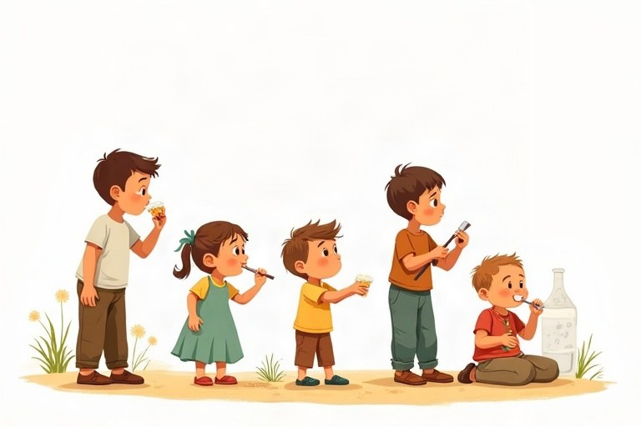
◆ The pattern
התבנית
النمط
 | Example
✔ I / you / we / they + verb | We walk to school.
✘ don't + verb | We don't walk to school.
? Do … + verb? | Do you walk to school?
Short answer | Yes, I do. / No, I don't.

◆ Daily routine verbs
פעלים של סדר היום
أفعال الروتين اليومي
1. get up, wash, get dressed, eat breakfast, go to school
2. do homework, play, have dinner, read, go to bed
◆ Time words
מילות זמן
كلمات الزمن
1. in the morning / afternoon / evening, at night, at 8 o'clock
2. every day, on Mondays, always, sometimes, never
🖼️ Picture words · מילים בתמונות‎ · كلمات بالصّور‎
school  בית ספר  مدرسة | bed  מיטה  سرير |   basketball  כדורסל  كرة السلة |   pizza  פיצה  بيتزا |   tennis  טניס  تنس | bus  אוטובוס  حافلة

1. Complete with a verb from the bank.
השלימו עם פועל מהמחסן.
أكمل بفعل من بنك الكلمات.
Word bank: get | have | do | go | brush | ride
a. I __________ up at 7:00.
b. We __________ dinner at 6:30.
c. They __________ their homework after lunch.
d. I __________ my teeth after breakfast.
e. You __________ your bike in the park.
f. We __________ to bed at 9:00.
2. Match the time to the activity.
התאימו את השעה לפעילות.
صل الوقت بالنشاط.
Column A | Column B
1. 7:00 in the morning | [ ] I go to bed.
2. 8:00 | [ ] I get up.
3. 1:30 in the afternoon | [ ] School starts.
4. 7:00 in the evening | [ ] We have dinner.
5. 9:00 at night | [ ] I eat lunch.

3. Sort the time words.
מיינו את מילות הזמן.
صنّف كلمات الزمن.
Words: always | in the morning | sometimes | at night | never | in the evening
How often? | When?

4. Circle the correct answer.
הקיפו את התשובה הנכונה.
ضع دائرة حول الإجابة الصحيحة.
a. Do they live in Ashdod? (✔)
○ Yes, they do. ○ Yes, they are. ○ Yes, they live.
b. Do you speak English? (✘)
○ No, I'm not. ○ No, I don't. ○ No, I doesn't.
c. We ___ swim in winter.
○ don't ○ aren't ○ not
5. Make the sentences negative.
הפכו את המשפטים לשלילה.
حوّل الجمل إلى النفي.
a. I like carrots. → I __________ carrots.
b. We play on Friday. → We __________ on Friday.
c. They eat fish. → They __________ fish.
d. You go to bed late. → You __________ to bed late.
6. Write the question and the short answer.
כתבו את השאלה ואת התשובה הקצרה.
اكتب السؤال والإجابة القصيرة.
Sentence | Question | Short answer
You like pizza. |  | Yes, I do.
They walk to school. |  | No, they don't.
We have math today. |  | Yes, we do.

7. True or False? Correct the false sentences.
נכון או לא נכון? תקנו את המשפטים הלא נכונים.
صحيح أم خطأ؟ صحّح الجمل الخاطئة.
a. "They don't likes cake." is correct. True / False
b. "Do we have homework?" is correct. True / False
c. "You go to school on Saturday?" is a correct question. True / False
d. "I always eat breakfast." is correct. True / False
8. Find the mistake and write the sentence correctly.
מצאו את הטעות וכתבו את המשפט נכון.
جد الخطأ واكتب الجملة بشكل صحيح.
a. I gets up at seven.
b. We doesn't watch TV.
c. Do you likes music?
d. They goes to the pool.
Friday at Grandma's
Every Friday, Daniel and his family visit Grandma Ruth in Rehovot. They drive there in the morning. Daniel and his cousins play in the garden. They climb the big lemon tree and run with the dog.
In the afternoon the children help Grandma in the kitchen. They make salad and set the table. In the evening the whole family sits together and eats a big dinner. They sing songs and tell stories. Daniel loves Fridays!
9. Read "Friday at Grandma's". Choose the correct answer.
קראו את ‎"Friday at Grandma's"‎. בחרו את התשובה הנכונה.
اقرأ ‎"Friday at Grandma's"‎. اختر الإجابة الصحيحة.
a. Where does Grandma Ruth live?
○ in Rehovot ○ in Ramla ○ in Eilat
b. What do the children do in the afternoon?
○ They swim. ○ They help in the kitchen. ○ They sleep.
c. Why do you think Daniel loves Fridays?
○ He has a test. ○ He is with his family. ○ He goes to school.
10. Read the text again. Complete.
קראו שוב את הטקסט. השלימו.
اقرأ النص مرة أخرى. أكمل.
a. The family visits Grandma every __________.
b. The children climb the big __________ tree.
c. In the evening they sing songs and tell __________.
11. Write 3 questions for a friend about his or her weekend. Use Do you …?
כתבו 3 שאלות לחבר או לחברה על סוף השבוע שלהם. השתמשו ב-‎Do you …?‎
اكتب 3 أسئلة لصديق أو صديقة عن عطلة نهاية الأسبوع. استعمل ‎Do you …?‎
________________________________________________________________________
________________________________________________________________________
________________________________________________________________________
12. Write about your Friday or Saturday. Write 4 sentences. Use we, they and one negative sentence.
כתבו על יום שישי או שבת שלכם. כתבו 4 משפטים. השתמשו ב-‎we‎, ב-‎they‎ ובמשפט שלילה אחד.
اكتب عن يوم الجمعة أو السبت عندك. اكتب 4 جمل. استعمل ‎we‎ و ‎they‎ وجملة نفي واحدة.
________________________________________________________________________
________________________________________________________________________
________________________________________________________________________
________________________________________________________________________

English · Grade 4 | Unit 7
Unit 7: "Can" and "can't" for ability
‎"Can"‎ ו-‎"can't"‎ ליכולת
‎"Can"‎ و ‎"can't"‎ للتعبير عن القدرة
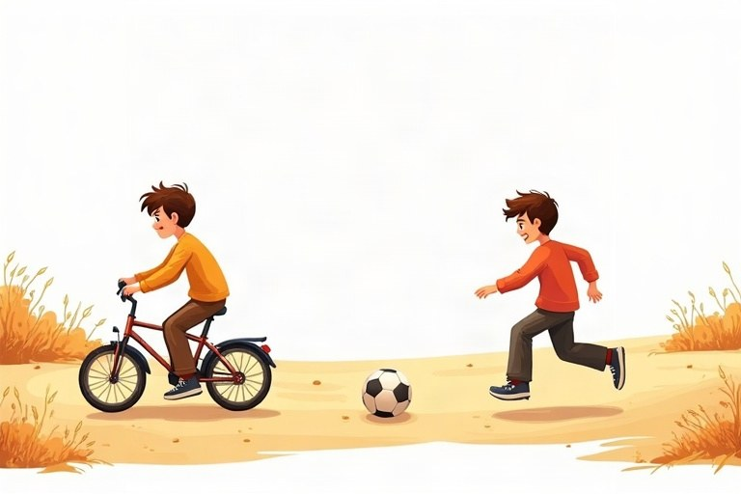
◆ The pattern
התבנית
النمط
 | Example
✔ can + verb | He can climb trees.
✘ can't + verb | He can't climb trees.
? Can … + verb? | Can he climb trees?
Short answer | Yes, he can. / No, he can't.

◆ Remember
זכרו
تذكّر
1. Same form for everyone: I can, she can, they can.
אותה צורה לכולם: ‎I can, she can, they can‎.
الصيغة نفسها للجميع: ‎I can, she can, they can‎.
2. No -s and no to after can: She can swim.
בלי -‎s‎ ובלי ‎to‎ אחרי ‎can: She can swim‎.
بدون -‎s‎ وبدون ‎to‎ بعد ‎can: She can swim‎.
◆ Ability words
מילים של יכולת
كلمات القدرة
1. swim, ride a bike, play the piano, speak English
2. jump, run fast, cook, draw, climb, dance
🖼️ Picture words · מילים בתמונות‎ · كلمات بالصّور‎
tree  עץ  شجرة | cat  חתול  قطة | dog  כלב  كلب |   fish  דג  سمكة |   bike  אופניים  دراجة |   horse  סוס  حصان

1. Complete with a verb from the bank.
השלימו עם פועל מהמחסן.
أكمل بفعل من بنك الكلمات.
Word bank: fly | swim | climb | jump | read | whistle
a. Fish can __________ in the sea.
b. Frogs can __________ very high.
c. Planes can __________ in the sky.
d. My grandma can __________ without glasses.
e. Cats can __________ trees.
f. I can't __________. I can only sing.
2. Match the question to the answer.
התאימו את השאלה לתשובה.
صِلِ السؤال بالإجابة.
Column A | Column B
1. Can you ski? | [ ] No, I can't. There is no snow here!
2. Can your dad cook? | [ ] Yes, she can.
3. Can birds fly? | [ ] No, it can't.
4. Can a cow climb a tree? | [ ] Yes, they can.
5. Can Tamar play chess? | [ ] Yes, he can. He makes great soup.

3. Sort the sentences: correct or wrong?
מיינו את המשפטים: נכון או שגוי?
صنّف الجمل: صحيحة أم خاطئة؟
Words: I can swim. | He cans run. | Can she dance? | We can to play. | They can't fly. | You can singing.
Correct ✔ | Wrong ✘

4. Circle the correct word.
הקיפו את המילה הנכונה.
ضع دائرة حول الكلمة الصحيحة.
a. A giraffe ___ eat leaves from tall trees.
○ can ○ can't
b. ___ you speak English? – Yes, I can.
○ Do ○ Can ○ Are
c. My little brother is two. He ___ write.
○ can ○ can't
d. Shira can ___ the piano.
○ play ○ plays ○ to play
5. Write short answers.
כתבו תשובות קצרות.
اكتب إجابات قصيرة.
a. Can a horse run? – Yes, it __________.
b. Can you fly? – No, I __________.
c. Can your parents swim? – Yes, they __________.
d. Can Noam play chess? – No, he __________.
6. Write questions with Can and short answers.
כתבו שאלות עם ‎Can‎ ותשובות קצרות.
اكتب أسئلة مع ‎Can‎ وإجابات قصيرة.
Information | Question | Short answer
Ben: ride a horse ✔
Maya: speak Russian ✘
The kids: swim ✔

7. True or False? Correct the false sentences.
נכון או לא נכון? תקנו את המשפטים הלא נכונים.
صحيح أم خطأ؟ صحّح الجمل الخاطئة.
a. A dolphin can swim. True / False
b. A chicken can fly high in the sky. True / False
c. "She can to dance." is correct. True / False
d. "Can they come? – No, they can't." is correct. True / False
8. Find the mistake and write the sentence correctly.
מצאו את הטעות וכתבו את המשפט נכון.
جد الخطأ واكتب الجملة بشكل صحيح.
a. Tom cans swim.
b. I can plays tennis.
c. You can speak Hebrew?
d. She can't to drive.
Super Dog Rex
Tamar has a smart dog. His name is Rex. Rex can do many things. He can sit, he can give his paw and he can catch a ball in the air. He can open the door with his nose!
But Rex can't do everything. He can't climb trees like a cat, and he can't swim very well. And Rex can't stay quiet when the mailman comes. He barks and barks! Tamar loves Rex very much.
9. Read "Super Dog Rex". Choose the correct answer.
קראו את ‎"Super Dog Rex"‎. בחרו את התשובה הנכונה.
اقرأ ‎"Super Dog Rex"‎. اختر الإجابة الصحيحة.
a. Who is Rex?
○ Tamar's brother ○ Tamar's dog ○ Tamar's cat
b. How can Rex open the door?
○ with his paw ○ with his nose ○ with a key
c. When does Rex bark a lot?
○ when the mailman comes ○ at night ○ when he eats
10. Read the text again. Sort: what can Rex do and what can't he do?
קראו שוב את הטקסט. מיינו: מה ‎Rex‎ יודע לעשות ומה הוא לא יודע לעשות?
اقرأ النص مرة أخرى. صنّف: ماذا يستطيع ‎Rex‎ أن يفعل وماذا لا يستطيع؟
Words: sit | climb trees | catch a ball | swim very well | open the door | stay quiet
Rex can | Rex can't

11. Write about an animal you like. What can it do? What can't it do? Write 3 sentences.
כתבו על חיה שאתם אוהבים. מה היא יודעת לעשות? מה היא לא יודעת לעשות? כתבו 3 משפטים.
اكتب عن حيوان تحبّه. ماذا يستطيع أن يفعل؟ وماذا لا يستطيع؟ اكتب 3 جمل.
________________________________________________________________________
________________________________________________________________________
________________________________________________________________________
12. Write a short note to a new friend (4 sentences). Say what you can do and ask 2 questions with Can you …?
כתבו פתק קצר לחבר חדש (4 משפטים). ספרו מה אתם יודעים לעשות ושאלו 2 שאלות עם ‎Can you …?‎
اكتب رسالة قصيرة لصديق جديد (4 جمل). قل ماذا تستطيع أن تفعل واسأل سؤالين مع ‎Can you …?‎
________________________________________________________________________
________________________________________________________________________
________________________________________________________________________
________________________________________________________________________

Review – What did we learn?
חזרה – מה למדנו?
مراجعة – ماذا تعلّمنا؟
1. Complete with am, is or are.
השלימו עם ‎am, is‎ או ‎are‎.
أكمل بـ ‎am‎ أو ‎is‎ أو ‎are‎.
a. I __________ in class 4.
b. My cats __________ black and white.
c. Where __________ your bag?
d. There __________ a big park near my house.
2. Circle the correct answer.
הקיפו את התשובה הנכונה.
ضع دائرة حول الإجابة الصحيحة.
a. There are three ___ in the box.
○ toy ○ toys
b. I have a ___.
○ red bike ○ bike red
c. ___ go to the beach!
○ Let's ○ Don't
d. She can ___ very fast.
○ runs ○ run
3. Match the question to the answer.
התאימו את השאלה לתשובה.
صِلِ السؤال بالإجابة.
Column A | Column B
1. Where is the ball? | [ ] I'm nine.
2. Can you swim? | [ ] Under the bed.
3. Do you like pizza? | [ ] Yes, I can.
4. Is there a pool? | [ ] No, I don't.
5. How old are you? | [ ] Yes, there is.

4. Write the plural.
כתבו את צורת הרבים.
اكتب صيغة الجمع.
One | Two
a box
a child
a man
a tooth

5. Find the mistake and write the sentence correctly.
מצאו את הטעות וכתבו את המשפט נכון.
جد الخطأ واكتب الجملة بشكل صحيح.
a. They is my friends.
b. There is two cats.
c. Tom cans swim.
d. Don't to run!
e. We doesn't play on Saturday.
Well done!
כל הכבוד!‎ · أحسنت!‎
I finished the English workbook for Grade 4.

