English · Grade 5 | Summary
Present simple: he, she, it (-s) and questions
‎Present simple: he, she, it (-s)‎ ושאלות
‎Present simple: he, she, it (-s)‎ والأسئلة
Summary: the present simple with he, she and it, negatives and questions
סיכום: ‎present simple‎ עם ‎he, she‎ ו־‎it‎, שלילה ושאלות
ملخّص: ‎present simple‎ مع ‎he‎ و‎she‎ و‎it‎، والنفي والأسئلة
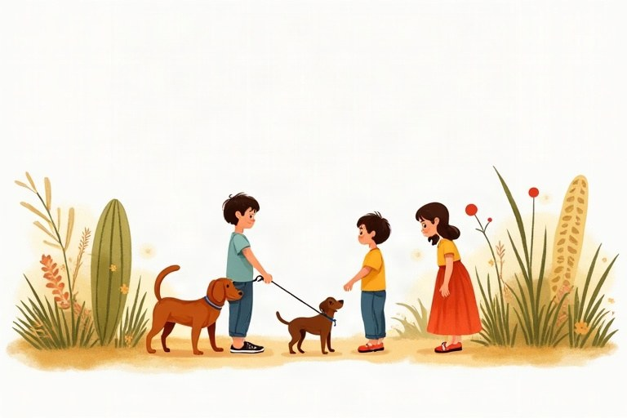
◆ Adding -s
הוספת -‎s‎
إضافة -‎s‎
Verb ending | Rule | Example
most verbs | + s | play, plays
-sh, -ch, -s, -x, -o | + es | watch, watches; go, goes
consonant + y | y, ies | study, studies
have | special | has

◆ Negatives
שלילה
النفي
1. I, you, we, they: don't + verb
‎I, you, we, they: don't +‎ פועל
‎I, you, we, they: don't +‎ فعل
2. he, she, it: doesn't + verb (no -s!)
‎he, she, it: doesn't +‎ פועל (בלי -‎s!)‎
‎he, she, it: doesn't +‎ فعل (بدون -‎s!)‎
Example:
דוגמה:
مثال:
We don't eat meat. · Itay doesn't eat meat.
◆ Questions and short answers
שאלות ותשובות קצרות
الأسئلة والإجابات القصيرة
1. Do + I/you/we/they + verb?
‎Do + I/you/we/they +‎ פועל?
‎Do + I/you/we/they +‎ فعل؟
2. Does + he/she/it + verb?
‎Does + he/she/it +‎ פועל?
‎Does + he/she/it +‎ فعل؟
3. Wh-word + do/does: Where does he live?
מילת שאלה ‎+ do/does: Where does he live?‎
أداة استفهام ‎+ do/does: Where does he live?‎
Example:
דוגמה:
مثال:
Does Ben swim? Yes, he does. · Do you swim? No, I don't.
🖼️ Picture words · מילים בתמונות‎ · كلمات بالصّور‎
  school  בית ספר  مدرسة |   bus  אוטובוס  حافلة |   cat  חתול  قطة |   dog  כלב  كلب |   milk  חלב  حليب |   bike  אופניים  دراجة

Remember! He, she, it: the -s goes on the verb OR on does, never on both: Does she play? (not Does she plays?)
‎He, she, it‎: ה־‎s‎ נכנסת לפועל או ל־‎does‎, אף פעם לא לשניהם: ‎Does she play? (‎ולא ‎Does she plays?)‎
‎He, she, it‎: نضيف ‎s‎ إمّا إلى الفعل أو إلى ‎does‎، وليس إلى الاثنين أبدًا: ‎Does she play? (‎وليس ‎Does she plays?)‎
✏️ Worked example: Make a question: Tamar reads comics. ___
1. Tamar = she, so we use Does.
2. After Does, the verb has no -s: read.
Answer: Does Tamar read comics?
Check yourself – Complete with the correct form.
השלימו בצורה הנכונה.
أكمل بالصيغة الصحيحة.
a. Daniel __________ (go) to the park on Saturdays.
b. My sister __________ (study) every evening.
c. Ariel __________ (not drink) coffee.
d. __________ your cat sleep on your bed?
Self-check answers: a. goes · b. studies · c. doesn't drink · d. Does

