English · Grade 5 | Summary
Past simple of "to be": was and were
‎past simple‎ של ‎"to be": was‎ ו־‎were‎
‎past simple‎ لـ ‎"to be": was‎ و‎were‎
Summary: was and were (the past of to be)
סיכום: ‎was‎ ו־‎were (‎העבר של ‎to be)‎
ملخّص: ‎was‎ و‎were (‎الماضي من ‎to be)‎
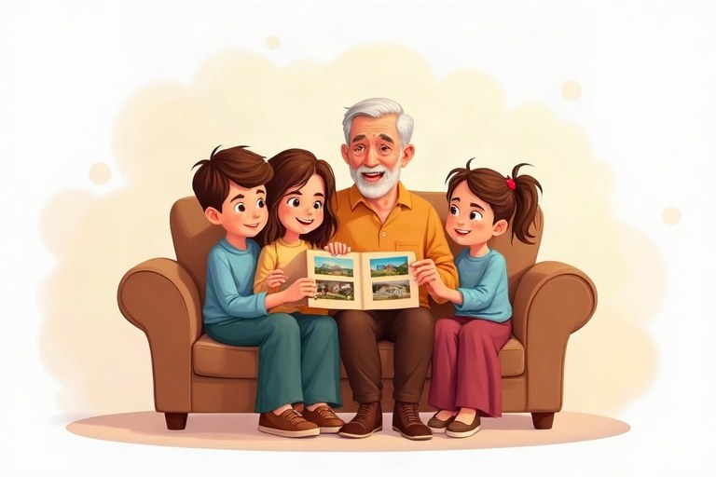
◆ Now and in the past
עכשיו ובעבר
الآن وفي الماضي
Subject | Present | Past
I | am | was
he / she / it | is | was
you / we / they | are | were

◆ Negatives and questions
שלילה ושאלות
النفي والأسئلة
1. wasn't = was not; weren't = were not
צורות מקוצרות: ‎wasn't = was not; weren't = were not‎
الصيغ المختصرة: ‎wasn't = was not‎؛ ‎weren't = were not‎
2. Was / Were + subject ...?
‎Was / Were +‎ נושא ...?
‎Was / Were +‎ الفاعل ...؟
3. Short answers: Yes, he was. No, we weren't.
תשובות קצרות: ‎Yes, he was.‎‏ ‎No, we weren't‎.
إجابات قصيرة: ‎Yes, he was.‎‏ ‎No, we weren't‎.
Example:
דוגמה:
مثال:
Was it hot? No, it wasn't.
◆ Wh-questions
שאלות ‎Wh‎
أسئلة ‎Wh‎
1. Where were you?
2. Who was at the party?
3. How was your day?
◆ Time words
מילות זמן
كلمات الزمن
yesterday · last night · last week · last year · two days ago · in 2020
🖼️ Picture words · מילים בתמונות‎ · كلمات بالصّور‎
  school  בית ספר  مدرسة |   park  פארק  حديقة عامة |   beach  חוף ים  شاطئ |   cat  חתול  قطة |   cake  עוגה  كعكة |   ball  כדור  كرة

Remember! Today: I am, he is, we are. Yesterday: I was, he was, we were.
היום: ‎I am, he is, we are‎. אתמול: ‎I was, he was, we were‎.
اليوم: ‎I am, he is, we are‎. أمس: ‎I was, he was, we were‎.
✏️ Worked example: Make it past: The children are in the garden. ___
1. The children = they.
2. are becomes were in the past.
Answer: The children were in the garden.
Check yourself – Complete with was, were, wasn't or weren't.
השלימו ב־‎was, were, wasn't‎ או ‎weren't‎.
أكمل بـ ‎was‎ أو ‎were‎ أو ‎wasn't‎ أو ‎weren't‎.
a. Tamar __________ at school yesterday. She was sick.
b. We __________ very happy at the party.
c. It __________ hot last week. It was cold.
d. __________ your parents at home last night?
Self-check answers: a. wasn't · b. were · c. wasn't · d. Were

