English · Grade 5 | Summary
Past simple: regular and irregular verbs
‎past simple‎: פעלים רגילים ויוצאי דופן
‎past simple‎: الأفعال المنتظمة والشاذّة
Summary: the past simple, regular and irregular verbs (affirmative)
סיכום: ‎past simple‎, פעלים רגילים ויוצאי דופן (חיוב)
ملخّص: ‎past simple‎، الأفعال المنتظمة والشاذّة (الإثبات)
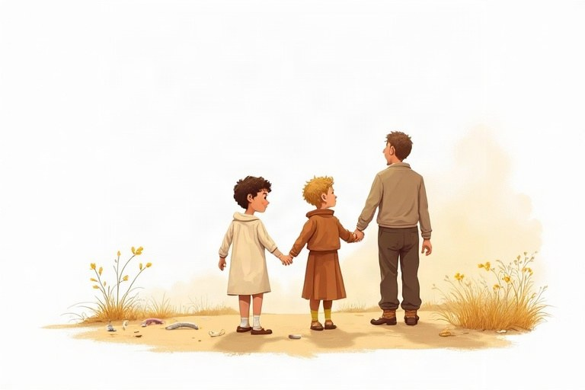
◆ Regular verbs: spelling
פעלים רגילים: כתיב
الأفعال المنتظمة: الإملاء
Verb | Rule | Past
walk | + ed | walked
dance | + d | danced
study | y, ied | studied
stop | double + ed | stopped

◆ Irregular verbs to remember
פעלים יוצאי דופן שכדאי לזכור
أفعال شاذّة يجب حفظها
Verb | Past | Verb | Past
go | went | see | saw
eat | ate | have | had
buy | bought | make | made
take | took | come | came

◆ Remember
זכרו
تذكّر
1. The past form is the same for I, he, she, we, they.
צורת העבר זהה ל־‎I, he, she, we, they‎.
صيغة الماضي واحدة مع ‎I‎ و‎he‎ و‎she‎ و‎we‎ و‎they‎.
2. Time words: yesterday, last week, two days ago.
מילות זמן: ‎yesterday, last week, two days ago‎.
كلمات الزمن: ‎yesterday, last week, two days ago‎.
Example:
דוגמה:
مثال:
Yesterday Tamar bought a new book.
🖼️ Picture words · מילים בתמונות‎ · كلمات بالصّور‎
  sandwich  כריך  شطيرة |   school  בית ספר  مدرسة |   beach  חוף ים  شاطئ |   book  ספר  كتاب |   fish  דג  سمكة |   horse  סוס  حصان

Remember! Regular or irregular, the past form is the same for everybody: I went, he went, they went.
רגיל או יוצא דופן, צורת העבר זהה לכולם: ‎I went, he went, they went‎.
منتظمًا كان الفعل أو شاذًّا، صيغة الماضي واحدة للجميع: ‎I went, he went, they went‎.
✏️ Worked example: Write in the past: Every day Omer eats a sandwich. Yesterday Omer ___
1. Yesterday is in the past.
2. eat is irregular: its past is ate.
Answer: Yesterday Omer ate a sandwich.
Check yourself – Write the verb in the past simple.
כתבו את הפועל ב־‎past simple‎.
اكتب الفعل بصيغة ‎past simple‎.
a. Last night we __________ (watch) a funny film.
b. Ben __________ (see) a big fish in the sea.
c. I __________ (carry) the heavy bag.
d. They __________ (have) pizza for dinner.
Self-check answers: a. watched · b. saw · c. carried · d. had

