English · Grade 5 | Summary
Possessives: 's, my, your, his, her, our, their
מילות שייכות: ‎'s, my, your, his, her, our, their‎
كلمات الملكيّة: ‎'s, my, your, his, her, our, their‎
Summary: possessive adjectives, 's and Who / Whose questions
סיכום: מילות שייכות, ‎'s‎ ושאלות ‎Who / Whose‎
ملخّص: صفات الملكيّة و‎'s‎ وأسئلة ‎Who / Whose‎
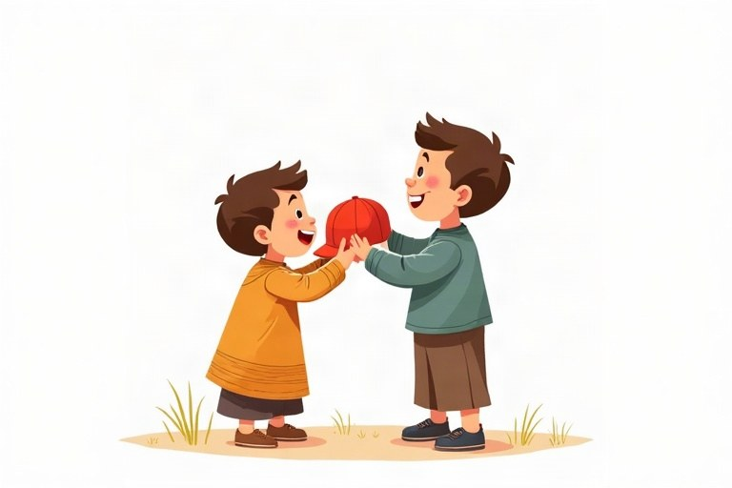
◆ Possessive adjectives
מילות שייכות ‎(possessive adjectives)‎
صفات الملكيّة ‎(possessive adjectives)‎
Subject | Possessive | Example
I / you | my / your | my book, your book
he / she / it | his / her / its | his cap, her cap
we / they | our / their | our class, their class

◆ 's and s'
‎'s‎ ו־‎s'‎
‎'s‎ و ‎s'‎
1. one person: Dan's bike, the girl's bag
אדם אחד: ‎Dan's bike, the girl's bag‎
شخص واحد: ‎Dan's bike, the girl's bag‎
2. plural with -s: the girls' bags
רבים עם -‎s: the girls' bags‎
جمع مع -‎s: the girls' bags‎
3. special plural: the children's books
רבים מיוחד: ‎the children's books‎
جمع خاصّ: ‎the children's books‎
◆ Who and Whose
‎Who‎ ו־‎Whose‎
‎Who‎ و‎Whose‎
1. Who is that? It's my cousin.
2. Whose shoes are these? They're Tom's.
🖼️ Picture words · מילים בתמונות‎ · كلمات بالصّور‎
  bag  תיק  حقيبة |   dog  כלב  كلب |   bike  אופניים  دراجة |   ball  כדור  كرة |   book  ספר  كتاب |   car  מכונית  سيارة

Remember! it's = it is (It's hot). its = belongs to it (The dog wags its tail).
‎it's = it is (It's hot).‎‏ ‎its =‎ שייך לו/לה ‎(The dog wags its tail)‎.
‎it's = it is (It's hot).‎‏ ‎its =‎ يعود له/لها ‎(The dog wags its tail)‎.
✏️ Worked example: Complete: The bike belongs to Itay. It's ___ bike.
1. Itay is a boy, so we use his.
2. Or we use the name + 's: Itay's bike.
Answer: his (Itay's)
Check yourself – Complete.
השלימו.
أكمل.
a. Maya and I are sisters. __________ room is big.
b. The cat is eating __________ food.
c. This is the __________ (teacher) car.
d. __________ is your best friend? Yoav.
Self-check answers: a. Our · b. its · c. teacher's · d. Who

