
Workbook
English
Grade 5

Contents
תוכן העניינים
المحتويات
Topic
Introduction
Unit 1: Present simple: he, she, it (-s) and questions
Unit 2: Present progressive: what is happening now?
Unit 3: Articles a, an, the and plural nouns
Unit 4: Past simple of "to be": was and were
Unit 5: Past simple: regular and irregular verbs
Unit 6: Possessives: 's, my, your, his, her, our, their
Unit 7: Reading a short text and writing a paragraph (and, but, then, because)
Review – What did we learn?

Introduction
מבוא
مقدّمة
Hello, fifth graders! Welcome to your English book for this year.
שלום, תלמידי כיתה ה'! ברוכים הבאים לספר האנגלית שלכם לשנה זו.
مرحبًا يا طلاب الصف الخامس! أهلًا بكم في كتاب اللغة الإنجليزية لهذه السنة.
This year you will learn to talk about every day, about now and about the past. You will learn about a, an and the, about plurals, and about words like my, his and their. You will also read short stories and write your own paragraphs.
השנה תלמדו לדבר על מה שקורה כל יום, על מה שקורה עכשיו ועל העבר. תלמדו על ‎a, an‎ ו־‎the‎, על רבים, ועל מילים כמו ‎my, his‎ ו־‎their‎. תקראו גם סיפורים קצרים ותכתבו פסקאות משלכם.
في هذه السنة ستتعلّم أن تتحدّث عن كلّ يوم، وعن الآن، وعن الماضي. ستتعلّم ‎a‎ و‎an‎ و‎the‎، والجمع، وكلمات مثل ‎my‎ و‎his‎ و‎their‎. وستقرأ أيضًا قصصًا قصيرة وتكتب فقراتك الخاصّة.
Every chapter has short explanations, examples, a "Remember" tip and a lot of practice. At the end there is a review and the answers. Good luck, and have fun with English!
בכל פרק יש הסברים קצרים, דוגמאות, טיפ ‎"Remember"‎ והרבה תרגול. בסוף יש חזרה ותשובות. בהצלחה, ותיהנו מהאנגלית!
في كلّ فصل شروح قصيرة وأمثلة ونصيحة ‎"Remember"‎ وتمارين كثيرة. وفي النهاية مراجعة وإجابات. بالتوفيق، واستمتع باللغة الإنجليزية!

English · Grade 5 | Unit 1
Unit 1: Present simple: he, she, it (-s) and questions
‎Present simple: he, she, it (-s)‎ ושאלות
‎Present simple: he, she, it (-s)‎ والأسئلة
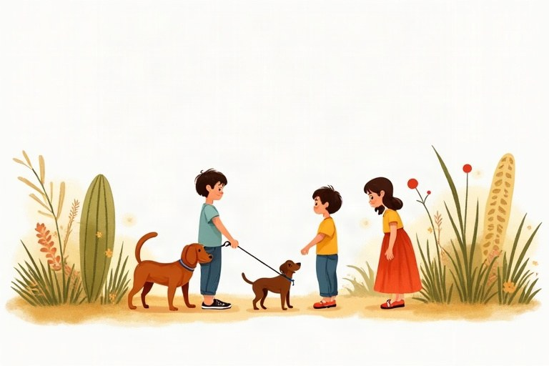
◆ Adding -s
הוספת -‎s‎
إضافة -‎s‎
Verb ending | Rule | Example
most verbs | + s | play, plays
-sh, -ch, -s, -x, -o | + es | watch, watches; go, goes
consonant + y | y, ies | study, studies
have | special | has

◆ Negatives
שלילה
النفي
1. I, you, we, they: don't + verb
‎I, you, we, they: don't +‎ פועל
‎I, you, we, they: don't +‎ فعل
2. he, she, it: doesn't + verb (no -s!)
‎he, she, it: doesn't +‎ פועל (בלי -‎s!)‎
‎he, she, it: doesn't +‎ فعل (بدون -‎s!)‎
Example:
דוגמה:
مثال:
We don't eat meat. · Itay doesn't eat meat.
◆ Questions and short answers
שאלות ותשובות קצרות
الأسئلة والإجابات القصيرة
1. Do + I/you/we/they + verb?
‎Do + I/you/we/they +‎ פועל?
‎Do + I/you/we/they +‎ فعل؟
2. Does + he/she/it + verb?
‎Does + he/she/it +‎ פועל?
‎Does + he/she/it +‎ فعل؟
3. Wh-word + do/does: Where does he live?
מילת שאלה ‎+ do/does: Where does he live?‎
أداة استفهام ‎+ do/does: Where does he live?‎
Example:
דוגמה:
مثال:
Does Ben swim? Yes, he does. · Do you swim? No, I don't.
🖼️ Picture words · מילים בתמונות‎ · كلمات بالصّور‎
  school  בית ספר  مدرسة |   bus  אוטובוס  حافلة |   cat  חתול  قطة |   dog  כלב  كلب |   milk  חלב  حليب |   bike  אופניים  دراجة

1. Where do they do it? Match.
איפה הם עושים את זה? התאימו.
أين يفعلون ذلك؟ صِل.
Column A | Column B
1. swim | [ ] at the bakery
2. read books | [ ] in the pool
3. buy bread | [ ] in the gym
4. see the doctor | [ ] in the bedroom
5. play basketball | [ ] in the library
6. sleep | [ ] at the clinic

2. Add -s, -es or -ies.
הוסיפו -‎s, -es‎ או -‎ies‎.
أضف -‎s‎ أو -‎es‎ أو -‎ies‎.
a. Dad wash__________ the car on Fridays.
b. My cat sleep__________ on the sofa.
c. Noa stud__________ English every day.
d. The bus go__________ to Tel Aviv.
e. Itay fix__________ his bike.
f. The bird fl__________ over the house.
3. Complete the table.
השלימו את הטבלה.
أكمل الجدول.
+ | − | ?
He reads.
She swims.
It works.
They play.

4. Do or Does? Sort the words.
‎Do‎ או ‎Does?‎ מיינו את המילים.
‎Do‎ أم ‎Does‎؟ صنّف الكلمات.
Words: you | she | they | Tamar | we | the dog | my parents | it
Do | Does

5. Complete with a word from the bank.
השלימו במילה ממחסן המילים.
أكمل بكلمة من بنك الكلمات.
Word bank: drinks | walks | lives | speaks | teaches | has
a. My grandma __________ in Eilat.
b. Mr. Levi __________ math at our school.
c. Shira __________ three languages.
d. Our dog __________ a long tail.
e. Daniel __________ milk every morning.
f. Ariel __________ to school with his friends.
6. Choose the correct answer.
בחרו את התשובה הנכונה.
اختر الإجابة الصحيحة.
a. Does Ben like pizza?
○ Yes, he likes. ○ Yes, he does. ○ Yes, he do.
b. Do you have a pet?
○ No, I don't. ○ No, I doesn't. ○ No, I not.
c. Does your mom work in a bank?
○ No, she don't. ○ No, she isn't. ○ No, she doesn't.
d. Do your friends play chess?
○ Yes, they do. ○ Yes, they does. ○ Yes, they plays.
7. Find the mistake. Write the sentence correctly.
מצאו את הטעות. כתבו את המשפט נכון.
جد الخطأ. اكتب الجملة بشكل صحيح.
a. He play tennis.
b. My sister watchs TV.
c. Tom don't like milk.
d. Does Maya likes dogs?
e. The baby crys a lot.
8. True or False? Correct the false rules.
נכון או לא נכון? תקנו את הכללים הלא נכונים.
صحيح أم خطأ؟ صحّح القواعد الخاطئة.
a. We add -es to verbs that end in -sh, -ch, -x and -o. True / False
b. With he, she and it, we use don't. True / False
c. In a question with does, the verb has no -s. True / False
d. The he/she form of have is haves. True / False
9. Complete the questions with do or does.
השלימו את השאלות ב־‎do‎ או ב־‎does‎.
أكمل الأسئلة بـ ‎do‎ أو ‎does‎.
a. Where __________ your uncle work?
b. What time __________ the film start?
c. What __________ your friends do on Fridays?
d. When __________ Yoav have his piano lesson?
e. Where __________ you buy your shoes?
10. Write sentences about Tom's day.
כתבו משפטים על היום של ‎Tom‎.
اكتب جملًا عن يوم ‎Tom‎.
a. 7:00 / get up
b. 7:30 / catch the bus
c. 1:00 / have lunch
d. 4:00 / do his homework
e. 8:00 / watch TV
Shira and Kiwi
Shira lives in Rehovot. She has a green parrot. His name is Kiwi. Kiwi is very smart. He knows ten words, and he says "Good morning!" every day. His favorite word is "pizza".
Kiwi lives in a big cage in the living room. He eats seeds and fruit, but he doesn't eat bread. Shira gives him fresh water every morning before school.
In the afternoon, Shira opens the cage. Kiwi flies around the room and sits on her shoulder. He likes music, and he sings when Shira plays the piano. Shira's brother, Ariel, doesn't like Kiwi very much, because Kiwi pulls his hair!
11. Read "Shira and Kiwi". Choose the correct answer.
קראו את ‎"Shira and Kiwi"‎. בחרו את התשובה הנכונה.
اقرأ ‎"Shira and Kiwi"‎. اختر الإجابة الصحيحة.
a. What is Kiwi?
○ a cat ○ a parrot ○ a dog
b. What does Kiwi say every day?
○ "Good morning!" ○ "Hello, Ariel!" ○ "I'm hungry!"
c. When does Kiwi sing?
○ when he eats ○ when Shira plays the piano ○ in the morning
d. Why doesn't Ariel like Kiwi very much?
○ Kiwi is noisy. ○ Kiwi eats his bread. ○ Kiwi pulls his hair.
12. Complete the sentences about the text.
השלימו את המשפטים על הטקסט.
أكمل الجمل حول النصّ.
a. Kiwi __________ ten words.
b. He __________ seeds and fruit.
c. Shira __________ him fresh water every morning.
d. In the afternoon, Kiwi __________ around the room.
13. Write 3 questions with Does about a friend's pet or brother. Then write the answers.
כתבו 3 שאלות עם ‎Does‎ על חיית המחמד או על האח של חבר. אחר כך כתבו את התשובות.
اكتب 3 أسئلة مع ‎Does‎ عن الحيوان الأليف لصديقك أو عن أخيه. ثمّ اكتب الإجابات.
________________________________________________________________________
________________________________________________________________________
________________________________________________________________________
________________________________________________________________________

English · Grade 5 | Unit 2
Unit 2: Present progressive: what is happening now?
‎Present progressive‎: מה קורה עכשיו?
‎Present progressive‎: ماذا يحدث الآن؟

◆ The form
המבנה
الصيغة
Subject | be | verb + ing
I | am ('m) | playing
he / she / it | is ('s) | playing
you / we / they | are ('re) | playing

◆ Spelling
כתיב
الإملاء
1. most verbs + ing: read, reading
רוב הפעלים ‎+ ing: read, reading‎
معظم الأفعال ‎+ ing: read, reading‎
2. silent e: drop it: write, writing
‎e‎ שקטה: מורידים אותה: ‎write, writing‎
‎e‎ صامتة: نحذفها: ‎write, writing‎
3. one vowel + one consonant: double it: swim, swimming
תנועה אחת + עיצור אחד: מכפילים אותו: ‎swim, swimming‎
حرف علّة واحد + حرف ساكن واحد: نضاعفه: ‎swim, swimming‎
◆ Negatives and questions
שלילה ושאלות
النفي والأسئلة
1. isn't / aren't / am not + -ing
שלילה: ‎isn't / aren't / am not + -ing‎
النفي: ‎isn't / aren't / am not + -ing‎
2. Is / Are + subject + -ing?
‎Is / Are +‎ נושא ‎+ -ing?‎
‎Is / Are +‎ الفاعل ‎+ -ing‎؟
3. Short answers: Yes, he is. No, they aren't.
תשובות קצרות: ‎Yes, he is.‎‏ ‎No, they aren't‎.
إجابات قصيرة: ‎Yes, he is.‎‏ ‎No, they aren't‎.
Example:
דוגמה:
مثال:
Is Noa singing? No, she isn't. She's dancing.
◆ Now or every day?
עכשיו או כל יום?
الآن أم كلّ يوم؟
Now, right now, look! and listen! go with the present progressive. Every day, often and usually go with the present simple.
‎Now, right now, look!‎ ו־‎listen!‎ באים עם ‎present progressive.‎‏ ‎Every day, often‎ ו־‎usually‎ באים עם ‎present simple‎.
‎Now‎ و‎right now‎ و‎look!‎ و‎listen!‎ تأتي مع ‎present progressive.‎‏ ‎Every day‎ و‎often‎ و‎usually‎ تأتي مع ‎present simple‎.
🖼️ Picture words · מילים בתמונות‎ · كلمات بالصّور‎
dog  כלב  كلب | bike  אופניים  دراجة |   cake  עוגה  كعكة |   hat  כובע  قبعة |   beach  חוף ים  شاطئ | cat  חתול  قطة

1. Match.
התאימו.
صل.
Column A | Column B
1. brush | [ ] the dog
2. wash | [ ] a kite
3. water | [ ] the floor
4. walk | [ ] a tree
5. fly | [ ] the dishes
6. climb | [ ] the plants

2. Add -ing. Be careful with the spelling!
הוסיפו -‎ing‎. שימו לב לכתיב!
أضف -‎ing‎. انتبه إلى الإملاء!
a. She is cut__________ the bread.
b. They are danc__________ at the party.
c. He is shop__________ at the mall.
d. I am drink__________ water.
e. We are com__________ home now.
f. The baby is cry__________.
3. Complete the table.
השלימו את הטבלה.
أكمل الجدول.
+ | − | ?
She is reading.
They are running.
He is eating.
You are working.

4. Sort the words: is or are?
מיינו את המילים: ‎is‎ או ‎are?‎
صنّف الكلمات: ‎is‎ أم ‎are‎؟
Words: Noam | the children | my sister | we | it | you | Ben and Tom | the dog
is | are

5. Complete with a verb from the bank. Use the present progressive.
השלימו בפועל ממחסן המילים. השתמשו ב־‎present progressive‎.
أكمل بفعل من بنك الكلمات. استعمل ‎present progressive‎.
Word bank: paint | sleep | fly | eat | clean | wait
a. The baby __________ in her room.
b. Look! Two planes __________ over the city.
c. Grandpa __________ the fence white.
d. We __________ for the teacher.
e. I __________ a sandwich.
f. Mom __________ the windows.
6. Find the mistake. Write the sentence correctly.
מצאו את הטעות. כתבו את המשפט נכון.
جد الخطأ. اكتب الجملة بشكل صحيح.
a. She is swiming.
b. They is playing.
c. I am write a story.
d. He not is working.
e. Are he sleeping?
7. Complete the questions with What, Where or Who.
השלימו את השאלות ב־‎What‎, ב־‎Where‎ או ב־‎Who‎.
أكمل الأسئلة بـ ‎What‎ أو ‎Where‎ أو ‎Who‎.
a. __________ is Noa doing? She's painting.
b. __________ are the boys going? To the park.
c. __________ is singing? Shira is singing.
d. __________ are you eating? A banana.
e. __________ is Dad sitting? In the garden.
8. Present simple or present progressive? Circle the correct form.
‎present simple‎ או ‎present progressive?‎ הקיפו את הצורה הנכונה.
‎present simple‎ أم ‎present progressive‎؟ ضع دائرة حول الصيغة الصحيحة.
a. Ben ___ to school every day.
○ walks ○ is walking
b. Shh! The baby ___.
○ sleeps ○ is sleeping
c. Look! Omer ___ a tree.
○ climbs ○ is climbing
d. We often ___ pizza on Fridays.
○ eat ○ are eating
e. Right now, I ___ to music.
○ listen ○ am listening
9. True or False? Correct the false rules.
נכון או לא נכון? תקנו את הכללים הלא נכונים.
صحيح أم خطأ؟ صحّح القواعد الخاطئة.
a. We use the present progressive for things happening now. True / False
b. The -ing form of run is runing. True / False
c. The -ing form of make is making. True / False
d. With they, we use is: They is eating. True / False
A Phone Call
It's Friday afternoon, and it's a little cloudy outside. Tamar is calling her friend Noa.
"Hi, Noa! What are you doing?" "Hi, Tamar! I'm helping my mom. We're making a cake for Grandpa's birthday. It's a chocolate cake!" "Yum! Is your brother helping too?" "No, he isn't. Ariel is sitting in his room. He's playing on his computer, as usual. And what are you doing?"
"I'm sitting on the balcony. I'm drawing a picture of the street. A man is walking with three dogs, and two kids are riding their bikes. Oh! It's starting to rain! I'm going inside. Bye, Noa!"
10. Read "A Phone Call". Write True or False. Correct the false sentences.
קראו את ‎"A Phone Call"‎. כתבו ‎True‎ או ‎False‎. תקנו את המשפטים הלא נכונים.
اقرأ ‎"A Phone Call"‎. اكتب ‎True‎ أو ‎False‎. صحّح الجمل الخاطئة.
a. Noa is helping her dad. True / False
b. They are making a cake for Grandpa. True / False
c. Ariel is helping in the kitchen. True / False
d. Tamar is drawing on the balcony. True / False
11. Answer the questions about the text.
ענו על השאלות על הטקסט.
أجب عن الأسئلة حول النصّ.
a. What kind of cake are they making?
b. Where is Ariel sitting?
c. What is the man doing?
d. Why is Tamar going inside?
12. It's Saturday morning. What are the people in your family doing now? Write 4 sentences.
שבת בבוקר. מה עושים עכשיו בני המשפחה שלכם? כתבו 4 משפטים.
إنّه صباح يوم السبت. ماذا يفعل أفراد عائلتك الآن؟ اكتب 4 جمل.
________________________________________________________________________
________________________________________________________________________
________________________________________________________________________
________________________________________________________________________

English · Grade 5 | Unit 3
Unit 3: Articles a, an, the and plural nouns
מילות היידוע ‎a, an, the‎ ושמות עצם ברבים
أدوات التعريف والتنكير ‎a‎ و‎an‎ و‎the‎، والأسماء في الجمع
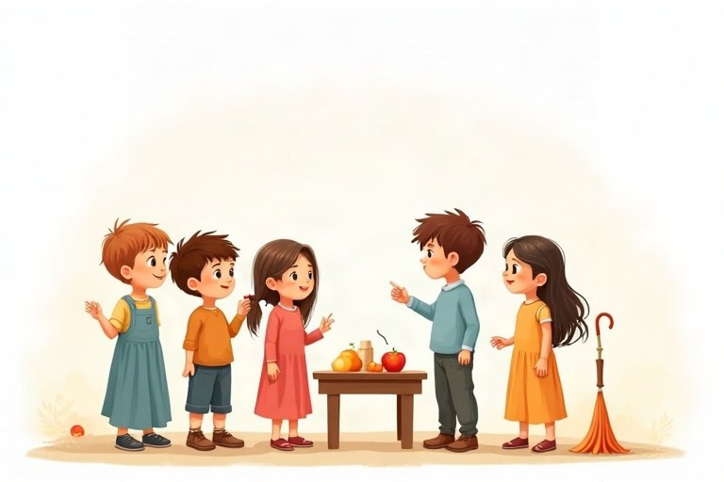
◆ a, an, the
Word | When? | Example
a | one thing, consonant sound | a bag, a uniform
an | one thing, vowel sound | an egg, an hour
the | we know which one / second time | the sun; The bag is red.

◆ Regular plurals
צורות רבים רגילות
الجموع المنتظمة
1. most nouns + s: book, books
רוב שמות העצם ‎+ s: book, books‎
معظم الأسماء ‎+ s: book, books‎
2. -s, -sh, -ch, -x + es: bus, buses
אחרי -‎s, -sh, -ch, -x‎ מוסיפים ‎es: bus, buses‎
بعد -‎s‎ و-‎sh‎ و-‎ch‎ و-‎x‎ نضيف ‎es: bus, buses‎
3. consonant + y: city, cities
עיצור ‎+ y: city, cities‎
حرف ساكن ‎+ y: city, cities‎
◆ Special plurals
צורות רבים מיוחדות
جموع خاصّة
man, men · woman, women · child, children · foot, feet · tooth, teeth · mouse, mice · person, people
🖼️ Picture words · מילים בתמונות‎ · كلمات بالصّور‎
bus  אוטובוס  حافلة |   box  קופסה  صندوق |   book  ספר  كتاب |   elephant  פיל  فيل | cat  חתול  قطة | dog  כלב  كلب

1. Complete with a or an.
השלימו ב־‎a‎ או ב־‎an‎.
أكمل بـ ‎a‎ أو ‎an‎.
a. __________ elephant
b. __________ letter
c. __________ old man
d. __________ idea
e. __________ T-shirt
f. __________ armchair
2. Match the singular to the plural.
התאימו את היחיד לרבים.
صل المفرد بالجمع.
Column A | Column B
1. leaf | [ ] families
2. knife | [ ] dresses
3. person | [ ] leaves
4. glass | [ ] people
5. dress | [ ] knives
6. family | [ ] glasses

3. Complete the table.
השלימו את הטבלה.
أكمل الجدول.
singular | plural
 | dishes
lady
 | keys
sandwich
 | feet
potato

4. Regular or special plural? Sort.
רבים רגיל או מיוחד? מיינו.
جمع منتظم أم خاصّ؟ صنّف.
Words: girls | men | buses | teeth | cities | children | women | toys
regular | special

5. Complete with the plural of the word in brackets.
השלימו בצורת הרבים של המילה שבסוגריים.
أكمل بصيغة الجمع للكلمة التي بين القوسين.
a. There are thirty __________ in my class. (child)
b. My dad has two __________. (watch)
c. We saw four __________ on the farm. (sheep)
d. I brush my __________ twice a day. (tooth)
e. The __________ are playing in the snow. (boy)
f. There are many __________ in Israel. (city)
6. Choose a, an, the or – (no word).
בחרו ‎a, an, the‎ או – (בלי מילה).
اختر ‎a‎ أو ‎an‎ أو ‎the‎ أو – (بدون كلمة).
a. I play ___ basketball on Mondays.
○ a ○ the ○ –
b. Can you close ___ door, please?
○ the ○ an ○ a
c. My mom is ___ doctor.
○ an ○ a ○ the
d. ___ moon is bright tonight.
○ A ○ An ○ The
7. Complete the story with a, an or the.
השלימו את הסיפור ב־‎a‎, ב־‎an‎ או ב־‎the‎.
أكمل القصّة بـ ‎a‎ أو ‎an‎ أو ‎the‎.
a. Itay has __________ dog and a cat.
b. __________ dog is called Max.
c. Max has __________ old ball.
d. He plays with the ball in __________ garden every day.
e. Itay also has __________ aquarium with fish.
8. Find the mistake. Write the sentence correctly.
מצאו את הטעות. כתבו את המשפט נכון.
جد الخطأ. اكتب الجملة بشكل صحيح.
a. I see two mouses.
b. She has a umbrella.
c. The mans are tall.
d. There are three boxs.
e. He is a honest boy.
9. True or False? Correct the false rules.
נכון או לא נכון? תקנו את הכללים הלא נכונים.
صحيح أم خطأ؟ صحّح القواعد الخاطئة.
a. We use an before a vowel sound. True / False
b. The plural of child is childs. True / False
c. We say the sun and the sea. True / False
d. The plural of baby is babys. True / False
Our Class Trip
Today is a special day. Our class is on a trip to a farm in the Galilee. There are forty children and three teachers on the bus.
The farmer shows us the animals. There are cows, goats, sheep and a lot of chickens. We feed the goats, and I hold a baby chick in my hands. It is soft and yellow!
Then we pick strawberries. I put twenty strawberries in a box, but I eat five of them! At lunchtime, we sit under the trees and eat sandwiches. It's a great day, and everybody is tired on the bus home.
10. Read "Our Class Trip". Choose the correct answer.
קראו את ‎"Our Class Trip"‎. בחרו את התשובה הנכונה.
اقرأ ‎"Our Class Trip"‎. اختر الإجابة الصحيحة.
a. Where is the class today?
○ at a zoo ○ on a farm ○ at a beach
b. How many teachers are on the bus?
○ three ○ forty ○ five
c. What do the children feed?
○ the cows ○ the chickens ○ the goats
11. Find the plurals in the text and complete.
מצאו בטקסט את צורות הרבים והשלימו.
جد صيغ الجمع في النصّ وأكمل.
a. There are forty __________ on the bus.
b. There are cows, goats, __________ and chickens.
c. We pick __________.
d. We sit under the __________.
12. Imagine you are at a zoo. Write 4 sentences about the animals you see. Use a, an, the and plurals.
דמיינו שאתם בגן חיות. כתבו 4 משפטים על החיות שאתם רואים. השתמשו ב־‎a, an, the‎ ובצורות רבים.
تخيّل أنّك في حديقة الحيوانات. اكتب 4 جمل عن الحيوانات التي تراها. استعمل ‎a‎ و‎an‎ و‎the‎ وصيغ الجمع.
________________________________________________________________________
________________________________________________________________________
________________________________________________________________________
________________________________________________________________________

English · Grade 5 | Unit 4
Unit 4: Past simple of "to be": was and were
‎past simple‎ של ‎"to be": was‎ ו־‎were‎
‎past simple‎ لـ ‎"to be": was‎ و‎were‎
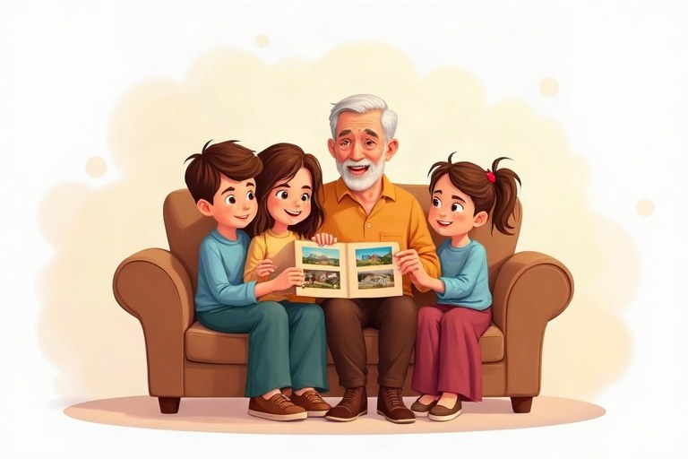
◆ Now and in the past
עכשיו ובעבר
الآن وفي الماضي
Subject | Present | Past
I | am | was
he / she / it | is | was
you / we / they | are | were

◆ Negatives and questions
שלילה ושאלות
النفي والأسئلة
1. wasn't = was not; weren't = were not
צורות מקוצרות: ‎wasn't = was not; weren't = were not‎
الصيغ المختصرة: ‎wasn't = was not‎؛ ‎weren't = were not‎
2. Was / Were + subject ...?
‎Was / Were +‎ נושא ...?
‎Was / Were +‎ الفاعل ...؟
3. Short answers: Yes, he was. No, we weren't.
תשובות קצרות: ‎Yes, he was.‎‏ ‎No, we weren't‎.
إجابات قصيرة: ‎Yes, he was.‎‏ ‎No, we weren't‎.
Example:
דוגמה:
مثال:
Was it hot? No, it wasn't.
◆ Wh-questions
שאלות ‎Wh‎
أسئلة ‎Wh‎
1. Where were you?
2. Who was at the party?
3. How was your day?
◆ Time words
מילות זמן
كلمات الزمن
yesterday · last night · last week · last year · two days ago · in 2020
🖼️ Picture words · מילים בתמונות‎ · كلمات بالصّور‎
school  בית ספר  مدرسة |   park  פארק  حديقة عامة | beach  חוף ים  شاطئ | cat  חתול  قطة | cake  עוגה  كعكة |   ball  כדור  كرة

1. Match the time words to the same meaning.
התאימו בין מילות הזמן שיש להן אותה משמעות.
صِل كلمات الزمن التي لها المعنى نفسه.
Column A | Column B
1. yesterday | [ ] the summer before this year
2. last night | [ ] the night before today
3. last week | [ ] the day before today
4. two days ago | [ ] the day before yesterday
5. last summer | [ ] the week before this week

2. Complete with was or were.
השלימו ב־‎was‎ או ב־‎were‎.
أكمل بـ ‎was‎ أو ‎were‎.
a. The museum __________ very interesting.
b. Dad and I __________ at the soccer game.
c. It __________ a long day.
d. The students __________ in the library.
e. My dog __________ in the garden all day.
f. Where __________ your shoes?
3. Complete the table.
השלימו את הטבלה.
أكمل الجدول.
+ | − | ?
He was at home.
They were hungry.
It was easy.
You were late.

4. Present or past? Sort the words.
הווה או עבר? מיינו את המילים.
حاضر أم ماضٍ؟ صنّف الكلمات.
Words: am | was | is | were | are | wasn't | isn't | weren't
present | past

5. Complete with a word from the bank.
השלימו במילה ממחסן המילים.
أكمل بكلمة من بنك الكلمات.
Word bank: was | were | wasn't | weren't | Was | Were
a. __________ you at the concert? Yes, I was.
b. The bus __________ on time. It was late.
c. We __________ in the classroom. We were outside.
d. __________ the soup hot? Yes, it was.
e. My grandma __________ a teacher in the past.
f. The kids __________ very excited about the trip.
6. Change the sentences to the past. Use yesterday.
הפכו את המשפטים לעבר. השתמשו ב־‎yesterday‎.
حوّل الجمل إلى الماضي. استعمل ‎yesterday‎.
a. I am at the dentist.
b. The weather is rainy.
c. Ben and Noam are at the swimming pool.
d. My cat isn't hungry.
7. Circle the correct question word.
הקיפו את מילת השאלה הנכונה.
ضع دائرة حول أداة الاستفهام الصحيحة.
a. ___ was your teacher? Mr. Cohen.
○ Where ○ Who ○ How
b. ___ were you on Friday? At the beach.
○ Where ○ Who ○ What
c. ___ was the test? It was hard.
○ Who ○ When ○ How
d. ___ was the party? On Monday.
○ When ○ Who ○ Where
8. Find the mistake. Write the sentence correctly.
מצאו את הטעות. כתבו את המשפט נכון.
جد الخطأ. اكتب الجملة بشكل صحيح.
a. We was at the zoo.
b. Were Tom at school?
c. The children wasn't tired.
d. I were very happy.
e. It weren't my fault.
9. True or False? Correct the false rules.
נכון או לא נכון? תקנו את הכללים הלא נכונים.
صحيح أم خطأ؟ صحّح القواعد الخاطئة.
a. We use were with I. True / False
b. We use were with you, we and they. True / False
c. Weren't is short for were not. True / False
d. The past of is is were. True / False
A Rainy Day
Yesterday was a strange day in Jerusalem. In the morning, the sky was blue and the sun was warm. Ariel and his friend Tom were in the park with their bikes.
At twelve o'clock, the sky was gray. Suddenly, there was a lot of rain! The boys weren't ready. Their jackets were at home, and they were very wet and cold.
Luckily, Tom's uncle was in his car near the park. "Quick, get in!" he said. Ten minutes later, the boys were at Tom's house. Tom's mom was in the kitchen. There was hot chocolate on the table for everyone. "It was a great adventure!" said Ariel.
10. Read "A Rainy Day". Write True or False. Correct the false sentences.
קראו את ‎"A Rainy Day"‎. כתבו ‎True‎ או ‎False‎. תקנו את המשפטים הלא נכונים.
اقرأ ‎"A Rainy Day"‎. اكتب ‎True‎ أو ‎False‎. صحّح الجمل الخاطئة.
a. In the morning, the sky was gray. True / False
b. The boys' jackets were at home. True / False
c. Tom's uncle was in his car near the park. True / False
d. There was soup on the table. True / False
11. Answer the questions about the text.
ענו על השאלות על הטקסט.
أجب عن الأسئلة حول النصّ.
a. Where were Ariel and Tom in the morning?
b. Why were the boys wet and cold?
c. Who was in the kitchen?
12. Where were you last weekend? Who was with you? How was it? Write 4 sentences.
איפה הייתם בסוף השבוע שעבר? מי היה איתכם? איך היה? כתבו 4 משפטים.
أين كنت في نهاية الأسبوع الماضي؟ مَن كان معك؟ كيف كان؟ اكتب 4 جمل.
________________________________________________________________________
________________________________________________________________________
________________________________________________________________________
________________________________________________________________________

English · Grade 5 | Unit 5
Unit 5: Past simple: regular and irregular verbs
‎past simple‎: פעלים רגילים ויוצאי דופן
‎past simple‎: الأفعال المنتظمة والشاذّة
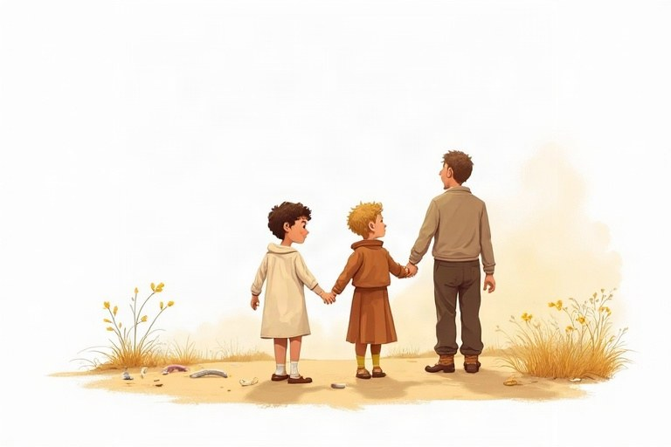
◆ Regular verbs: spelling
פעלים רגילים: כתיב
الأفعال المنتظمة: الإملاء
Verb | Rule | Past
walk | + ed | walked
dance | + d | danced
study | y, ied | studied
stop | double + ed | stopped

◆ Irregular verbs to remember
פעלים יוצאי דופן שכדאי לזכור
أفعال شاذّة يجب حفظها
Verb | Past | Verb | Past
go | went | see | saw
eat | ate | have | had
buy | bought | make | made
take | took | come | came

◆ Remember
זכרו
تذكّر
1. The past form is the same for I, he, she, we, they.
צורת העבר זהה ל־‎I, he, she, we, they‎.
صيغة الماضي واحدة مع ‎I‎ و‎he‎ و‎she‎ و‎we‎ و‎they‎.
2. Time words: yesterday, last week, two days ago.
מילות זמן: ‎yesterday, last week, two days ago‎.
كلمات الزمن: ‎yesterday, last week, two days ago‎.
Example:
דוגמה:
مثال:
Yesterday Tamar bought a new book.
🖼️ Picture words · מילים בתמונות‎ · كلمات بالصّور‎
  sandwich  כריך  شطيرة | school  בית ספר  مدرسة | beach  חוף ים  شاطئ | book  ספר  كتاب |   fish  דג  سمكة |   horse  סוס  حصان

1. Match the verb to its past form.
התאימו בין הפועל לצורת העבר שלו.
صِل الفعل بصيغة الماضي الخاصّة به.
Column A | Column B
1. come | [ ] took
2. take | [ ] gave
3. give | [ ] swam
4. sit | [ ] got
5. swim | [ ] came
6. get | [ ] sat

2. Sort the regular verbs by spelling in the past.
מיינו את הפעלים הרגילים לפי הכתיב שלהם בעבר.
صنّف الأفعال المنتظمة حسب إملائها في الماضي.
Words: walk | smile | carry | jump | close | hurry | help | move
+ ed | + d | y, ied

3. Complete the table.
השלימו את הטבלה.
أكمل الجدول.
verb | past
 | had
make
 | ran
read
 | found
fly

4. Complete with a verb from the bank in the past simple.
השלימו בפועל ממחסן המילים ב־‎past simple‎.
أكمل بفعل من بنك الكلمات بصيغة ‎past simple‎.
Word bank: break | win | lose | forget | sing | sleep
a. Our team __________ the game 3–1!
b. Noa __________ a song at the party.
c. I __________ my homework at home.
d. Yoav __________ his arm last year.
e. The baby __________ for three hours.
f. Dad __________ his keys, so we looked for them.
5. Complete with the past simple of the verb in brackets.
השלימו ב־‎past simple‎ של הפועל שבסוגריים.
أكمل بصيغة ‎past simple‎ للفعل الذي بين القوسين.
a. Two days ago, we __________ in the sea. (swim)
b. Last night, Mom __________ a delicious soup. (cook)
c. Omer __________ his bike to school. (ride)
d. The teacher __________ us a story. (tell)
e. I __________ the door and went out. (open)
f. We __________ a lot of photos on the trip. (take)
6. Circle the correct word.
הקיפו את המילה הנכונה.
ضع دائرة حول الكلمة الصحيحة.
a. Last year my family ___ to Eilat.
○ drived ○ drove ○ drive
b. Shira ___ a picture of a horse.
○ drew ○ drawed ○ draws
c. The bus ___ at the red light.
○ stoped ○ stops ○ stopped
d. I ___ a strange noise last night.
○ heard ○ heared ○ hear
7. Find the mistake. Write the sentence correctly.
מצאו את הטעות. כתבו את המשפט נכון.
جد الخطأ. اكتب الجملة بشكل صحيح.
a. Yesterday I eated pizza.
b. She buyed a new dress.
c. We planed a party.
d. He runned to the bus.
e. Last week they goes to Haifa.
8. True or False? Correct the false rules.
נכון או לא נכון? תקנו את הכללים הלא נכונים.
صحيح أم خطأ؟ صحّح القواعد الخاطئة.
a. All verbs in the past end in -ed. True / False
b. The past of study is studied. True / False
c. With he and she, the past form gets -s: he wents. True / False
d. The past of stop is stopped. True / False
9. Put the words in order. Write the sentence.
סדרו את המילים. כתבו את המשפט.
رتّب الكلمات. اكتب الجملة.
a. went / to the beach / We / last Saturday
b. a cake / made / Grandma / yesterday
c. the window / broke / The ball
d. saw / at the zoo / a lion / I
The Lost Puppy
Last Tuesday, Itay walked home from school with his friend Daniel. Near the playground, they heard a small noise. They looked under a bench and found a little brown puppy. It was wet and hungry.
Itay took the puppy home in his schoolbag. His mom gave it some milk and a towel. Then Itay and Daniel made a sign with a photo of the puppy: "FOUND! A little brown puppy. Call 052-1234567." They put the sign on a tree near the playground.
Two hours later, the phone rang. A girl named Shira cried with happiness. "That's my puppy, Coco!" she said. She came to Itay's house and thanked the boys. Coco jumped into her arms.
10. Read "The Lost Puppy". Choose the correct answer.
קראו את ‎"The Lost Puppy"‎. בחרו את התשובה הנכונה.
اقرأ ‎"The Lost Puppy"‎. اختر الإجابة الصحيحة.
a. Where did the boys find the puppy?
○ in the school ○ under a bench ○ in a tree
b. What did Itay's mom give the puppy?
○ milk and a towel ○ bread and water ○ a ball
c. Why did Shira cry?
○ She was sad. ○ She was hurt. ○ She was very happy.
11. Complete the sentences about the text with the past simple.
השלימו את המשפטים על הטקסט ב־‎past simple‎.
أكمل الجمل حول النصّ بصيغة ‎past simple‎.
a. The boys __________ a small noise.
b. Itay __________ the puppy home.
c. They __________ the sign on a tree.
d. Two hours later, the phone __________.
12. Write a short story (4 lines) about a day when something surprising happened. Use the past simple.
כתבו סיפור קצר (4 שורות) על יום שבו קרה משהו מפתיע. השתמשו ב־‎past simple‎.
اكتب قصّة قصيرة (4 أسطر) عن يوم حدث فيه شيء مفاجئ. استعمل ‎past simple‎.
________________________________________________________________________
________________________________________________________________________
________________________________________________________________________
________________________________________________________________________

English · Grade 5 | Unit 6
Unit 6: Possessives: 's, my, your, his, her, our, their
מילות שייכות: ‎'s, my, your, his, her, our, their‎
كلمات الملكيّة: ‎'s, my, your, his, her, our, their‎

◆ Possessive adjectives
מילות שייכות ‎(possessive adjectives)‎
صفات الملكيّة ‎(possessive adjectives)‎
Subject | Possessive | Example
I / you | my / your | my book, your book
he / she / it | his / her / its | his cap, her cap
we / they | our / their | our class, their class

◆ 's and s'
‎'s‎ ו־‎s'‎
‎'s‎ و ‎s'‎
1. one person: Dan's bike, the girl's bag
אדם אחד: ‎Dan's bike, the girl's bag‎
شخص واحد: ‎Dan's bike, the girl's bag‎
2. plural with -s: the girls' bags
רבים עם -‎s: the girls' bags‎
جمع مع -‎s: the girls' bags‎
3. special plural: the children's books
רבים מיוחד: ‎the children's books‎
جمع خاصّ: ‎the children's books‎
◆ Who and Whose
‎Who‎ ו־‎Whose‎
‎Who‎ و‎Whose‎
1. Who is that? It's my cousin.
2. Whose shoes are these? They're Tom's.
🖼️ Picture words · מילים בתמונות‎ · كلمات بالصّور‎
  bag  תיק  حقيبة | dog  כלב  كلب | bike  אופניים  دراجة | ball  כדור  كرة | book  ספר  كتاب |   car  מכונית  سيارة

1. Complete with a possessive word.
השלימו במילת שייכות.
أكمل بكلمة ملكيّة.
a. I am Daniel. This is __________ room.
b. You are my friend. Is this __________ jacket?
c. Ariel is ten. __________ birthday is in May.
d. Shira has a parrot. __________ parrot can talk.
e. We are in Class 5B. __________ class is on the second floor.
f. My cousins live in Akko. __________ house is old.
2. Match the sentences that mean the same.
התאימו בין המשפטים שיש להם אותה משמעות.
صِل الجمل التي لها المعنى نفسه.
Column A | Column B
1. It's Tom's ball. | [ ] It's their ball.
2. It's Noa's ball. | [ ] It's her ball.
3. It's Ben and Dan's ball. | [ ] It's our ball.
4. The ball belongs to me. | [ ] It's my ball.
5. The ball belongs to you. | [ ] It's your ball.
6. The ball belongs to Noa and me. | [ ] It's his ball.

3. Sort the words.
מיינו את המילים.
صنّف الكلمات.
Words: my | Who | his | Whose | their | its | our | her
possessive words | question words

4. Complete with the 's or s' form.
השלימו בצורה ‎'s‎ או ‎s'‎.
أكمل بالصيغة ‎'s‎ أو ‎s'‎.
the owner | the thing | together
Maya | book
my parents | car
the children | toys
the teacher | desk
the girls | bags

5. Complete with it's or its.
השלימו ב־‎it's‎ או ב־‎its‎.
أكمل بـ ‎it's‎ أو ‎its‎.
a. __________ very hot today.
b. The bird is building __________ nest.
c. Look at that dog! __________ tail is so long.
d. __________ my birthday tomorrow.
6. Circle the correct answer.
הקיפו את התשובה הנכונה.
ضع دائرة حول الإجابة الصحيحة.
a. ___ is that man? He's my uncle.
○ Whose ○ Who ○ What
b. This is ___ bag.
○ Tamars ○ Tamar's ○ Tamars'
c. The ___ room is very big. (two boys)
○ boys' ○ boy's ○ boys's
d. Noam and I love ___ school.
○ their ○ our ○ his
7. Write a sentence with 's. Example: Ben / skateboard: This is Ben's skateboard.
כתבו משפט עם ‎'s‎. דוגמה: ‎Ben / skateboard: This is Ben's skateboard‎.
اكتب جملة مع ‎'s‎. مثال: ‎Ben / skateboard: This is Ben's skateboard‎.
a. Noa / guitar
b. my brother / phone
c. Grandpa / glasses
d. the cat / bowl
8. Find the mistake. Write the sentence correctly.
מצאו את הטעות. כתבו את המשפט נכון.
جد الخطأ. اكتب الجملة بشكل صحيح.
a. She loves his mother. (Shira's mother)
b. Whose is your teacher?
c. This is the girls bag. (one girl)
d. The dog is eating it's food.
e. They are playing with our ball. (their own ball)
9. True or False? Correct the false rules.
נכון או לא נכון? תקנו את הכללים הלא נכונים.
صحيح أم خطأ؟ صحّح القواعد الخاطئة.
a. We use her for a girl or a woman. True / False
b. Whose asks who something belongs to. True / False
c. It's means "belongs to it". True / False
d. For two boys we write the boy's room. True / False
Lost and Found
At the end of the school year, our teacher, Mrs. Ben-David, opened the lost and found box. "Whose things are these?" she asked.
First, she took out a blue water bottle. "That's Omer's bottle!" said Maya. Omer was very happy. Then there was a pink pencil case with stars. It was Noa's pencil case. Her name was on it in small letters.
At the bottom of the box, there were two black sweatshirts. "These are the twins' sweatshirts," said the teacher. Itay and Ariel are twins, and their sweatshirts are the same. "But which one is mine?" asked Itay. Ariel smiled. "Mine has a hole in the pocket!"
10. Read "Lost and Found". Write True or False. Correct the false sentences.
קראו את ‎"Lost and Found"‎. כתבו ‎True‎ או ‎False‎. תקנו את המשפטים הלא נכונים.
اقرأ ‎"Lost and Found"‎. اكتب ‎True‎ أو ‎False‎. صحّح الجمل الخاطئة.
a. The blue water bottle was Maya's. True / False
b. Noa's name was on the pencil case. True / False
c. The black sweatshirts were the twins'. True / False
d. Itay's sweatshirt has a hole in the pocket. True / False
11. Answer the questions about the text.
ענו על השאלות על הטקסט.
أجب عن الأسئلة حول النصّ.
a. Whose pencil case had stars on it?
b. Who are Itay and Ariel?
c. How do they know which sweatshirt is Ariel's?
12. Write about 4 things in your classroom and who they belong to. Use 's, his, her or their.
כתבו על 4 דברים בכיתה שלכם ולמי הם שייכים. השתמשו ב־‎'s, his, her‎ או ‎their‎.
اكتب عن 4 أشياء في صفّك ولِمن تعود. استعمل ‎'s‎ أو ‎his‎ أو ‎her‎ أو ‎their‎.
________________________________________________________________________
________________________________________________________________________
________________________________________________________________________
________________________________________________________________________

English · Grade 5 | Unit 7
Unit 7: Reading a short text and writing a paragraph (and, but, then, because)
קריאת טקסט קצר וכתיבת פסקה ‎(and, but, then, because)‎
قراءة نصّ قصير وكتابة فقرة ‎(and, but, then, because)‎
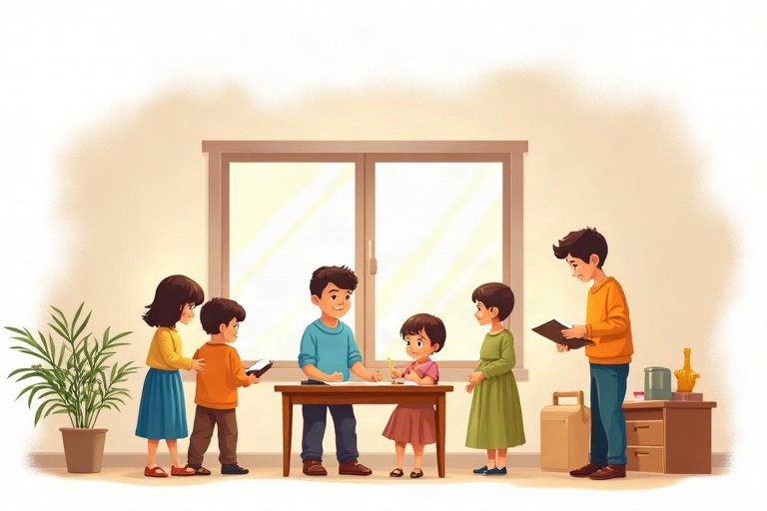
◆ Linking words
מילות קישור
أدوات الربط
Word | Meaning | Example
and | adds information | I have a cat and a dog.
but | something different | It was sunny, but cold.
then | what happened next | We ate. Then we played.
because | a reason (Why?) | I ran because I was late.

◆ Paragraph plan
תכנון פסקה
خطّة الفقرة
1. Opening sentence: the topic
משפט פתיחה: הנושא
جملة افتتاحيّة: الموضوع
2. 3–4 detail sentences
3–4 משפטים עם פרטים
3–4 جمل فيها تفاصيل
3. Closing sentence: your feeling or opinion
משפט סיום: ההרגשה או הדעה שלכם
جملة ختاميّة: شعورك أو رأيك
◆ Reading tips
טיפים לקריאה
نصائح للقراءة
1. Read the title and guess.
קראו את הכותרת ונחשו.
اقرأ العنوان وخمّن.
2. Read the questions.
קראו את השאלות.
اقرأ الأسئلة.
3. Find key words in the text.
מצאו מילות מפתח בטקסט.
جد الكلمات المفتاحيّة في النصّ.
🖼️ Picture words · מילים בתמונות‎ · كلمات بالصّور‎
beach  חוף ים  شاطئ | dog  כלב  كلب | cat  חתול  قطة | park  פארק  حديقة عامة |   apple  תפוח  تفاحة |   key  מפתח  مفتاح

1. Match the questions to the answers.
התאימו בין השאלות לתשובות.
صِل الأسئلة بالإجابات.
Column A | Column B
1. Who is your best friend? | [ ] Daniel.
2. Where do you live? | [ ] Pizza.
3. When is your birthday? | [ ] In Petah Tikva.
4. Why are you late? | [ ] In October.
5. What is your favorite food? | [ ] Because I missed the bus.

2. Complete with and, but, then or because.
השלימו ב־‎and, but, then‎ או ‎because‎.
أكمل بـ ‎and‎ أو ‎but‎ أو ‎then‎ أو ‎because‎.
Word bank: and | but | then | because
a. I like to read __________ I like to draw.
b. Shira can swim, __________ she can't dive.
c. We had breakfast, and __________ we went to school.
d. I took an umbrella __________ it was raining.
e. Tom is good at math __________ science.
3. Sort the sentences: opening, detail or closing sentence?
מיינו את המשפטים: משפט פתיחה, משפט פרטים או משפט סיום?
صنّف الجمل: جملة افتتاحيّة أم جملة تفاصيل أم جملة ختاميّة؟
Words: My favorite animal is the dolphin. | Dolphins live in the sea. | They are very smart. | That is why I love dolphins.
opening | detail | closing

4. Choose the best ending.
בחרו את הסיום הטוב ביותר.
اختر أفضل نهاية.
a. I went to bed early because ...
○ I was very tired. ○ I wanted to play. ○ it was morning.
b. We wanted to swim, but ...
○ the sea was warm. ○ the pool was closed. ○ we had towels.
c. Noam was sad because ...
○ he won the game. ○ he got a present. ○ his team lost.
5. Answer with because.
ענו עם ‎because‎.
أجب مع ‎because‎.
a. Why do you wear a hat in summer?
b. Why do we brush our teeth?
c. Why do people go to the beach?
d. Why do you like your best friend?
6. Correct the capital letters and the full stops. Write the missing letter or mark.
תקנו את האותיות הגדולות ואת הנקודות. כתבו את האות או את הסימן החסרים.
صحّح الأحرف الكبيرة والنقاط. اكتب الحرف أو العلامة الناقصة.
a. __________ like ice cream. (i)
b. my sister and __________ went to school. (i)
c. We live in __________aifa. (h)
d. Where are you going__________ (? or .)
7. Join the sentences. Use the word in brackets.
חברו את המשפטים. השתמשו במילה שבסוגריים.
اربط الجمل. استعمل الكلمة التي بين القوسين.
a. Maya is tall. Her brother is short. (but)
b. I finished my homework. I went outside. (then)
c. Ben is happy. He got a puppy. (because)
d. Grandma made soup. Grandma made salad. (and)
8. Put the sentences in the correct order. Write the numbers 1–4.
סדרו את המשפטים בסדר הנכון. כתבו את המספרים 1–4.
رتّب الجمل بالترتيب الصحيح. اكتب الأرقام 1–4.
a. Then he looked under his bed.
b. Yesterday Omer couldn't find his shoe.
c. He was happy because he wasn't late for school.
d. The shoe was there, with his dog next to it!
9. True or False? Correct the false rules.
נכון או לא נכון? תקנו את הכללים הלא נכונים.
صحيح أم خطأ؟ صحّح القواعد الخاطئة.
a. A paragraph is about one topic. True / False
b. We use but to give a reason. True / False
c. We always write I with a capital letter. True / False
d. Then tells us what happened before. True / False
A New Neighbor
Last month, a new family moved into the apartment next to ours in Ashdod. They came from France, and they didn't speak much Hebrew. They had a boy my age. His name was Lucas.
On the first day, Lucas sat on the stairs alone. He looked sad, because he didn't know anybody. I wanted to talk to him, but I was shy. Then I had an idea. I took my soccer ball and went outside.
"Do you want to play?" I asked in English. Lucas smiled and said, "Yes!" We played for two hours. Now we are good friends. I help him with Hebrew, and he teaches me French words. Last week, he taught me to say "merci"!
10. Read "A New Neighbor". Write True or False. Correct the false sentences.
קראו את ‎"A New Neighbor"‎. כתבו ‎True‎ או ‎False‎. תקנו את המשפטים הלא נכונים.
اقرأ ‎"A New Neighbor"‎. اكتب ‎True‎ أو ‎False‎. صحّح الجمل الخاطئة.
a. The new family came from France. True / False
b. Lucas was happy on the first day. True / False
c. The boys spoke English at first. True / False
d. Lucas teaches the writer Hebrew. True / False
11. Answer the questions about the text.
ענו על השאלות על הטקסט.
أجب عن الأسئلة حول النصّ.
a. Where did the new family come from?
b. Why did Lucas look sad?
c. What was the writer's idea?
d. How do the boys help each other now?
12. Write a paragraph (4 lines) about a friend. Who is he or she? How did you meet? What do you do together? Use and, but, then and because.
כתבו פסקה (4 שורות) על חבר או חברה. מי הוא או היא? איך הכרתם? מה אתם עושים יחד? השתמשו ב־‎and, but, then‎ ו־‎because‎.
اكتب فقرة (4 أسطر) عن صديق أو صديقة. مَن هو أو هي؟ كيف تعارفتما؟ ماذا تفعلان معًا؟ استعمل ‎and‎ و‎but‎ و‎then‎ و‎because‎.
________________________________________________________________________
________________________________________________________________________
________________________________________________________________________
________________________________________________________________________

Review – What did we learn?
חזרה – מה למדנו?
مراجعة – ماذا تعلّمنا؟
1. Complete with the correct form of the verb in brackets.
השלימו בצורה הנכונה של הפועל שבסוגריים.
أكمل بالصيغة الصحيحة للفعل الذي بين القوسين.
a. My brother __________ to school by bike every day. (ride)
b. Look! The children __________ in the rain. (dance)
c. Yesterday we __________ at the zoo. (be)
d. Last week Noa __________ a new book. (buy)
e. Itay __________ like spicy food. (not)
2. Circle the correct word.
הקיפו את המילה הנכונה.
ضع دائرة حول الكلمة الصحيحة.
a. She has ___ umbrella.
○ a ○ an ○ the
b. Two ___ are playing in the garden.
○ childs ○ children ○ childrens
c. ___ bag is this? It's Ben's.
○ Who ○ Whose ○ Where
d. I was late ___ I missed the bus.
○ but ○ and ○ because
3. Complete the table.
השלימו את הטבלה.
أكمل الجدول.
verb | he / she (present) | -ing | past
go
swim
study
have

4. Sort the sentences by time.
מיינו את המשפטים לפי הזמן.
صنّف الجمل حسب الزمن.
Words: I play tennis on Mondays. | I am playing tennis now. | I played tennis yesterday. | She watches TV every evening. | She is watching TV right now. | She watched TV last night.
every day | now | in the past

5. Complete with my, his, her, our, their or 's.
השלימו ב־‎my, his, her, our, their‎ או ב־‎'s‎.
أكمل بـ ‎my‎ أو ‎his‎ أو ‎her‎ أو ‎our‎ أو ‎their‎ أو ‎'s‎.
a. Tamar loves __________ new bike.
b. Omer and Yoav are with __________ grandfather.
c. This is Ariel__________ room.
d. We love __________ teacher.
6. Find the mistake. Write the sentence correctly.
מצאו את הטעות. כתבו את המשפט נכון.
جد الخطأ. اكتب الجملة بشكل صحيح.
a. He don't like milk.
b. They was at the beach.
c. She is runing to the bus.
d. Yesterday I goed to the park.
e. I have a apple.
7. True or False? Correct the false sentences.
נכון או לא נכון? תקנו את המשפטים הלא נכונים.
صحيح أم خطأ؟ صحّح الجمل الخاطئة.
a. Does your dog sleep inside? True / False
b. Where were you last night? True / False
c. Is Maya play the piano now? True / False
d. The mens are tall. True / False
8. Write 4 sentences about yourself: one about every day, one about now, one about yesterday and one with because.
כתבו 4 משפטים על עצמכם: אחד על מה שקורה כל יום, אחד על עכשיו, אחד על אתמול ואחד עם ‎because‎.
اكتب 4 جمل عن نفسك: جملة عن كلّ يوم، وجملة عن الآن، وجملة عن أمس، وجملة فيها ‎because‎.
________________________________________________________________________
________________________________________________________________________
________________________________________________________________________
________________________________________________________________________
Well done!
כל הכבוד!‎ · أحسنت!‎
I finished the English workbook for Grade 5.

