English · Grade 6 | Summary
Past simple: negatives and questions
‎Past simple‎: שלילה ושאלות
‎Past simple‎: النفي والأسئلة
Summary: how to say no and ask questions in the past simple
סיכום: איך שוללים ושואלים שאלות ב-‎past simple‎
ملخّص: كيف ننفي ونسأل في ‎past simple‎
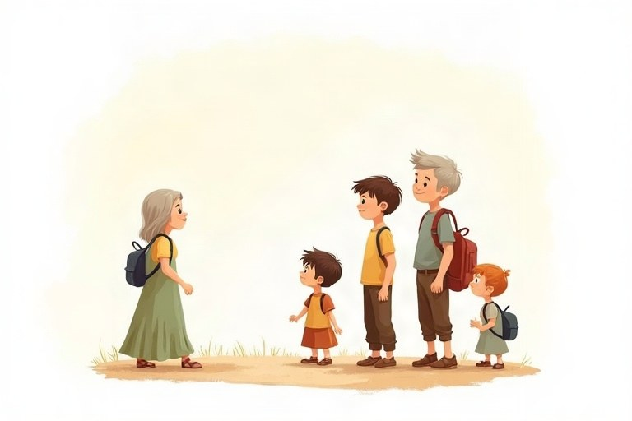
◆ Three sentence types
שלושה סוגי משפטים
ثلاثة أنواع من الجمل
 | Past simple | Example
+ | verb-ed / irregular | Yoav played. Yoav went.
– | didn't + base form | Yoav didn't play. Yoav didn't go.
? | Did + subject + base form? | Did Yoav play? Did Yoav go?

◆ Short answers
תשובות קצרות
الإجابات القصيرة
1. Did you see it? Yes, I did. / No, I didn't.
2. Did they win? Yes, they did. / No, they didn't.
◆ Common irregular verbs
פעלים יוצאי דופן נפוצים
أفعال شاذّة شائعة
Base | Past | Base | Past
go | went | eat | ate
see | saw | buy | bought
have | had | take | took
make | made | write | wrote

◆ Wh-questions
שאלות ‎Wh‎
أسئلة ‎Wh‎
Question word + did + subject + base form.
מילת שאלה ‎+ did +‎ נושא + צורת בסיס.
كلمة السؤال ‎+ did +‎ الفاعل + الصيغة الأساسية.
Examples:
דוגמאות:
أمثلة:
What did you eat? · Why did Tom leave early?
🖼️ Picture words · מילים בתמונות‎ · كلمات بالصّور‎
  phone  טלפון  هاتف |   park  פארק  حديقة عامة |   bag  תיק  حقيبة |   school  בית ספר  مدرسة |   cake  עוגה  كعكة |   basketball  כדורסל  كرة السلة

Remember! After did or didn't the verb goes back to its base form: Did he go? He didn't go. (Not: Did he went? He didn't went.)
אחרי ‎did‎ או ‎didn't‎ הפועל חוזר לצורת הבסיס: ‎Did he go?‎‏ ‎He didn't go. (‎לא: ‎Did he went?‎‏ ‎He didn't went.)‎
بعد ‎did‎ أو ‎didn't‎ يعود الفعل إلى صيغته الأساسية: ‎Did he go?‎‏ ‎He didn't go. (‎وليس: ‎Did he went?‎‏ ‎He didn't went.)‎
✏️ Worked example: Noa bought a new bag. (Make it negative.) Noa ___ a new bag.
1. Negative in the past: didn't + base form.
2. The base form of «bought» is «buy».
Answer: didn't buy
Check yourself – Complete.
השלימו.
أكمل.
a. We went to the park. (negative) We __________ to the park.
b. They saw the show. (question) __________ they see the show?
c. Itay ate pizza. (question) What __________ Itay eat?
d. I wrote a letter. (negative) I __________ a letter.
Self-check answers: a. didn't go · b. Did · c. did · d. didn't write

