English · Grade 6 | Summary
"Going to" for future plans
‎«going to»‎ לתוכניות לעתיד
‎«going to»‎ للخطط المستقبلية
Summary: talking about future plans with «going to»
סיכום: מדברים על תוכניות לעתיד עם ‎«going to»‎
ملخّص: الحديث عن خطط المستقبل باستعمال ‎«going to»‎
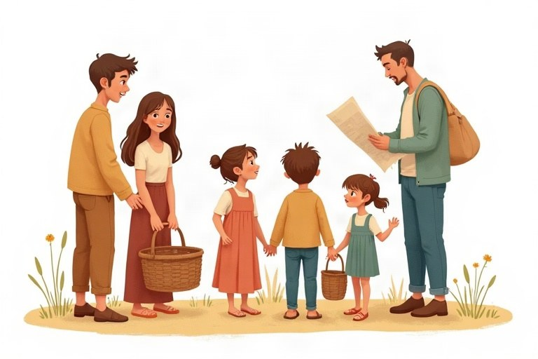
◆ The form
המבנה
الصيغة
 | Form | Example
+ | am / is / are + going to + verb | He is going to travel.
– | am not / isn't / aren't + going to + verb | He isn't going to travel.
? | Am / Is / Are + subject + going to + verb? | Is he going to travel?

◆ Who takes what?
מי מקבל מה?
مَن يأخذ ماذا؟
1. I: am
2. he / she / it: is
3. you / we / they: are
◆ Future time words
מילות זמן לעתיד
كلمات زمن للمستقبل
tomorrow, tonight, next week, next month, next year, this summer, on Friday, soon.
◆ Wh-questions
שאלות ‎Wh‎
أسئلة ‎Wh‎
Examples:
דוגמאות:
أمثلة:
What are you going to do on Saturday? · Where is Maya going to celebrate her birthday?
🖼️ Picture words · מילים בתמונות‎ · كلمات بالصّور‎
  car  מכונית  سيارة |   book  ספר  كتاب |   dog  כלב  كلب |   cake  עוגה  كعكة |   kite  עפיפון  طائرة ورقية |   train  רכבת  قطار

Remember! going to + the BASE form: She is going to dance. (Not: She is going to dances.) Don't forget am / is / are!
‎going to +‎ צורת הבסיס: ‎She is going to dance. (‎לא: ‎She is going to dances.)‎ אל תשכחו ‎am / is / are!‎
‎going to +‎ الصيغة الأساسية: ‎She is going to dance. (‎وليس: ‎She is going to dances.)‎ لا تنسَ ‎am / is / are!‎
✏️ Worked example: Tamar / visit / her grandma / tomorrow. Tamar ___ her grandma tomorrow.
1. Tamar = she, so we use «is».
2. Then «going to» + the base form «visit».
Answer: is going to visit
Check yourself – Complete with going to and the verb in brackets.
השלימו ב-‎going to‎ ובפועל שבסוגריים.
أكمل بـ ‎going to‎ والفعل الذي بين القوسين.
a. I __________ (read) a new book next week.
b. My parents __________ (not / buy) a new car.
c. Is Ben __________ (join) the team?
d. They __________ (have) a picnic on Saturday.
Self-check answers: a. am going to read · b. aren't going to buy · c. going to join · d. are going to have

