English · Grade 6 | Summary
Comparatives and superlatives
צורות השוואה ‎(comparatives)‎ והפלגה ‎(superlatives)‎
صيغ المقارنة ‎(comparatives)‎ والتفضيل ‎(superlatives)‎
Summary: how to compare with -er / more and -est / most
סיכום: איך משווים עם -‎er / more‎ ועם -‎est / most‎
ملخّص: كيف نقارن باستعمال -‎er / more‎ و -‎est / most‎
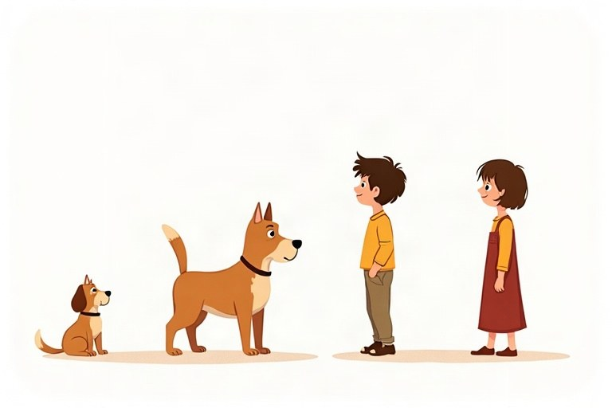
◆ The rules
הכללים
القواعد
Adjective | Comparative | Superlative
short: tall | taller than | the tallest
ends in -e: large | larger than | the largest
ends in -y: funny | funnier than | the funniest
long: beautiful | more beautiful than | the most beautiful

◆ Double the last letter
מכפילים את האות האחרונה
نضاعف الحرف الأخير
1. big – bigger – the biggest
2. hot – hotter – the hottest
3. thin – thinner – the thinnest
◆ Irregular adjectives
שמות תואר יוצאי דופן
صفات شاذّة
Adjective | Comparative | Superlative
good | better | the best
bad | worse | the worst
far | farther | the farthest

◆ Two or many?
שניים או הרבה?
اثنان أم كثير؟
1. Two things: Noa is older than Maya.
שני דברים: ‎Noa is older than Maya‎.
شيئان: ‎Noa is older than Maya‎.
2. One in a group: Noa is the oldest girl in the class.
אחד מתוך קבוצה: ‎Noa is the oldest girl in the class‎.
واحد من مجموعة: ‎Noa is the oldest girl in the class‎.
🖼️ Picture words · מילים בתמונות‎ · كلمات بالصّور‎
  dog  כלב  كلب |   park  פארק  حديقة عامة |   water  מים  ماء |   book  ספר  كتاب |   cat  חתול  قطة |   bag  תיק  حقيبة

Remember! Comparative: two things + than. Superlative: the + -est / the most, for one thing in a group.
‎Comparative‎: שני דברים ‎+ than.‎‏ ‎Superlative: the + -est / the most‎, לדבר אחד מתוך קבוצה.
‎Comparative‎: شيئان ‎+ than.‎‏ ‎Superlative: the + -est / the most‎، لشيء واحد من مجموعة.
✏️ Worked example: Mount Hermon is ___ (high) mountain in Israel.
1. One mountain in a group (all the mountains in Israel): superlative.
2. Short adjective: the + -est.
Answer: the highest
Check yourself – Complete with the comparative or the superlative.
השלימו בצורת ההשוואה או בצורת ההפלגה.
أكمل بصيغة المقارنة أو بصيغة التفضيل.
a. My bag is __________ (heavy) than your bag.
b. Yesterday was __________ (hot) day of the year.
c. Soccer is __________ (popular) than tennis in my class.
d. This is __________ (bad) movie I have ever seen!
Self-check answers: a. heavier · b. the hottest · c. more popular · d. the worst

