English · Grade 6 | Summary
Modal verbs: can, could, must, should
פעלי עזר מודאליים: ‎can, could, must, should‎
الأفعال المساعدة: ‎can, could, must, should‎
Summary: modal verbs for requests, rules and advice
סיכום: פעלים מודאליים לבקשות, לכללים ולעצות
ملخّص: الأفعال المساعدة للطلبات والقواعد والنصائح
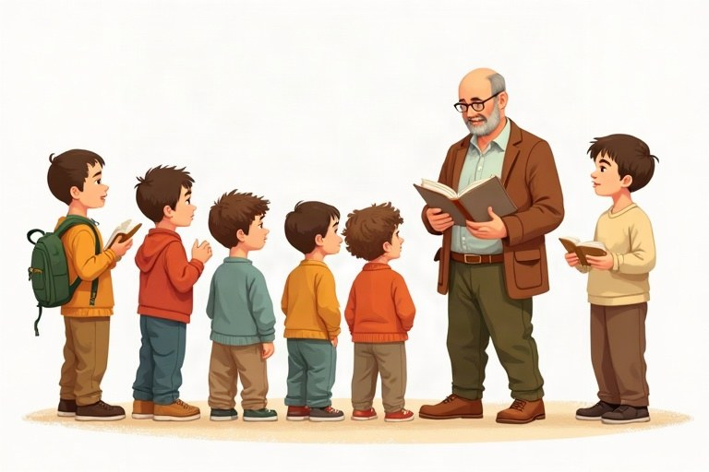
◆ What do they mean?
מה הם אומרים?
ماذا تعني؟
Modal | Use | Example
can / could | requests, ability | Could you help me, please?
must | a rule, it is necessary | You must wear a seat belt.
mustn't | not allowed | You mustn't touch the paintings.
should / shouldn't | advice | You should study for the test.

◆ The form
המבנה
الصيغة
1. modal + base form: She must go.
פועל מודאלי + צורת בסיס: ‎She must go‎.
فعل مساعد + الصيغة الأساسية: ‎She must go‎.
2. No -s: He can play. (Not: He cans play.)
בלי -‎s: He can play. (‎לא: ‎He cans play.)‎
بدون -‎s: He can play. (‎وليس: ‎He cans play.)‎
3. No to: You should rest. (Not: You should to rest.)
בלי ‎to: You should rest. (‎לא: ‎You should to rest.)‎
بدون ‎to: You should rest. (‎وليس: ‎You should to rest.)‎
◆ Questions and answers
שאלות ותשובות
أسئلة وأجوبة
Examples:
דוגמאות:
أمثلة:
Can I come in? Yes, you can. / Sorry, you can't. · Should I take a coat? Yes, you should.
🖼️ Picture words · מילים בתמונות‎ · كلمات بالصّور‎
  water  מים  ماء | 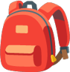  bag  תיק  حقيبة |   red  אדום  أحمر | 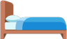  bed  מיטה  سرير |   phone  טלפון  هاتف |   hat  כובע  قبعة

Remember! Modal verbs never change: I can, he can, they can. After them comes the base form, without to.
פעלים מודאליים אף פעם לא משתנים: ‎I can, he can, they can‎. אחריהם בא הפועל בצורת הבסיס, בלי ‎to‎.
الأفعال المساعدة لا تتغيّر أبدًا: ‎I can, he can, they can‎. بعدها يأتي الفعل في صيغته الأساسية، بدون ‎to‎.
✏️ Worked example: Library rule: no food. You ___ eat in the library.
1. «No food» means it is not allowed.
2. Not allowed = mustn't.
Answer: mustn't
Check yourself – Complete with can, could, must, mustn't, should or shouldn't.
השלימו ב-‎can, could, must, mustn't, should‎ או ‎shouldn't‎.
أكمل بـ ‎can‎ أو ‎could‎ أو ‎must‎ أو ‎mustn't‎ أو ‎should‎ أو ‎shouldn't‎.
a. __________ I use your phone? Mine is broken.
b. Pupils __________ bring their notebooks to class. It's a rule.
c. You have a toothache. You __________ go to the dentist.
d. You __________ swim when there is no lifeguard.
Self-check answers: a. Can · b. must · c. should · d. mustn't

