English · Grade 6 | Summary
Asking questions: Wh-questions review
שואלים שאלות: חזרה על שאלות ‎Wh-‎
طرح الأسئلة: مراجعة أسئلة ‎Wh-‎
Summary: Wh-question words and how to build a question
סיכום: מילות שאלה ‎Wh-‎ ואיך בונים שאלה
ملخّص: كلمات السؤال ‎Wh-‎ وكيف نبني سؤالًا
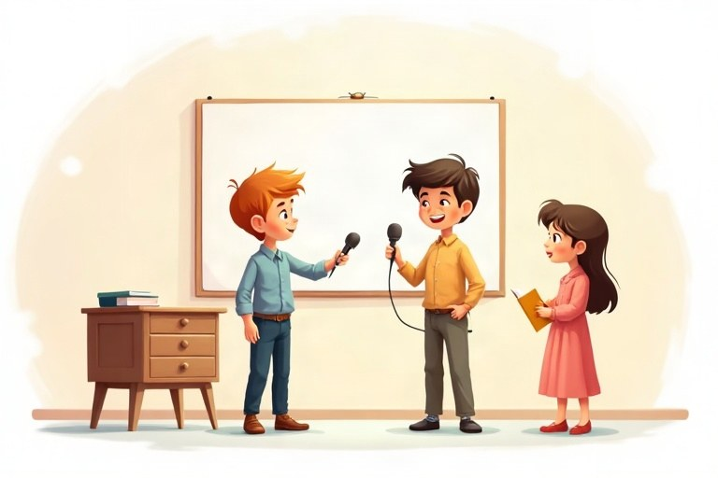
◆ Question words
מילות שאלה
كلمات السؤال
Word | Asks about | Example
Who | a person | Who is that boy?
What | a thing / an action | What are you eating?
Where | a place | Where is my bag?
When | a time | When does the movie start?
Why | a reason | Why are you late?
How | the way | How do you spell it?

◆ How + …
1. How many + count nouns: How many pencils?
‎How many +‎ שמות עצם שאפשר לספור: ‎How many pencils?‎
‎How many +‎ أسماء يمكن عدّها: ‎How many pencils?‎
2. How much + no-count nouns / price: How much milk? How much is it?
‎How much +‎ שמות עצם שאי אפשר לספור / מחיר: ‎How much milk?‎‏ ‎How much is it?‎
‎How much +‎ أسماء لا يمكن عدّها / السعر: ‎How much milk?‎‏ ‎How much is it?‎
3. How old / How often / How long
◆ Word order
סדר המילים
ترتيب الكلمات
1. Question word + be + subject: Where is Noa?
מילת שאלה ‎+ be +‎ נושא: ‎Where is Noa?‎
كلمة السؤال ‎+ be +‎ الفاعل: ‎Where is Noa?‎
2. Question word + do / does / did + subject + base form: What did Ben say?
מילת שאלה ‎+ do / does / did +‎ נושא + צורת בסיס: ‎What did Ben say?‎
كلمة السؤال ‎+ do / does / did +‎ الفاعل + الصيغة الأساسية: ‎What did Ben say?‎
🖼️ Picture words · מילים בתמונות‎ · كلمات بالصّور‎
  school  בית ספר  مدرسة |   bag  תיק  حقيبة |   cat  חתול  قطة |   milk  חלב  حليب |   blue  כחול  أزرق |   bus  אוטובוס  حافلة

Remember! Find the missing information in the answer, and choose the question word that asks about it: a place → Where, a time → When, a reason → Why.
מצאו את המידע החסר בתשובה, ובחרו את מילת השאלה ששואלת עליו: מקום ‎→ Where‎, זמן ‎→ When‎, סיבה ‎→ Why‎.
جد المعلومة الناقصة في الإجابة، واختر كلمة السؤال التي تسأل عنها: مكان ‎→ Where‎، وقت ‎→ When‎، سبب ‎→ Why‎.
✏️ Worked example: Answer: Ariel plays soccer twice a week. Question: ___ does Ariel play soccer?
1. The missing information is «twice a week».
2. It tells us how many times: How often.
Answer: How often
Check yourself – Complete with the correct question word.
השלימו במילת השאלה הנכונה.
أكمل بكلمة السؤال الصحيحة.
a. __________ is your best friend? Omer.
b. __________ are you laughing? Because the movie is funny.
c. __________ is this jacket? It's Maya's.
d. __________ does the bus come? At 8:15.
Self-check answers: a. Who · b. Why · c. Whose · d. When

