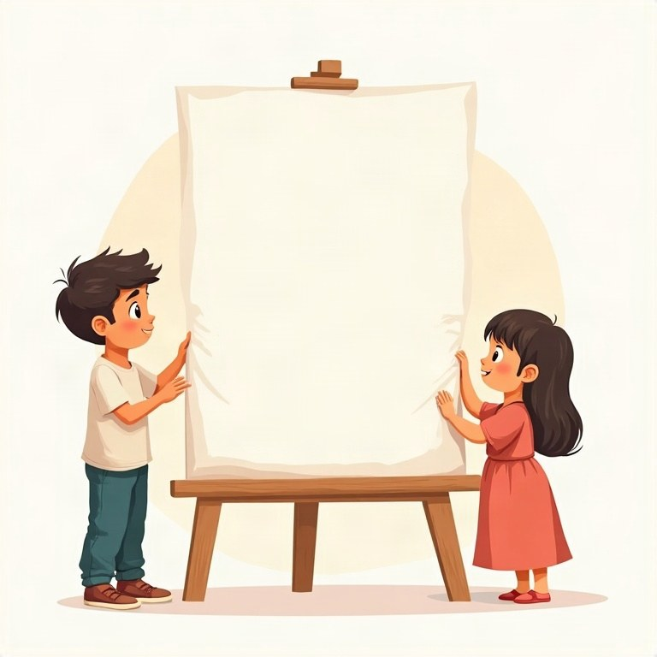
Workbook
English
Grade 6

Contents
תוכן העניינים
المحتويات
Topic
Introduction
Unit 1: Present simple or present progressive?
Unit 2: Past simple: negatives and questions
Unit 3: "Going to" for future plans
Unit 4: Comparatives and superlatives
Unit 5: Modal verbs: can, could, must, should
Unit 6: Asking questions: Wh-questions review
Unit 7: Reading comprehension and writing an email
Review – What did we learn?

Introduction
מבוא
مقدّمة
Hello, sixth graders!
שלום, תלמידי כיתה ו'!
مرحبًا يا طلاب الصف السادس!
This is your last year in elementary school, and your English is getting stronger every day. In this book you are going to talk about now, the past and the future, compare things, give advice and follow rules, ask good questions, and write your own emails.
זו השנה האחרונה שלכם בבית הספר היסודי, והאנגלית שלכם מתחזקת מיום ליום. בחוברת הזאת תדברו על ההווה, העבר והעתיד, תשוו בין דברים, תיתנו עצות ותמלאו כללים, תשאלו שאלות טובות ותכתבו מיילים משלכם.
هذه سنتك الأخيرة في المدرسة الابتدائية، ولغتك الإنجليزية تقوى يومًا بعد يوم. في هذا الكتاب ستتحدث عن الحاضر والماضي والمستقبل، وتقارن بين الأشياء، وتقدّم النصائح وتتّبع القواعد، وتطرح أسئلة جيدة، وتكتب رسائلك الإلكترونية بنفسك.
Each unit has short explanations with examples, a «Remember!» tip and lots of practice. At the end you will find a review and the answers. Good luck, and enjoy!
בכל יחידה יש הסברים קצרים עם דוגמאות, טיפ ‎«Remember!»‎ והרבה תרגול. בסוף תמצאו חזרה ותשובות. בהצלחה ותיהנו!
في كل وحدة شروح قصيرة مع أمثلة، ونصيحة ‎«Remember!»‎ وتمارين كثيرة. في النهاية ستجد مراجعة والإجابات. بالتوفيق، واستمتع!

English · Grade 6 | Unit 1
Unit 1: Present simple or present progressive?
‎Present simple‎ או ‎present progressive?‎
‎Present simple‎ أم ‎present progressive‎؟
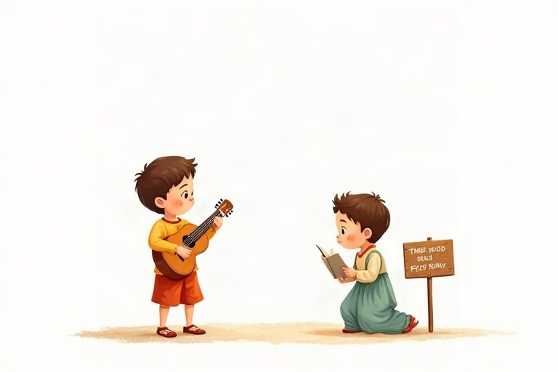
◆ Two present tenses
שני זמני הווה
زمنان للحاضر
Tense | When? | Example
Present simple | habits, facts, routines | Omer swims every Sunday.
Present progressive | now, at this moment | Omer is swimming now.

◆ How do we build them?
איך בונים אותם?
كيف نبنيهما؟
 | Present simple | Present progressive
+ | She reads. | She is reading.
– | She doesn't read. | She isn't reading.
? | Does she read? | Is she reading?

◆ Time words
מילות זמן
كلمات الزمن
1. Present simple: always, usually, often, sometimes, never, every day, on Mondays.
2. Present progressive: now, right now, at the moment, today, Look!, Listen!
◆ Spelling of -ing
כתיב של -‎ing‎
إملاء -‎ing‎
1. play – playing, read – reading
2. write – writing (drop the e)
‎write – writing (‎מורידים את ה-‎e)‎
‎write – writing (‎نحذف الـ ‎e)‎
3. swim – swimming, run – running (double the last letter)
‎swim – swimming, run – running (‎מכפילים את האות האחרונה)
‎swim – swimming, run – running (‎نضاعف الحرف الأخير)
🖼️ Picture words · מילים בתמונות‎ · كلمات بالصّور‎
  school  בית ספר  مدرسة |   bike  אופניים  دراجة |   ball  כדור  كرة |   bus  אוטובוס  حافلة |   computer  מחשב  حاسوب |   tennis  טניס  تنس

1. Add -s or -es to the verb.
הוסיפו לפועל -‎s‎ או -‎es‎.
أضف إلى الفعل -‎s‎ أو -‎es‎.
a. he walk__________
b. she wash__________
c. it fix__________
d. he read__________
e. she go__________
f. he catch__________
2. Match the beginnings and the endings.
התאימו בין תחילת המשפט לסופו.
صِل بداية كل جملة بنهايتها.
Column A | Column B
1. Every evening Shira | [ ] are baking a cake.
2. Right now the girls | [ ] have a piano lesson.
3. On Tuesdays I | [ ] is knocking on the door.
4. Listen! Someone | [ ] live in Haifa.
5. My grandparents | [ ] feeds her cat.

3. Sort the sentences: habit or happening now?
מיינו את המשפטים: הרגל או קורה עכשיו?
صنّف الجمل: عادة أم يحدث الآن؟
Words: Ben rides his bike to school. | Ben is riding his bike now. | We often visit the zoo. | Look! The monkey is eating a banana. | Tamar never drinks soda. | The teacher is writing on the board.
Habit | Now

4. Circle the correct form.
הקיפו את הצורה הנכונה.
ضع دائرة حول الصيغة الصحيحة.
a. My dad ___ to work by train.
○ is going usually ○ usually goes
b. Why ___ you ___? Are you sad?
○ are … crying ○ do … cry
c. Water ___ at 100 degrees.
○ is boiling ○ boils
d. I can't come now. I ___ my room.
○ am cleaning ○ clean
5. Complete with the present progressive.
השלימו ב־‎present progressive‎.
أكمل بصيغة ‎present progressive‎.
a. Omer __________ (wear) a red shirt today.
b. The birds __________ (sing) in the tree.
c. I __________ (make) a card for Mom.
d. Look! Itay __________ (climb) the wall.
6. Complete with do, does, don't or doesn't.
השלימו ב-‎do, does, don't‎ או ‎doesn't‎.
أكمل بـ ‎do‎ أو ‎does‎ أو ‎don't‎ أو ‎doesn't‎.
Word bank: do | does | don't | doesn't
a. __________ you like ice cream? Yes, I do.
b. Maya __________ eat meat. She is a vegetarian.
c. __________ your brother play the drums?
d. We __________ have school on Saturday.
7. Write questions and short answers.
כתבו שאלות ותשובות קצרות.
اكتب أسئلة وإجابات قصيرة.
Sentence | Question | Short answer
Noam is reading.
They play chess.
She is not dancing.

8. Circle the time word, then complete with the correct form of the verb.
הקיפו את מילת הזמן, ואז השלימו בצורה הנכונה של הפועל.
ضع دائرة حول كلمة الزمن، ثم أكمل بالصيغة الصحيحة للفعل.
a. We sometimes __________ (go) camping in the summer.
b. At the moment Dad __________ (wash) the car.
c. Daniel __________ (not / eat) breakfast every day.
d. Today Yoav __________ (help) his grandma in the garden.
A Message from the Class Trip
Hi Grandma!
I am writing to you from the class trip in the Galilee. It is three o'clock and we are sitting near a river. Some of my friends are swimming, and Omer is taking photos of everyone. The teacher is reading a map.
At home I usually play computer games in the afternoon, but on the trip there are no computers. Every morning we wake up at six and walk for four hours. I don't love the early mornings, but I love the views!
Right now I am eating an orange and drinking cold water. See you on Friday!
Love, Tom
9. Read the message and circle the correct answer.
קראו את ההודעה והקיפו את התשובה הנכונה.
اقرأ الرسالة وضع دائرة حول الإجابة الصحيحة.
a. Where is Tom now?
○ at home ○ near a river ○ in the classroom
b. What is the teacher doing?
○ taking photos ○ swimming ○ reading a map
c. When does Tom wake up on the trip?
○ at six ○ at three ○ at four
10. Answer according to the text. Complete the sentences.
ענו לפי הטקסט. השלימו את המשפטים.
أجب حسب النص. أكمل الجمل.
a. Omer is __________ photos of everyone.
b. At home Tom usually __________ computer games.
c. Every morning the children __________ for four hours.
d. Right now Tom is __________ an orange.
11. True or false? Correct the false sentences.
נכון או לא נכון? תקנו את המשפטים הלא נכונים.
صحيح أم خطأ؟ صحّح الجمل الخاطئة.
a. Tom loves the early mornings. True / False
b. There are no computers on the trip. True / False
c. Tom is drinking hot tea. True / False
12. Find the mistake and write the correct sentence.
מצאו את הטעות וכתבו את המשפט הנכון.
جد الخطأ واكتب الجملة الصحيحة.
a. She play tennis every day.
b. Look! The boys is running.
c. Do Noa like music?
d. I am usually walking to school.
13. Look around you. Write 4 sentences about what people are doing right now, and one sentence about what they usually do.
הסתכלו סביבכם. כתבו 4 משפטים על מה שאנשים עושים ממש עכשיו, ומשפט אחד על מה שהם עושים בדרך כלל.
انظر حولك. اكتب 4 جمل عمّا يفعله الناس الآن، وجملة واحدة عمّا يفعلونه عادةً.
________________________________________________________________________
________________________________________________________________________
________________________________________________________________________
________________________________________________________________________

English · Grade 6 | Unit 2
Unit 2: Past simple: negatives and questions
‎Past simple‎: שלילה ושאלות
‎Past simple‎: النفي والأسئلة
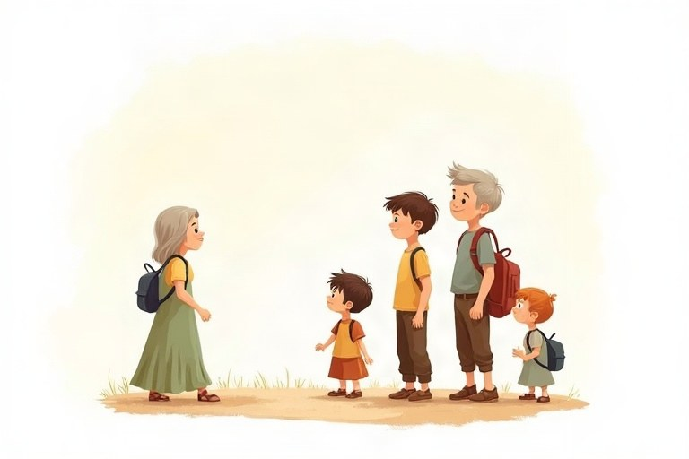
◆ Three sentence types
שלושה סוגי משפטים
ثلاثة أنواع من الجمل
 | Past simple | Example
+ | verb-ed / irregular | Yoav played. Yoav went.
– | didn't + base form | Yoav didn't play. Yoav didn't go.
? | Did + subject + base form? | Did Yoav play? Did Yoav go?

◆ Short answers
תשובות קצרות
الإجابات القصيرة
1. Did you see it? Yes, I did. / No, I didn't.
2. Did they win? Yes, they did. / No, they didn't.
◆ Common irregular verbs
פעלים יוצאי דופן נפוצים
أفعال شاذّة شائعة
Base | Past | Base | Past
go | went | eat | ate
see | saw | buy | bought
have | had | take | took
make | made | write | wrote

◆ Wh-questions
שאלות ‎Wh‎
أسئلة ‎Wh‎
Question word + did + subject + base form.
מילת שאלה ‎+ did +‎ נושא + צורת בסיס.
كلمة السؤال ‎+ did +‎ الفاعل + الصيغة الأساسية.
Examples:
דוגמאות:
أمثلة:
What did you eat? · Why did Tom leave early?
🖼️ Picture words · מילים בתמונות‎ · كلمات بالصّور‎
  phone  טלפון  هاتف |   park  פארק  حديقة عامة |   bag  תיק  حقيبة | school  בית ספר  مدرسة |   cake  עוגה  كعكة |   basketball  כדורסל  كرة السلة

1. Match the base form to the past form.
התאימו את צורת הבסיס לצורת העבר.
صِل الصيغة الأساسية بصيغة الماضي.
Column A | Column B
1. drink | [ ] sat
2. give | [ ] sang
3. find | [ ] found
4. sing | [ ] told
5. get | [ ] got
6. run | [ ] ran
7. sit | [ ] gave
8. tell | [ ] drank

2. Complete with the past simple of the verb in brackets.
השלימו ב־‎past simple‎ של הפועל שבסוגריים.
أكمل بصيغة ‎past simple‎ للفعل الذي بين القوسين.
a. Yesterday we __________ (bake) cookies.
b. Noa __________ (lose) her pencil case.
c. The boys __________ (run) to the gate.
d. I __________ (cry) at the end of the movie.
e. Grandpa __________ (tell) us a funny story.
3. Correct or not correct? Sort the sentences.
נכון או לא נכון? מיינו את המשפטים.
صحيحة أم غير صحيحة؟ صنّف الجمل.
Words: He didn't go. | He didn't went. | Did you see it? | Did you saw it? | We didn't play. | She didn't ate.
Correct | Not correct

4. Complete with did or didn't.
השלימו ב-‎did‎ או ‎didn't‎.
أكمل بـ ‎did‎ أو ‎didn't‎.
Word bank: did | didn't
a. __________ you have a good time at the party? Yes, I did.
b. Omer was sick, so he __________ come to school.
c. I __________ hear the bell. Sorry I'm late!
d. What __________ your teacher say?
5. Circle the correct question.
הקיפו את השאלה הנכונה.
ضع دائرة حول السؤال الصحيح.
a. Which question is correct?
○ Where you went? ○ Where did you go? ○ Where did you went?
b. Which question is correct?
○ Did she buy a dress? ○ Did she bought a dress? ○ She did buy a dress?
c. Which question is correct?
○ What did they eat? ○ What they ate? ○ What did they ate?
d. Which question is correct?
○ Why did Tom left? ○ Why Tom left? ○ Why did Tom leave?
6. Complete the table.
השלימו את הטבלה.
أكمل الجدول.
Positive | Negative | Question
She swam.
 | They didn't sing.
 |  | Did you sleep well?
He took a photo.

7. Write the question. Use the word in brackets.
כתבו את השאלה. השתמשו במילה שבסוגריים.
اكتب السؤال. استعمل الكلمة التي بين القوسين.
a. (Where) __________ you buy your shoes? At the mall.
b. (What) __________ Ariel see at the zoo? A lion.
c. (When) __________ the game start? At six.
d. (How) __________ you get to school? By bike.
8. Find the mistake and write the correct sentence.
מצאו את הטעות וכתבו את המשפט הנכון.
جد الخطأ واكتب الجملة الصحيحة.
a. I didn't saw the show.
b. Did Maya went home?
c. They don't come to the party yesterday.
d. Where you did put my book?
Daniel's Birthday
Last Friday was Daniel's twelfth birthday. In the morning, he didn't feel very happy. His friends didn't say anything at school, and nobody gave him a card.
In the afternoon his mom asked him to come to the community center. "Why?" asked Daniel. "Did I forget something?" She didn't answer. She just smiled.
When Daniel opened the door, all the lights went on. Everyone shouted, "Surprise!" His friends were there, and his grandparents, too. There was a big chocolate cake with twelve candles. Daniel's friends made a video for him, and they all watched it together. "Did you plan all this?" Daniel asked his mom. "Of course I did," she laughed.
9. Read the text and circle the correct answer.
קראו את הטקסט והקיפו את התשובה הנכונה.
اقرأ النص وضع دائرة حول الإجابة الصحيحة.
a. How old was Daniel last Friday?
○ eleven ○ twelve ○ thirteen
b. Why didn't Daniel feel happy in the morning?
○ He was sick. ○ His friends didn't say anything. ○ He lost his card.
c. What did Daniel's friends make for him?
○ a cake ○ a card ○ a video
10. True or false? Correct the false sentences.
נכון או לא נכון? תקנו את המשפטים הלא נכונים.
صحيح أم خطأ؟ صحّح الجمل الخاطئة.
a. Daniel's friends gave him a card at school. True / False
b. Daniel's mom answered his question. True / False
c. Daniel's grandparents came to the party. True / False
11. Complete the questions about the text.
השלימו את השאלות על הטקסט.
أكمل الأسئلة حول النص.
a. Where __________ the party take place? At the community center.
b. __________ Daniel's mom plan the party? Yes, she did.
c. What __________ everyone shout? «Surprise!»
12. Imagine you were at Daniel's party. Write 3–4 sentences: what did you do, and what didn't you do?
דמיינו שהייתם במסיבה של דניאל. כתבו 3–4 משפטים: מה עשיתם, ומה לא עשיתם?
تخيّل أنك كنت في حفلة دانيال. اكتب 3–4 جمل: ماذا فعلت، وماذا لم تفعل؟
________________________________________________________________________
________________________________________________________________________
________________________________________________________________________
________________________________________________________________________
13. Write 3 questions to ask a friend about his or her last vacation. Use did.
כתבו 3 שאלות לשאול חבר או חברה על החופשה האחרונה שלהם. השתמשו ב-‎did‎.
اكتب 3 أسئلة تسأل بها صديقًا أو صديقة عن عطلته الأخيرة. استعمل ‎did‎.
________________________________________________________________________
________________________________________________________________________
________________________________________________________________________

English · Grade 6 | Unit 3
Unit 3: "Going to" for future plans
‎«going to»‎ לתוכניות לעתיד
‎«going to»‎ للخطط المستقبلية
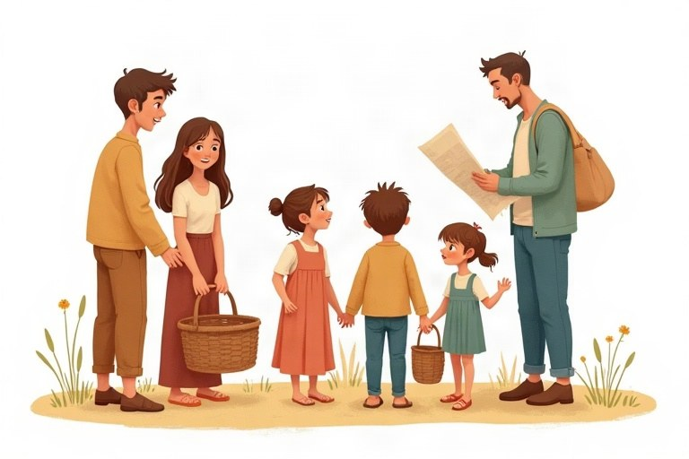
◆ The form
המבנה
الصيغة
 | Form | Example
+ | am / is / are + going to + verb | He is going to travel.
– | am not / isn't / aren't + going to + verb | He isn't going to travel.
? | Am / Is / Are + subject + going to + verb? | Is he going to travel?

◆ Who takes what?
מי מקבל מה?
مَن يأخذ ماذا؟
1. I: am
2. he / she / it: is
3. you / we / they: are
◆ Future time words
מילות זמן לעתיד
كلمات زمن للمستقبل
tomorrow, tonight, next week, next month, next year, this summer, on Friday, soon.
◆ Wh-questions
שאלות ‎Wh‎
أسئلة ‎Wh‎
Examples:
דוגמאות:
أمثلة:
What are you going to do on Saturday? · Where is Maya going to celebrate her birthday?
🖼️ Picture words · מילים בתמונות‎ · كلمات بالصّور‎
  car  מכונית  سيارة |   book  ספר  كتاب |   dog  כלב  كلب | cake  עוגה  كعكة |   kite  עפיפון  طائرة ورقية |   train  רכבת  قطار

1. Sort the time words.
מיינו את מילות הזמן.
صنّف كلمات الزمن.
Words: next month | last night | soon | yesterday | this summer | a year ago | on Sunday | in 2020
Past | Future

2. Match the plans to the reasons.
התאימו בין התוכניות לסיבות.
صِل الخطط بالأسباب.
Column A | Column B
1. I'm going to wear a coat | [ ] because she is thirsty.
2. Ben is going to study hard | [ ] because it's Mom's birthday.
3. We are going to buy flowers | [ ] because it's raining.
4. They are going to take an umbrella | [ ] because it's cold.
5. Noa is going to drink water | [ ] because he has a test.

3. Complete with the correct form of going to and the verb in brackets.
השלימו בצורה הנכונה של ‎going to‎ ובפועל שבסוגריים.
أكمل بالصيغة الصحيحة لـ ‎going to‎ والفعل الذي بين القوسين.
a. Next week I __________ (start) guitar lessons.
b. Tamar __________ (paint) a picture for her grandma.
c. My cousins __________ (stay) with us this summer.
d. Daniel __________ (ride) his new bike tomorrow.
e. We __________ (watch) the fireworks tonight.
4. Circle the correct sentence.
הקיפו את המשפט הנכון.
ضع دائرة حول الجملة الصحيحة.
a. Which sentence is correct?
○ He going to sleep. ○ He is going to sleep. ○ He is going sleep.
b. Which sentence is correct?
○ Are you going to eat? ○ You are going to eat? ○ Do you going to eat?
c. Which sentence is correct?
○ They isn't going to come. ○ They don't going to come. ○ They aren't going to come.
5. Complete the questions with a question word from the box.
השלימו את השאלות במילת שאלה מהתיבה.
أكمل الأسئلة بكلمة سؤال من المربع.
Word bank: What | Where | When | Who | How
a. __________ are you going to invite? Noam and Ben.
b. __________ is Maya going to do after school? Her homework.
c. __________ are we going to get there? By train.
d. __________ are they going to fly? On Monday morning.
e. __________ is Itay going to sleep? At his friend's house.
6. Read Ariel's diary for next week and write sentences with going to.
קראו את היומן של אריאל לשבוע הבא וכתבו משפטים עם ‎going to‎.
اقرأ مفكّرة أريئيل للأسبوع القادم واكتب جملًا مع ‎going to‎.
Day | Plan | Sentence
Sunday | play tennis
Tuesday | visit Grandpa
Thursday | go to the dentist
Friday | bake a cake

7. Find the mistake and write the correct sentence.
מצאו את הטעות וכתבו את המשפט הנכון.
جد الخطأ واكتب الجملة الصحيحة.
a. I am going to plays football.
b. She are going to call you.
c. Is going to rain tomorrow?
d. We not going to be late.
Yoav's Big Plan
Yoav is twelve years old, and he has a big plan for the summer vacation. He is going to raise money for the animal shelter in his town.
How is he going to do it? First, he is going to wash cars in his neighborhood every Friday. His older brother, Ariel, is going to help him. Then Yoav and his friend Shira are going to sell lemonade at the park. Shira's mom is going to make a sign for them.
Yoav isn't going to keep any of the money. At the end of the summer, he is going to give it all to the shelter. "The dogs there need food and blankets," he says. "I'm going to visit them too, and maybe I'm going to bring one home!"
8. True or false? Correct the false sentences.
נכון או לא נכון? תקנו את המשפטים הלא נכונים.
صحيح أم خطأ؟ صحّح الجمل الخاطئة.
a. Yoav is going to raise money for a hospital. True / False
b. Ariel is going to help Yoav wash cars. True / False
c. Yoav is going to keep some of the money. True / False
9. Answer the questions about the text. Complete the answers.
ענו על השאלות על הטקסט. השלימו את התשובות.
أجب عن الأسئلة حول النص. أكمل الإجابات.
a. When is Yoav going to wash cars? Every __________.
b. What are Yoav and Shira going to sell? __________.
c. Who is going to make a sign? Shira's __________.
10. Think about the text and circle the best answer.
חשבו על הטקסט והקיפו את התשובה הטובה ביותר.
فكّر في النص وضع دائرة حول أفضل إجابة.
a. What word describes Yoav best?
○ lazy ○ kind ○ angry
b. What do you think Yoav wants at the end?
○ to adopt a dog ○ to buy a car ○ to open a shop
11. Write 3 questions you want to ask Yoav about his plan. Use going to.
כתבו 3 שאלות שהייתם רוצים לשאול את יואב על התוכנית שלו. השתמשו ב-‎going to‎.
اكتب 3 أسئلة تريد أن تسألها ليوآف عن خطته. استعمل ‎going to‎.
________________________________________________________________________
________________________________________________________________________
________________________________________________________________________
12. What are you going to do this summer? Write 4 sentences: three plans and one thing you are not going to do.
מה אתם הולכים לעשות בקיץ הזה? כתבו 4 משפטים: שלוש תוכניות ודבר אחד שאתם לא הולכים לעשות.
ماذا ستفعل في هذا الصيف؟ اكتب 4 جمل: ثلاث خطط وشيئًا واحدًا لن تفعله.
________________________________________________________________________
________________________________________________________________________
________________________________________________________________________
________________________________________________________________________

English · Grade 6 | Unit 4
Unit 4: Comparatives and superlatives
צורות השוואה ‎(comparatives)‎ והפלגה ‎(superlatives)‎
صيغ المقارنة ‎(comparatives)‎ والتفضيل ‎(superlatives)‎
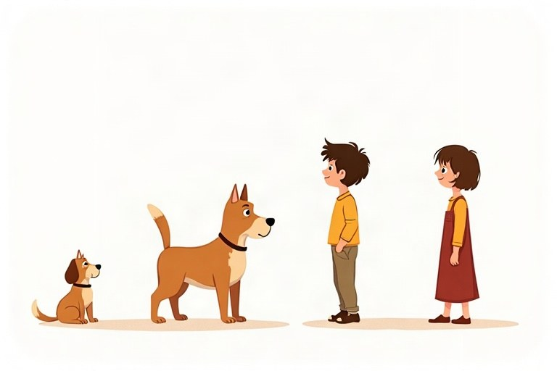
◆ The rules
הכללים
القواعد
Adjective | Comparative | Superlative
short: tall | taller than | the tallest
ends in -e: large | larger than | the largest
ends in -y: funny | funnier than | the funniest
long: beautiful | more beautiful than | the most beautiful

◆ Double the last letter
מכפילים את האות האחרונה
نضاعف الحرف الأخير
1. big – bigger – the biggest
2. hot – hotter – the hottest
3. thin – thinner – the thinnest
◆ Irregular adjectives
שמות תואר יוצאי דופן
صفات شاذّة
Adjective | Comparative | Superlative
good | better | the best
bad | worse | the worst
far | farther | the farthest

◆ Two or many?
שניים או הרבה?
اثنان أم كثير؟
1. Two things: Noa is older than Maya.
שני דברים: ‎Noa is older than Maya‎.
شيئان: ‎Noa is older than Maya‎.
2. One in a group: Noa is the oldest girl in the class.
אחד מתוך קבוצה: ‎Noa is the oldest girl in the class‎.
واحد من مجموعة: ‎Noa is the oldest girl in the class‎.
🖼️ Picture words · מילים בתמונות‎ · كلمات بالصّور‎
dog  כלב  كلب | park  פארק  حديقة عامة |   water  מים  ماء | book  ספר  كتاب |   cat  חתול  قطة | bag  תיק  حقيبة

1. Write the comparative form.
כתבו את צורת ההשוואה.
اكتب صيغة المقارنة.
a. long → __________
b. late → __________
c. busy → __________
d. thin → __________
e. far → __________
f. careful → __________
2. Write the superlative form.
כתבו את צורת ההפלגה.
اكتب صيغة التفضيل.
a. short → __________
b. safe → __________
c. heavy → __________
d. wet → __________
e. bad → __________
f. important → __________
3. Match the beginnings and the endings.
התאימו בין תחילת המשפט לסופו.
صِل بداية كل جملة بنهايتها.
Column A | Column B
1. A giraffe is taller | [ ] in August than in March.
2. Jupiter is the biggest | [ ] planet in our solar system.
3. Chess is more difficult | [ ] grade in the test.
4. Shira got the best | [ ] than checkers.
5. The sea is warmer | [ ] than a zebra.

4. Correct or not correct? Sort.
נכון או לא נכון? מיינו.
صحيحة أم غير صحيحة؟ صنّف.
Words: more fast | faster | the most beautiful | the beautifullest | gooder | better | biger | bigger
Correct | Not correct

5. Circle the correct answer.
הקיפו את התשובה הנכונה.
ضع دائرة حول الإجابة الصحيحة.
a. Yoav is ___ boy in the class.
○ the youngest ○ younger ○ the most young
b. My room is ___ than my brother's room.
○ clean ○ cleaner ○ cleanest
c. Today is ___ than yesterday.
○ more sunny ○ sunnier ○ the sunniest
6. Omer is 11 years old and 1.40 m tall. Itay is 12 and 1.45 m tall. Tom is 13 and 1.38 m tall. Complete with a comparative or a superlative.
עומר בן 11 וגובהו 1.40 מ'. איתי בן 12 וגובהו 1.45 מ'. תום בן 13 וגובהו 1.38 מ'. השלימו בצורת השוואה או בצורת הפלגה.
عومر عمره 11 سنة وطوله 1.40 م. إيتاي عمره 12 سنة وطوله 1.45 م. توم عمره 13 سنة وطوله 1.38 م. أكمل بصيغة المقارنة أو بصيغة التفضيل.
a. Itay is __________ (old) than Omer.
b. Tom is __________ (old) of the three boys.
c. Itay is __________ (tall) boy.
d. Tom is __________ (short) than Omer.
7. Find the mistake and write the correct sentence.
מצאו את הטעות וכתבו את המשפט הנכון.
جد الخطأ واكتب الجملة الصحيحة.
a. My dog is more big than your dog.
b. This is the most cheap shirt in the shop.
c. Maya is more taller than Noa.
d. It is the goodest cake ever!
The Class Trip Vote
Class 6A is going on a trip, and the children are voting for the place. There are three choices: the zoo in Jerusalem, a water park, and a nature reserve in the north.
"The water park is the most fun," says Itay. "It's hotter in June, so water is the best idea!" Maya doesn't agree. "The zoo is more interesting than a water park. We can learn about animals." Ben likes the nature reserve. "It's the most beautiful place, and it's quieter than the other two."
The teacher counts the votes. The water park gets 14 votes, the zoo gets 10 votes, and the nature reserve gets only 6. The water park wins! But the nature reserve is the cheapest choice, so the teacher says, "Next year we are going to go there."
8. Read the text and circle the correct answer.
קראו את הטקסט והקיפו את התשובה הנכונה.
اقرأ النص وضع دائرة حول الإجابة الصحيحة.
a. Which place gets the most votes?
○ the zoo ○ the water park ○ the nature reserve
b. Why does Ben like the nature reserve?
○ It's the cheapest. ○ It's quieter. ○ There are animals.
9. Complete the sentences according to the text.
השלימו את המשפטים לפי הטקסט.
أكمل الجمل حسب النص.
a. Maya thinks the zoo is more __________ than a water park.
b. The water park gets __________ votes than the zoo.
c. The nature reserve is the __________ choice.
10. True or false? Correct the false sentences.
נכון או לא נכון? תקנו את המשפטים הלא נכונים.
صحيح أم خطأ؟ صحّح الجمل الخاطئة.
a. There are 30 children who vote. True / False
b. The zoo is the cheapest choice. True / False
c. The class is going to the nature reserve this year. True / False
11. Which place do you like best for a class trip? Write 3–4 sentences and compare it to another place.
איזה מקום אתם הכי אוהבים לטיול שנתי? כתבו 3–4 משפטים והשוו אותו למקום אחר.
أيّ مكان تحبه أكثر لرحلة الصف؟ اكتب 3–4 جمل وقارنه بمكان آخر.
________________________________________________________________________
________________________________________________________________________
________________________________________________________________________
________________________________________________________________________
12. Write about your family. Who is the oldest? Who is the youngest? Who is the funniest? Write 3 sentences.
כתבו על המשפחה שלכם. מי הכי מבוגר? מי הכי צעיר? מי הכי מצחיק? כתבו 3 משפטים.
اكتب عن عائلتك. مَن الأكبر سنًّا؟ مَن الأصغر سنًّا؟ مَن الأكثر مرحًا؟ اكتب 3 جمل.
________________________________________________________________________
________________________________________________________________________
________________________________________________________________________

English · Grade 6 | Unit 5
Unit 5: Modal verbs: can, could, must, should
פעלי עזר מודאליים: ‎can, could, must, should‎
الأفعال المساعدة: ‎can, could, must, should‎
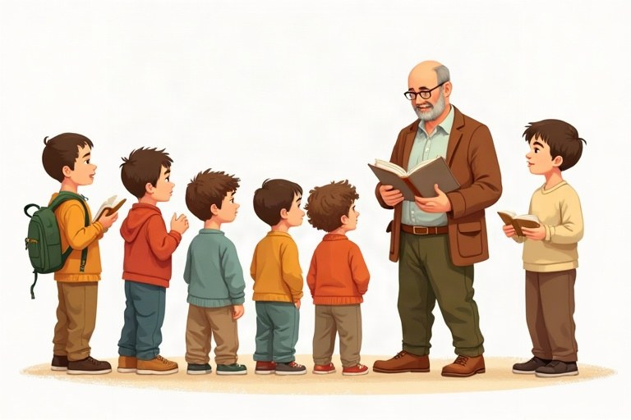
◆ What do they mean?
מה הם אומרים?
ماذا تعني؟
Modal | Use | Example
can / could | requests, ability | Could you help me, please?
must | a rule, it is necessary | You must wear a seat belt.
mustn't | not allowed | You mustn't touch the paintings.
should / shouldn't | advice | You should study for the test.

◆ The form
המבנה
الصيغة
1. modal + base form: She must go.
פועל מודאלי + צורת בסיס: ‎She must go‎.
فعل مساعد + الصيغة الأساسية: ‎She must go‎.
2. No -s: He can play. (Not: He cans play.)
בלי -‎s: He can play. (‎לא: ‎He cans play.)‎
بدون -‎s: He can play. (‎وليس: ‎He cans play.)‎
3. No to: You should rest. (Not: You should to rest.)
בלי ‎to: You should rest. (‎לא: ‎You should to rest.)‎
بدون ‎to: You should rest. (‎وليس: ‎You should to rest.)‎
◆ Questions and answers
שאלות ותשובות
أسئلة وأجوبة
Examples:
דוגמאות:
أمثلة:
Can I come in? Yes, you can. / Sorry, you can't. · Should I take a coat? Yes, you should.
🖼️ Picture words · מילים בתמונות‎ · كلمات بالصّور‎
water  מים  ماء | bag  תיק  حقيبة |   red  אדום  أحمر |   bed  מיטה  سرير | phone  טלפון  هاتف |   hat  כובע  قبعة

1. Match the problems to the advice.
התאימו בין הבעיות לעצות.
صِل المشكلات بالنصائح.
Column A | Column B
1. I'm hungry. | [ ] You should look in your bag.
2. I'm bored. | [ ] You should wear a sweater.
3. I have a headache. | [ ] You should eat a sandwich.
4. I'm cold. | [ ] You should read a book.
5. I can't find my keys. | [ ] You should rest.

2. Complete with can or can't.
השלימו עם ‎can‎ או ‎can't‎.
أكمل بـ ‎can‎ أو ‎can't‎.
Word bank: can | can't
a. Fish __________ swim.
b. Fish __________ walk.
c. A baby __________ drive a car.
d. Birds __________ fly.
e. I __________ hear you. Please speak louder!
3. Circle the more polite request.
הקיפו את הבקשה המנומסת יותר.
ضع دائرة حول الطلب الأكثر تهذيبًا.
a. Which request is more polite?
○ Give me the book. ○ Could you give me the book, please?
b. Which request is more polite?
○ Could I sit here, please? ○ I sit here.
c. Which request is more polite?
○ Open the door! ○ Could you open the door, please?
4. Complete the museum rules with must or mustn't.
השלימו את כללי המוזיאון ב-‎must‎ או ‎mustn't‎.
أكمل قوانين المتحف بـ ‎must‎ أو ‎mustn't‎.
a. You __________ touch the paintings.
b. You __________ buy a ticket.
c. You __________ take photos with a flash.
d. You __________ leave your bag at the entrance.
5. Sort the sentences: good advice or bad advice?
מיינו את המשפטים: עצה טובה או עצה לא טובה?
صنّف الجمل: نصيحة جيدة أم نصيحة سيئة؟
Words: You should brush your teeth twice a day. | You should eat candy for breakfast. | You shouldn't cross the road on a red light. | You should sleep only four hours. | You should drink water when it's hot. | You shouldn't share your password.
Good advice | Bad advice

6. Complete with can, could, must, mustn't, should or shouldn't.
השלימו ב-‎can, could, must, mustn't, should‎ או ‎shouldn't‎.
أكمل بـ ‎can‎ أو ‎could‎ أو ‎must‎ أو ‎mustn't‎ أو ‎should‎ أو ‎shouldn't‎.
a. __________ you tell me the time, please?
b. In Israel, drivers __________ drive on the right side of the road.
c. You __________ play with matches. It's dangerous.
d. Your shoes are old. You __________ buy new ones.
7. Write a question and an answer.
כתבו שאלה ותשובה.
اكتب سؤالًا وإجابة.
Question words | Question | Answer
Can / I / open the window?
Should / we / bring food?
Can / Noam / swim?

8. Find the mistake and write the correct sentence.
מצאו את הטעות וכתבו את המשפט הנכון.
جد الخطأ واكتب الجملة الصحيحة.
a. You mustn't to talk in the library.
b. Can you to help me?
c. She must goes to the dentist.
d. We should to leave now.
Tips for a Hike
Next week class 6C is going on a hike in the Negev. The teacher, Mr. Cohen, wrote a letter to the pupils.
"Dear pupils, the desert is beautiful, but it can be dangerous. Everyone must bring three liters of water. You must wear a hat and good shoes, not sandals. You mustn't leave the group, and you mustn't climb on rocks without a guide.
You should go to bed early the night before, because we are going to start walking at six in the morning. You shouldn't bring heavy things in your bag. You can bring a camera or a small game for the bus.
If you have any questions, you can call me. See you on Sunday!"
9. Read the text and circle the correct answer.
קראו את הטקסט והקיפו את התשובה הנכונה.
اقرأ النص وضع دائرة حول الإجابة الصحيحة.
a. How much water must everyone bring?
○ one liter ○ two liters ○ three liters
b. Why should the pupils go to bed early?
○ They start walking at six. ○ The bus is slow. ○ It is cold at night.
10. True or false? Correct the false sentences.
נכון או לא נכון? תקנו את המשפטים הלא נכונים.
صحيح أم خطأ؟ صحّح الجمل الخاطئة.
a. The pupils can wear sandals on the hike. True / False
b. The pupils mustn't leave the group. True / False
c. Mr. Cohen thinks the desert is never dangerous. True / False
11. Complete according to the text.
השלימו לפי הטקסט.
أكمل حسب النص.
a. You __________ climb on rocks without a guide.
b. You __________ bring a camera for the bus.
c. You __________ bring heavy things in your bag.
12. Your friend is going to visit your town for the first time. Write 4 sentences of advice and rules.
חבר או חברה שלכם עומדים לבקר בעיר שלכם בפעם הראשונה. כתבו 4 משפטים של עצות וכללים.
صديقك سيزور بلدتك لأول مرة. اكتب 4 جمل فيها نصائح وقواعد.
________________________________________________________________________
________________________________________________________________________
________________________________________________________________________
________________________________________________________________________

English · Grade 6 | Unit 6
Unit 6: Asking questions: Wh-questions review
שואלים שאלות: חזרה על שאלות ‎Wh-‎
طرح الأسئلة: مراجعة أسئلة ‎Wh-‎
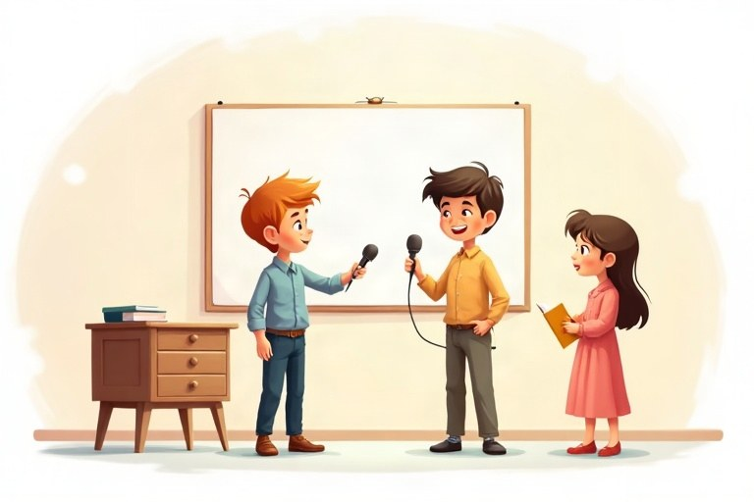
◆ Question words
מילות שאלה
كلمات السؤال
Word | Asks about | Example
Who | a person | Who is that boy?
What | a thing / an action | What are you eating?
Where | a place | Where is my bag?
When | a time | When does the movie start?
Why | a reason | Why are you late?
How | the way | How do you spell it?

◆ How + …
1. How many + count nouns: How many pencils?
‎How many +‎ שמות עצם שאפשר לספור: ‎How many pencils?‎
‎How many +‎ أسماء يمكن عدّها: ‎How many pencils?‎
2. How much + no-count nouns / price: How much milk? How much is it?
‎How much +‎ שמות עצם שאי אפשר לספור / מחיר: ‎How much milk?‎‏ ‎How much is it?‎
‎How much +‎ أسماء لا يمكن عدّها / السعر: ‎How much milk?‎‏ ‎How much is it?‎
3. How old / How often / How long
◆ Word order
סדר המילים
ترتيب الكلمات
1. Question word + be + subject: Where is Noa?
מילת שאלה ‎+ be +‎ נושא: ‎Where is Noa?‎
كلمة السؤال ‎+ be +‎ الفاعل: ‎Where is Noa?‎
2. Question word + do / does / did + subject + base form: What did Ben say?
מילת שאלה ‎+ do / does / did +‎ נושא + צורת בסיס: ‎What did Ben say?‎
كلمة السؤال ‎+ do / does / did +‎ الفاعل + الصيغة الأساسية: ‎What did Ben say?‎
🖼️ Picture words · מילים בתמונות‎ · كلمات بالصّور‎
school  בית ספר  مدرسة | bag  תיק  حقيبة | cat  חתול  قطة |   milk  חלב  حليب |   blue  כחול  أزرق | bus  אוטובוס  حافلة

1. Complete with Who, What, Where or When.
השלימו ב-‎Who, What, Where‎ או ‎When‎.
أكمل بـ ‎Who‎ أو ‎What‎ أو ‎Where‎ أو ‎When‎.
a. __________ is the library? Next to the gym.
b. __________ is your favorite singer? I don't have one.
c. __________ time is it? It's ten o'clock.
d. __________ does school end? At 1:30.
e. __________ did you see at the mall? Shira and Tamar.
2. Match the questions to the answers.
התאימו בין השאלות לתשובות.
صِل الأسئلة بالإجابات.
Column A | Column B
1. How often do you play tennis? | [ ] Twice a week.
2. How long is the movie? | [ ] Two hours.
3. Which shirt do you want? | [ ] The blue one.
4. Whose phone is ringing? | [ ] Thirty shekels.
5. How much is the ticket? | [ ] Five.
6. How many people are in your family? | [ ] It's Dad's.

3. Sort the answers by the question word they answer.
מיינו את התשובות לפי מילת השאלה שהן עונות עליה.
صنّف الإجابات حسب كلمة السؤال التي تجيب عنها.
Words: In Tel Aviv. | At midnight. | Because I'm hungry. | Under the bed. | On Tuesday. | Because it's my birthday.
Where? | When? | Why?

4. Circle the correct question.
הקיפו את השאלה הנכונה.
ضع دائرة حول السؤال الصحيح.
a. Which question is correct?
○ Where you live? ○ Where do you live? ○ Where does you live?
b. Which question is correct?
○ What is Noam doing? ○ What Noam is doing? ○ What does Noam doing?
c. Which question is correct?
○ When you did arrive? ○ When did you arrived? ○ When did you arrive?
5. Complete with How many, How much, How old or How often.
השלימו ב-‎How many, How much, How old‎ או ‎How often‎.
أكمل بـ ‎How many‎ أو ‎How much‎ أو ‎How old‎ أو ‎How often‎.
a. __________ is your dog? He's four.
b. __________ juice is in the bottle?
c. __________ pupils are in your class?
d. __________ do you eat pizza? Once a week.
6. Write a question about the words in CAPITAL letters.
כתבו שאלה על המילים שכתובות באותיות גדולות ‎(CAPITAL)‎.
اكتب سؤالًا عن الكلمات المكتوبة بالأحرف الكبيرة ‎(CAPITAL)‎.
Answer | Question
Yoav lives in HAIFA.
The concert starts AT EIGHT.
Maya is crying BECAUSE SHE FELL.
Omer has THREE cats.

7. Find the mistake and write the correct question.
מצאו את הטעות וכתבו את השאלה הנכונה.
جد الخطأ واكتب السؤال الصحيح.
a. Where you are going?
b. What did Tom bought?
c. How many money do you have?
d. Who's bag is this?
An Interview with a Young Chef
Our school newspaper interviewed Noa, a pupil in class 6D who won a cooking competition for kids.
Q: When did you start cooking?
Noa: When I was seven. I helped my grandma in her kitchen every Friday.
Q: What is your favorite dish?
Noa: Shakshuka! I make it with tomatoes, peppers and a little cheese.
Q: How often do you cook at home?
Noa: About three times a week. On Fridays I cook for the whole family.
Q: Why did you join the competition?
Noa: Because my teacher told me I'm good at it, and I wanted to try something new.
Q: What are you going to do with the prize?
Noa: I'm going to buy a professional knife and a cookbook!
8. Read the interview and circle the correct answer.
קראו את הראיון והקיפו את התשובה הנכונה.
اقرأ المقابلة وضع دائرة حول الإجابة الصحيحة.
a. Who taught Noa to cook?
○ her teacher ○ her grandma ○ her mom
b. How often does Noa cook at home?
○ once a week ○ every day ○ about three times a week
9. Complete the answers according to the interview.
השלימו את התשובות לפי הראיון.
أكمل الإجابات حسب المقابلة.
a. Noa started cooking when she was __________.
b. Her favorite dish is __________.
c. She joined the competition because her __________ told her she's good at it.
d. With the prize she is going to buy a knife and a __________.
10. True or false? Correct the false sentences.
נכון או לא נכון? תקנו את המשפטים הלא נכונים.
صحيح أم خطأ؟ صحّح الجمل الخاطئة.
a. Noa puts tomatoes and peppers in her shakshuka. True / False
b. Noa cooks for her family on Saturdays. True / False
c. Noa won a singing competition. True / False
11. Write two more questions you want to ask Noa. Use two different question words.
כתבו עוד שתי שאלות שהייתם רוצים לשאול את נועה. השתמשו בשתי מילות שאלה שונות.
اكتب سؤالين آخرين تريد أن تسألهما لنوعا. استعمل كلمتي سؤال مختلفتين.
________________________________________________________________________
________________________________________________________________________
12. Interview a family member. Write 3 questions and his or her answers.
ראיינו בן או בת משפחה. כתבו 3 שאלות ואת התשובות שלהם.
قابِل أحد أفراد عائلتك. اكتب 3 أسئلة وإجاباته عنها.
________________________________________________________________________
________________________________________________________________________
________________________________________________________________________
________________________________________________________________________

English · Grade 6 | Unit 7
Unit 7: Reading comprehension and writing an email
הבנת הנקרא וכתיבת מייל
فهم المقروء وكتابة رسالة إلكترونية
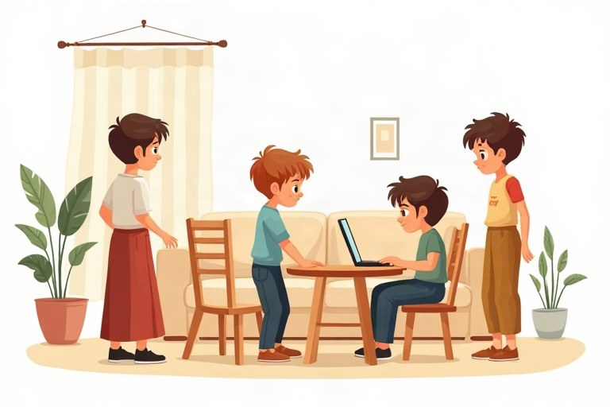
◆ Reading in three steps
קריאה בשלושה שלבים
القراءة في ثلاث خطوات
1. Before: look at the title and pictures; guess the topic.
לפני: הסתכלו על הכותרת ועל התמונות; נחשו את הנושא.
قبل: انظر إلى العنوان والصور؛ خمّن الموضوع.
2. While: read the questions, find key words, underline the evidence.
בזמן: קראו את השאלות, מצאו מילות מפתח, מתחו קו מתחת לראיה.
أثناء: اقرأ الأسئلة، جد الكلمات المفتاحية، ضع خطًّا تحت الدليل.
3. After: check that your answer really answers the question.
אחרי: בדקו שהתשובה שלכם באמת עונה על השאלה.
بعد: تأكّد أن إجابتك تجيب فعلًا عن السؤال.
◆ The parts of an email
חלקי המייל
أجزاء الرسالة الإلكترونية
Part | Example
Subject | Our class trip
Greeting | Hi Ben, / Dear Ms. Levi,
Opening | How are you? Thanks for your email.
Body | what happened, details, feelings, questions
Closing + name | See you soon! / Love, Noa

◆ Linking words
מילות קישור
أدوات الربط
Word | Use | Example
and / also | add | I swam and I also ran.
but | contrast | It was cold, but fun.
because | reason | I stayed home because I was sick.
so | result | I was sick, so I stayed home.

🖼️ Picture words · מילים בתמונות‎ · كلمات بالصّور‎
bus  אוטובוס  حافلة |   ice cream  גלידה  بوظة |   key  מפתח  مفتاح | school  בית ספר  مدرسة |   sea  ים  بحر | bike  אופניים  دراجة

1. Match the email subject to the message.
התאימו כל נושא מייל להודעה.
صِل كل موضوع رسالة بالرسالة المناسبة.
Column A | Column B
1. Thank you! | [ ] I'm sorry I forgot your book.
2. Party on Friday | [ ] What pages do we need for tomorrow?
3. I'm sorry | [ ] Can you come to my party?
4. Lost dog | [ ] Thanks for the great present.
5. Homework question | [ ] Did anyone see a small brown dog?

2. Sort the sentences: formal (to a teacher) or friendly (to a friend)?
מיינו את המשפטים: רשמי (למורה) או חברי (לחבר)?
صنّف الجمل: رسمية (إلى معلّم) أم ودّية (إلى صديق)؟
Words: Dear Ms. Cohen, | Hey Ben! | Best regards, | See ya! | Thank you for your help. | Thanks a lot!!!
Formal | Friendly

3. Complete with and, but, because or so.
השלימו ב-‎and, but, because‎ או ‎so‎.
أكمل بـ ‎and‎ أو ‎but‎ أو ‎because‎ أو ‎so‎.
a. I studied hard, __________ I got a good grade.
b. Tom has a cat __________ two dogs.
c. We stayed inside __________ it was raining.
d. I called Shira, __________ she didn't answer.
4. Circle the best opening sentence for an email to a friend.
הקיפו את משפט הפתיחה הטוב ביותר למייל לחבר.
ضع دائرة حول أفضل جملة افتتاحية لرسالة إلكترونية إلى صديق.
a. Choose the best opening.
○ Goodbye. ○ How are you? I have some news! ○ Love, Noam
b. Choose the best opening.
○ Thanks for your email. It was great to hear from you! ○ See you! ○ Dear Sir,
An Ad and an Email
AD: Kids' Science Club! Every Wednesday, 4:00–6:00 p.m., at the Community Center. Ages 10–13. Build robots, do experiments and visit the planetarium. Price: 120 shekels a month. Call Dana: 050-0000000.
EMAIL:
Subject: Science Club?
Hi Ben,
Did you see the ad for the new Science Club? I want to join because I love robots. It's on Wednesdays after school, so we can go together on our bikes. It costs 120 shekels a month. That's a little expensive, but I'm going to use my birthday money.
Do you want to come with me? Please ask your parents and write back soon!
Your friend,
Ariel
5. Read the ad and the email. Complete the sentences.
קראו את המודעה ואת המייל. השלימו את המשפטים.
اقرأ الإعلان والرسالة الإلكترونية. أكمل الجمل.
a. The Science Club meets every __________.
b. The club is for children aged 10 to __________.
c. Ariel wants to join because he loves __________.
d. Ariel is going to pay with his __________ money.
6. Circle the correct answer.
הקיפו את התשובה הנכונה.
ضع دائرة حول الإجابة الصحيحة.
a. How many hours is each meeting?
○ one hour ○ two hours ○ four hours
b. What does Ariel want Ben to do?
○ buy a robot ○ call Dana ○ ask his parents
7. True or false? Write the evidence.
נכון או לא נכון? כתבו את הראיה.
صحيح أم خطأ؟ اكتب الدليل.
a. The club meets at the school. True / False
b. Ariel thinks the price is a little high. True / False
c. Ariel wants to go to the club by bus. True / False
8. Complete the information from the ad.
השלימו את המידע מהמודעה.
أكمل المعلومات من الإعلان.
Question | Answer
What day?
What time?
Where?
How much?

9. Find the linking words in Ariel's email. Copy the sentence.
מצאו את מילות הקישור במייל של אריאל. העתיקו את המשפט.
جد كلمات الربط في رسالة أريئيل الإلكترونية. انسخ الجملة.
a. because
b. so
c. but
10. Fix the email. Each line has one mistake. Write it correctly.
תקנו את המייל. בכל שורה יש טעות אחת. כתבו אותה נכון.
صحّح الرسالة الإلكترونية. في كل سطر خطأ واحد. اكتبه بشكل صحيح.
a. dear Noa,
b. How you are?
c. I go to the beach yesterday.
d. Love Shira
11. Complete the email with words from the box.
השלימו את המייל במילים מהתיבה.
أكمل الرسالة الإلكترونية بكلمات من المربع.
Word bank: Subject | Hi | because | so | Love
a. __________: My new room
b. __________ Tamar,
c. I have a new room __________ we moved to a bigger apartment.
d. It's very big, __________ you can sleep over next week!
e. __________, Maya
12. You are Ben. Write an email (4 lines) back to Ariel. Say yes or no, and explain why.
אתם בן. כתבו מייל תשובה (4 שורות) לאריאל. כתבו כן או לא, והסבירו למה.
أنت بن. اكتب رسالة إلكترونية (4 أسطر) ردًّا على أريئيل. قل نعم أو لا، واشرح لماذا.
________________________________________________________________________
________________________________________________________________________
________________________________________________________________________
________________________________________________________________________
13. Write an email (4 lines) to a friend about a fun day you had. Use a greeting, a closing, and the words because and but.
כתבו מייל (4 שורות) לחבר או לחברה על יום כיף שהיה לכם. השתמשו בפתיחה, בסיום ובמילים ‎because‎ ו-‎but‎.
اكتب رسالة إلكترونية (4 أسطر) إلى صديق عن يوم ممتع قضيته. استعمل تحية وخاتمة والكلمتين ‎because‎ و ‎but‎.
________________________________________________________________________
________________________________________________________________________
________________________________________________________________________
________________________________________________________________________

Review – What did we learn?
חזרה – מה למדנו?
مراجعة – ماذا تعلّمنا؟
1. Complete with the correct form of the verb in brackets.
השלימו בצורה הנכונה של הפועל שבסוגריים.
أكمل بالصيغة الصحيحة للفعل الذي بين القوسين.
a. Noam usually __________ (walk) to school.
b. Look! The children __________ (dance).
c. Yesterday we __________ (not / go) to the pool.
d. Next week Maya __________ (visit) her aunt. (going to)
e. Did you __________ (see) the game last night?
2. Complete the table.
השלימו את הטבלה.
أكمل الجدول.
Adjective | Comparative | Superlative
fast
funny
important
bad

3. Circle the correct answer.
הקיפו את התשובה הנכונה.
ضع دائرة حول الإجابة الصحيحة.
a. You ___ wear a seat belt in the car. It's the law.
○ should ○ must ○ can
b. ___ did you put my keys? On the table.
○ When ○ Who ○ Where
c. Did Itay ___ the test?
○ pass ○ passed ○ passes
d. This is ___ day of my life!
○ the happiest ○ happier ○ the most happy
4. Match the questions to the answers.
התאימו בין השאלות לתשובות.
صِل الأسئلة بالإجابات.
Column A | Column B
1. Are you going to come? | [ ] Yes, she does.
2. Did you like the book? | [ ] Yes, I am.
3. Can I borrow your pen? | [ ] No, it isn't.
4. Is it raining now? | [ ] No, I didn't.
5. Does she speak French? | [ ] Sure, here you are.

5. Find the mistake and write the correct sentence.
מצאו את הטעות וכתבו את המשפט הנכון.
جد الخطأ واكتب الجملة الصحيحة.
a. She don't like milk.
b. Did you went to the party?
c. He is going to plays tennis.
d. This bag is more heavy than mine.
e. You must to be quiet.
6. Complete with and, but, because or so.
השלימו ב-‎and, but, because‎ או ‎so‎.
أكمل بـ ‎and‎ أو ‎but‎ أو ‎because‎ أو ‎so‎.
a. I was tired, __________ I went to bed early.
b. We wanted to swim, __________ the sea was too cold.
c. Tom is happy __________ his team won.
7. Write 4 sentences about yourself: something you do every day, something you did last week, something you are going to do next week, and your best friend compared to you.
כתבו 4 משפטים על עצמכם: משהו שאתם עושים כל יום, משהו שעשיתם בשבוע שעבר, משהו שאתם הולכים לעשות בשבוע הבא, ואת החבר/ה הכי טוב/ה שלכם בהשוואה אליכם.
اكتب 4 جمل عن نفسك: شيئًا تفعله كل يوم، وشيئًا فعلته في الأسبوع الماضي، وشيئًا ستفعله في الأسبوع القادم، وصديقك المفضّل مقارنةً بك.
________________________________________________________________________
________________________________________________________________________
________________________________________________________________________
________________________________________________________________________
Well done!
כל הכבוד!‎ · أحسنت!‎
I finished the English workbook for Grade 6.

